POKEMON DATASET

PROJECT MEMBERS:

VINAY 20/49061

ASHISH 20/49017

Introduction about Database:

THIS DATABASE IS ABOUT “POKEMON”. This dataset contains information about Pokémon from all Seven Generations of Pokémon. The information contained in this dataset include Base Stats, Performance against Other Types, Height, Weight, Classification, Egg Steps, Experience Points, Abilities, etc.

Content

* name: The English name of the Pokemon
* japanese_name: The Original Japanese name of the Pokemon
* pokedex_number: The entry number of the Pokemon in the National Pokedex
* percentage_male: The percentage of the species that are male. Blank if the Pokemon is genderless.
* type1: The Primary Type of the Pokemon
* type2: The Secondary Type of the Pokemon
* classification: The Classification of the Pokemon as described by the Sun and Moon Pokedex
* height_m: Height of the Pokemon in metres
* weight_kg: The Weight of the Pokemon in kilograms
* capture_rate: Capture Rate of the Pokemon
* base*egg*steps: The number of steps required to hatch an egg of the Pokemon
* abilities: A stringified list of abilities that the Pokemon is capable of having
* experience_growth: The Experience Growth of the Pokemon
* base_happiness: Base Happiness of the Pokemon
* against_?: Eighteen features that denote the amount of damage taken against an attack of a particular type
* hp: The Base HP of the Pokemon
* attack: The Base Attack of the Pokemon
* defense: The Base Defense of the Pokemon
* sp_attack: The Base Special Attack of the Pokemon
* sp_defense: The Base Special Defense of the Pokemon
* speed: The Base Speed of the Pokemon
* generation: The numbered generation which the Pokemon was first introduced
* is_legendary: Denotes if the Pokemon is legendary.

VIEW OF DATABASE IS:

View(pokemon)

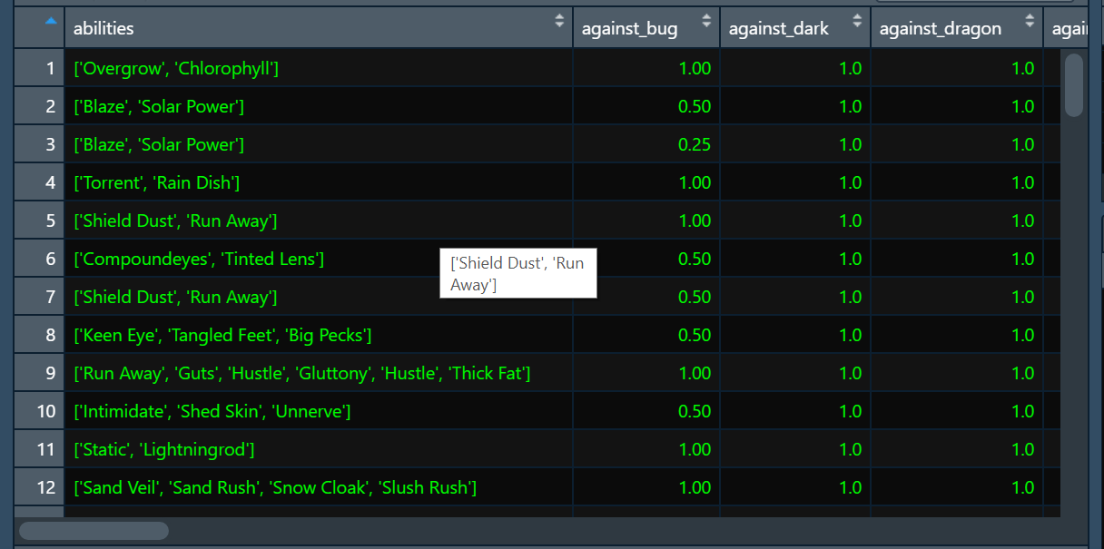

STRUCTURE OF DATABASE IS:

Str(pokemon)

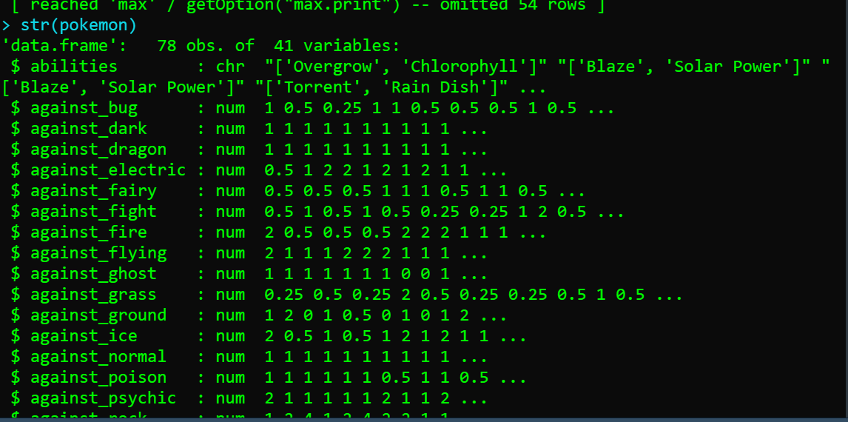

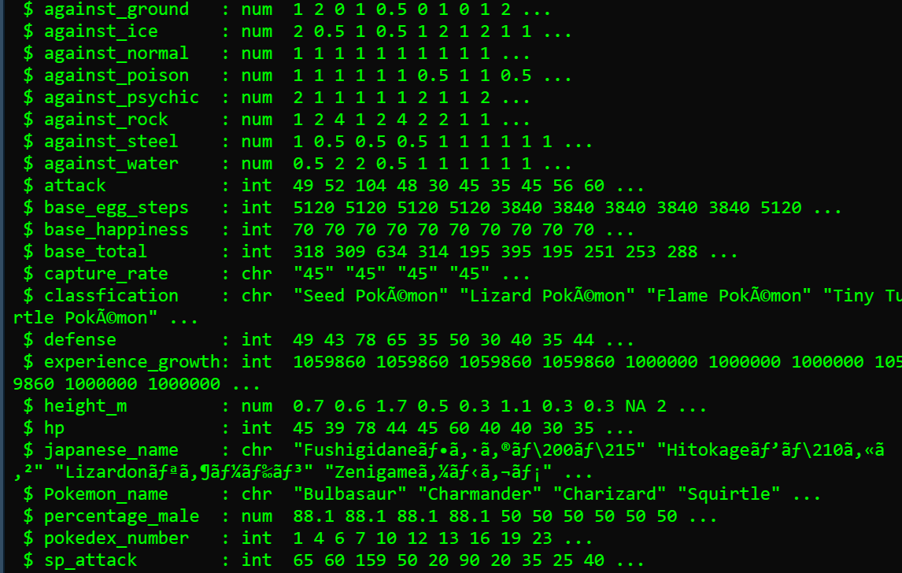

SUMMARY OF DATABSE IS:

Summary(pokemon)

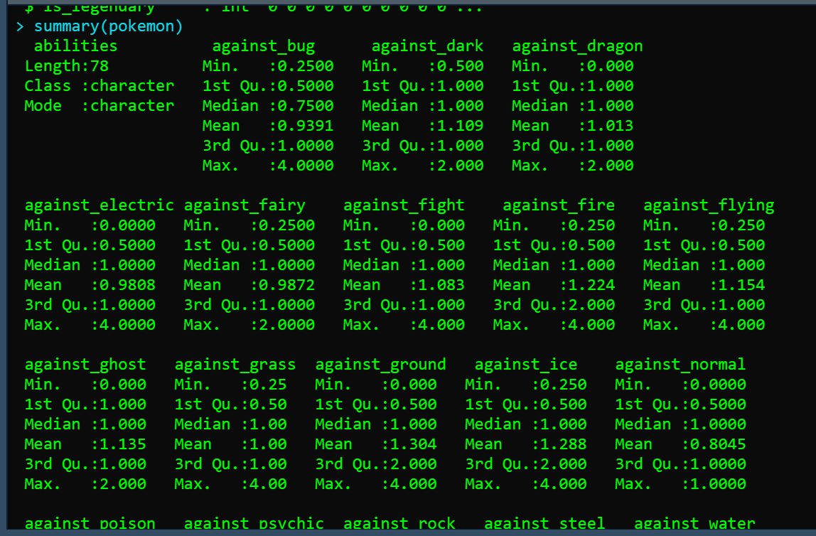

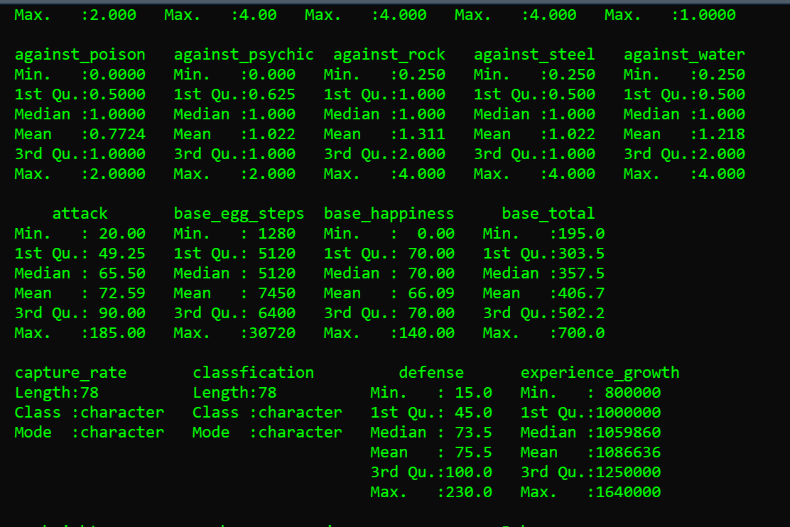

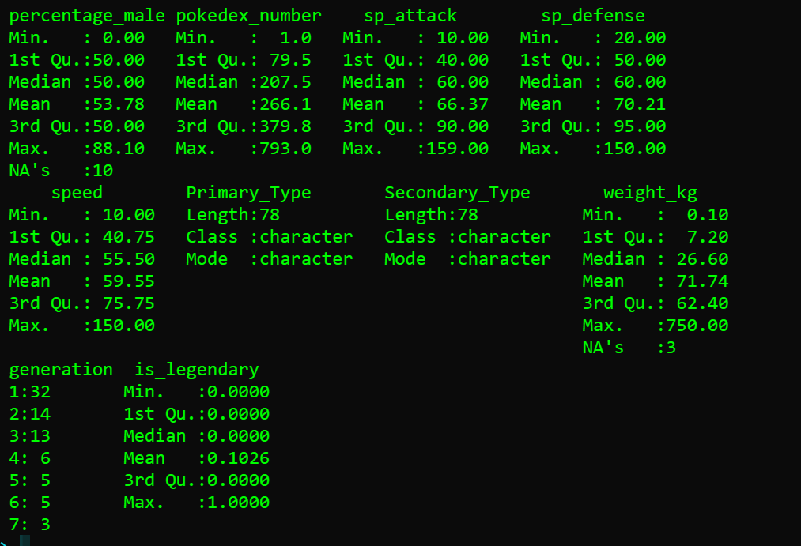

* NUMBER OF ROW AND COLUMN IN POKEMON
* nrow(pokemon)
* ncol(pokemon)

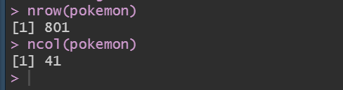

DATA CLEANING:

pokemon$generation<- as.factor(pokemon$generation)

#printing missing values by creating a new data frame.

a<-data.frame("Variable"=c(colnames(pokemon)), "Missing Values"=sapply(pokemon, function(x) sum(is.na(x))), row.names = NULL)

print(a)

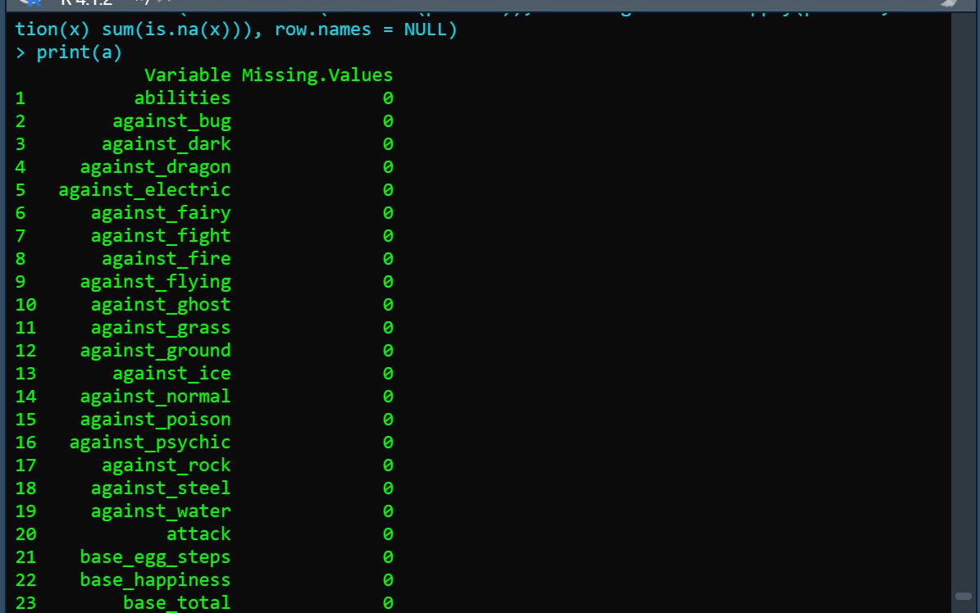

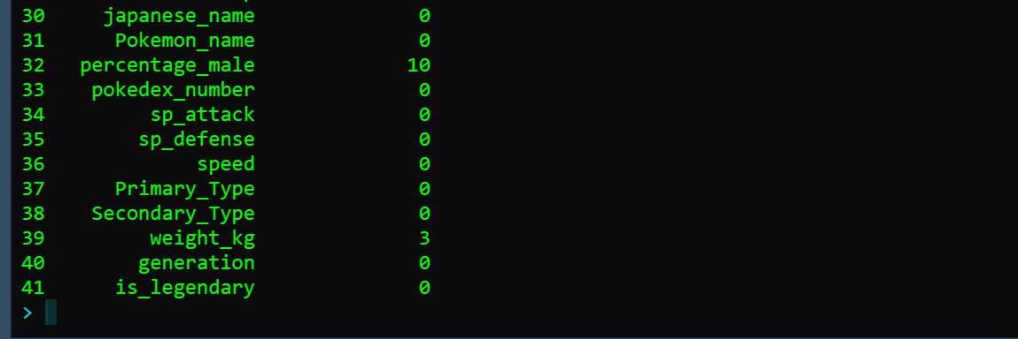

f1<- function(a){

uni<- unique(a)

uni[which.max(tabulate(match(a,uni)))]

}

pokemon$generation[is.na(pokemon$generation)] = f1(pokemon$generation)

b<-data.frame("Variable"=c(colnames(pokemon)), "Missing Values"=sapply(pokemon, function(x) sum(is.na(x))), row.names = NULL)

print(b)

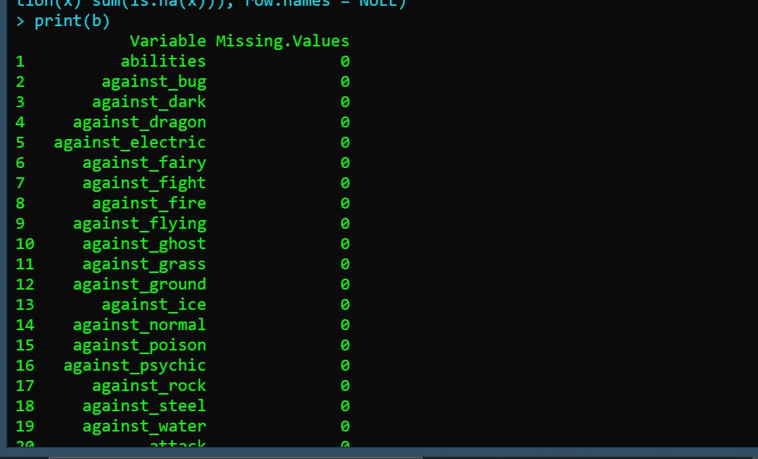

library("dplyr")

pokemon= distinct(pokemon, against_fire, against_ground,against_ice, against_bug, .keep_all = TRUE)

print(pokemon)

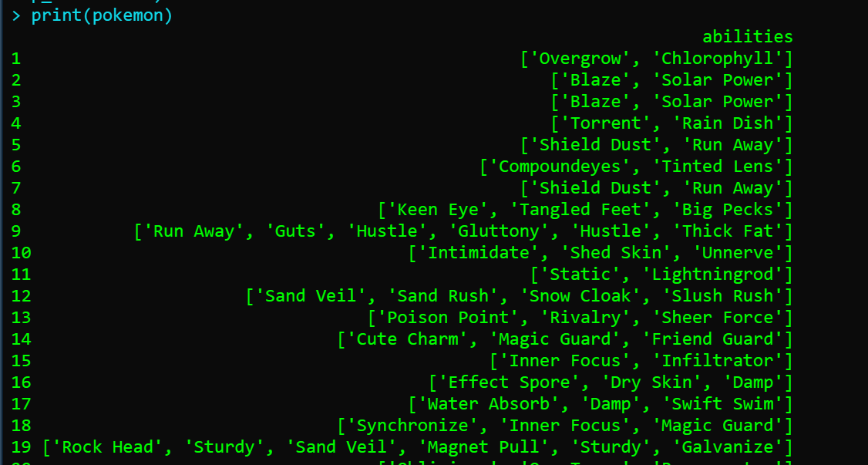

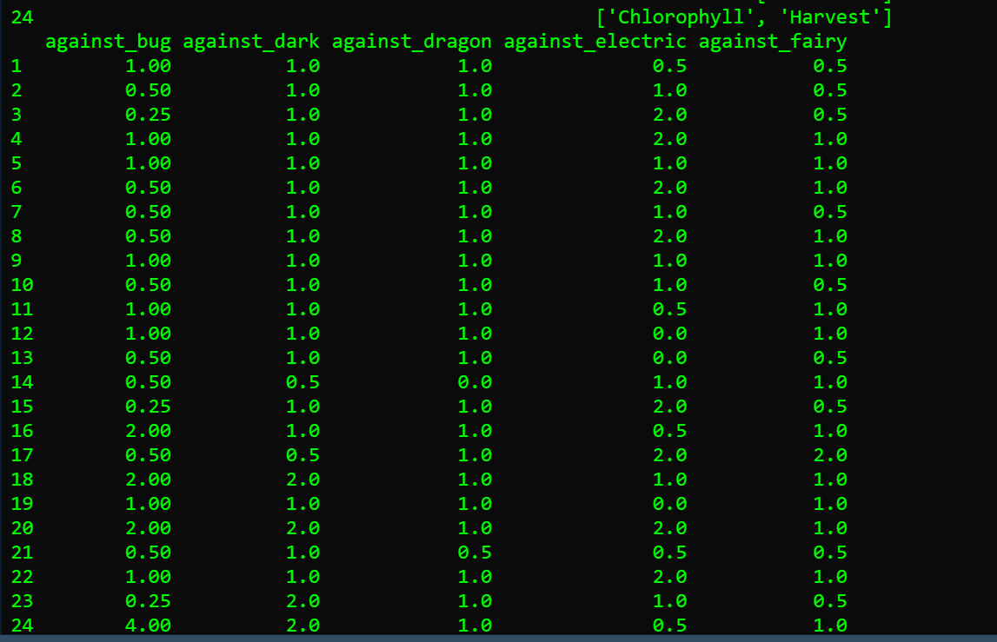

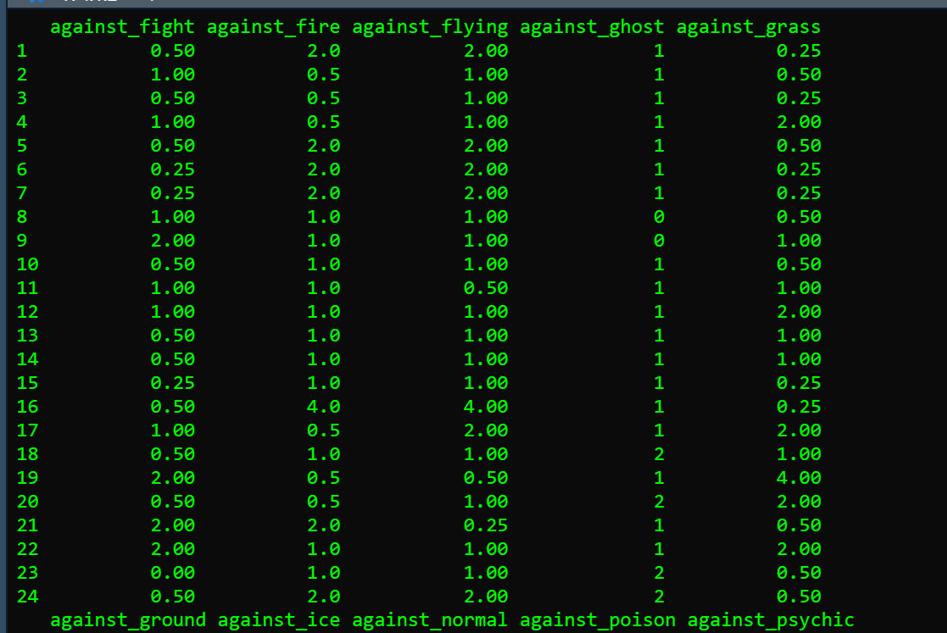

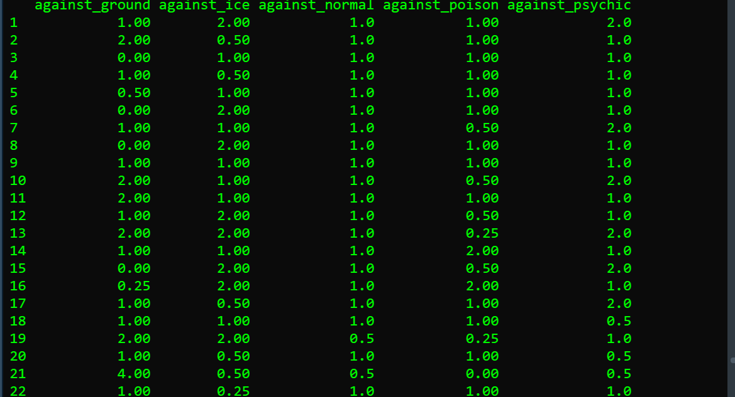

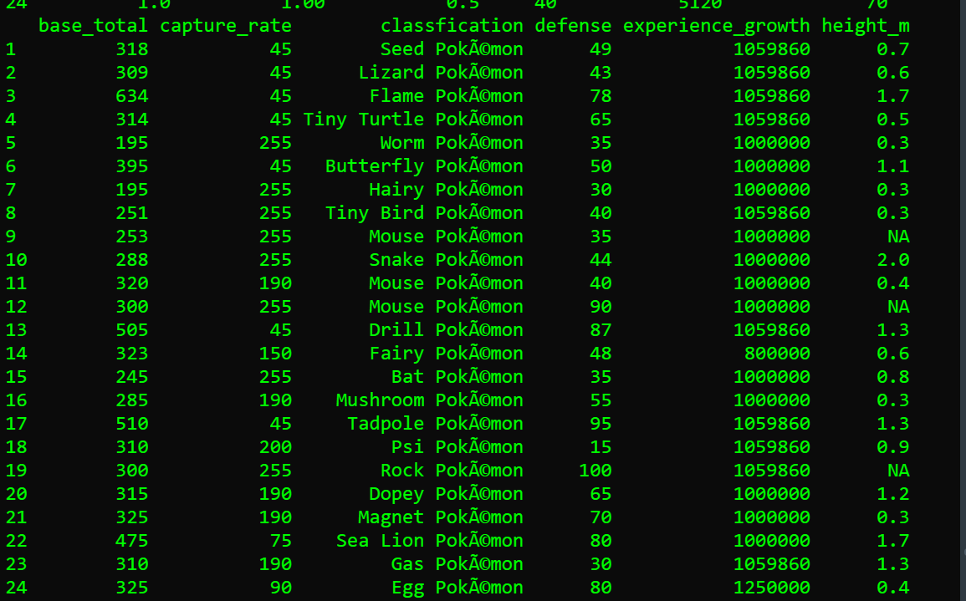

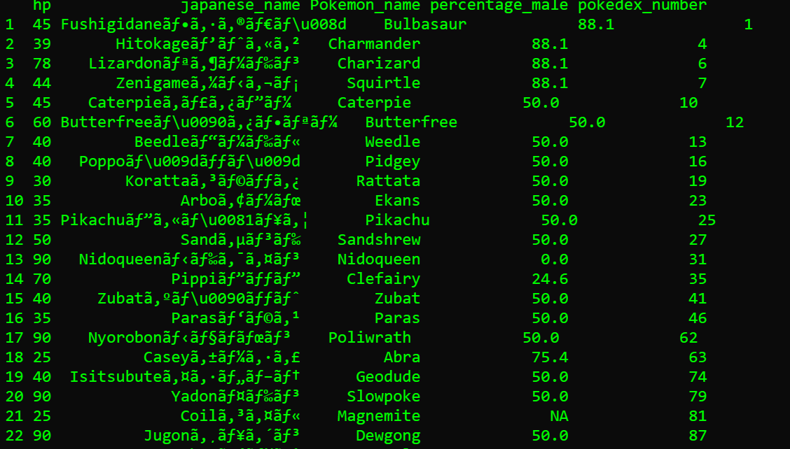

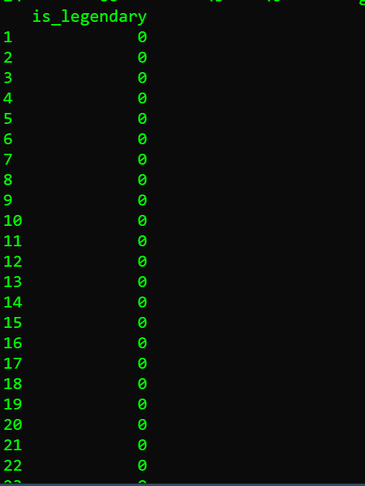

* MEAN OF GRASS TYPE POKEMON ATTACK



* MIN SPEED OF FIRE TYPE POKEMON



* MAX SPEED OF WATER TYPE POKEMON



* TABLE FORM OF LEGENDARY POKEMON, GENERATION AND PRIMARY TYPE

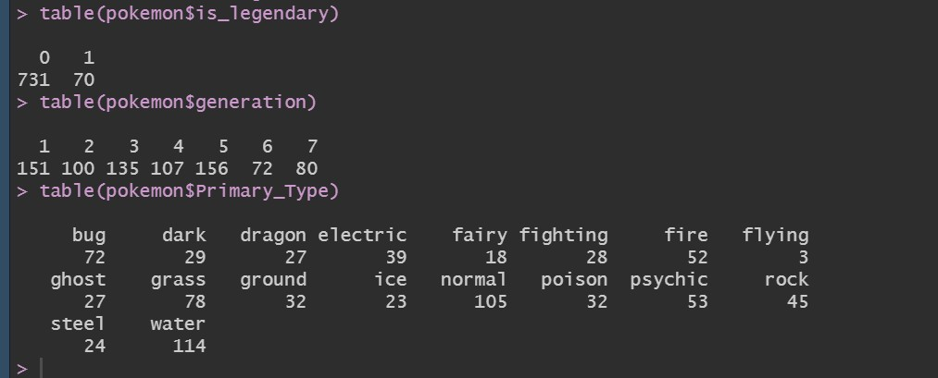

* CREATING SUBSET OF GRASS, WATER, FIRE, MYSTIC TYPE

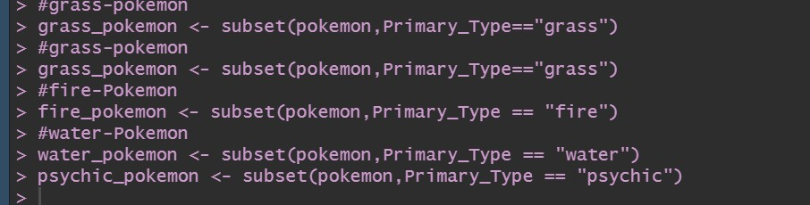

* CREATING HISTOGRAM OF HEALTH OF GRASS TYPE POKEMON
* The bars of the graph are showing the hp of grass type Pokémon.



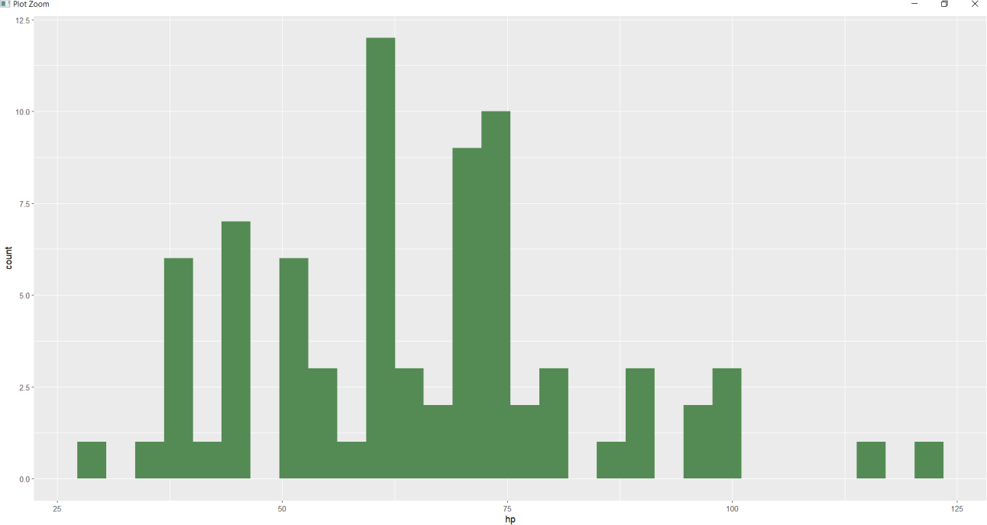

* CREATING BARGRAPH OF LEGENDARY GRASS TYPE POKEMON
* The is showing the count of legendary Pokémon in grass type Pokémon.



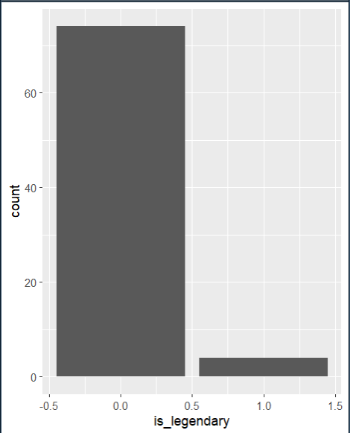

* DIFFERENT TYPE OF GENERATION IN FIRE TYPE POKEMON
* This is showing the different type of generations.



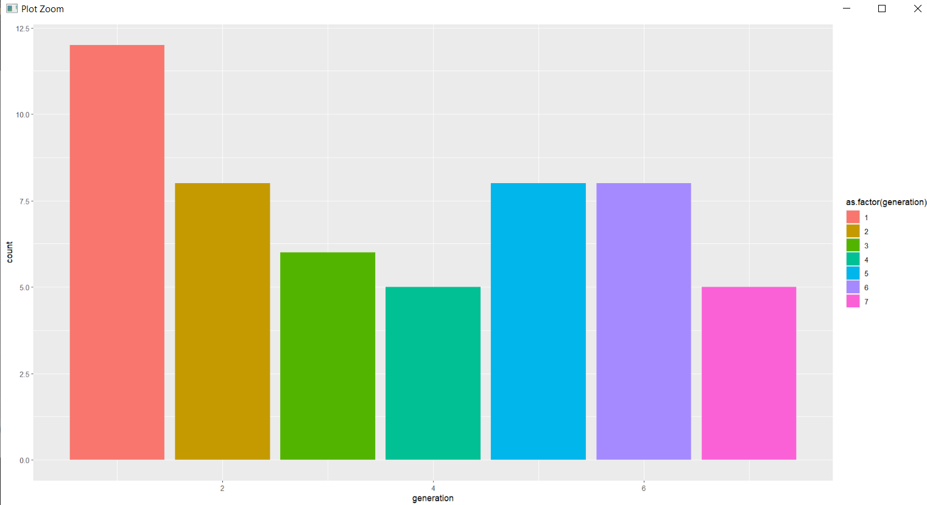

* SECONDARY TYPE OF FIRE TYPE POKEMON
* It is showing the secondary type of fire type Pokémon.



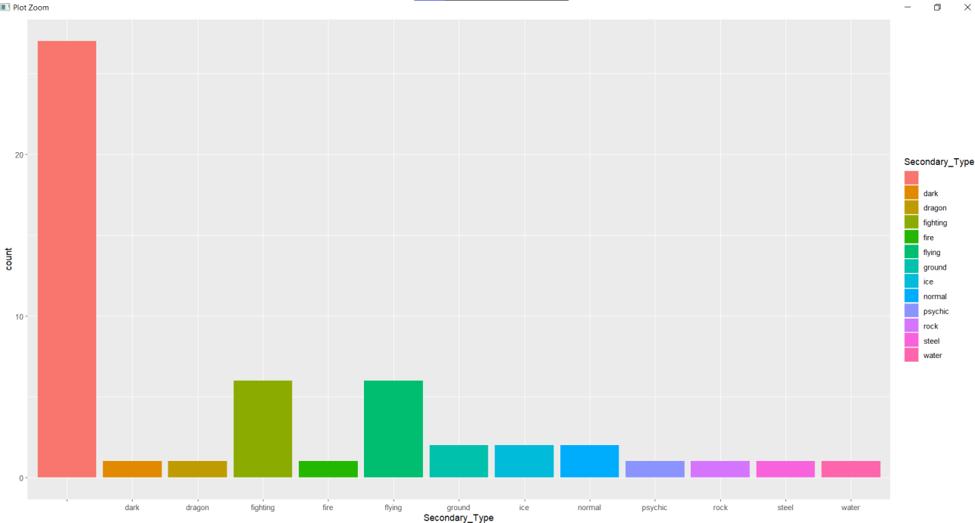

* SPECIAL ATTACK AND SPECIAL DEFENSE POINT GRAPH
* Every Pokémon has different type of attack and defense power, we have shown their sp_attack and sp_defense via points in point graph



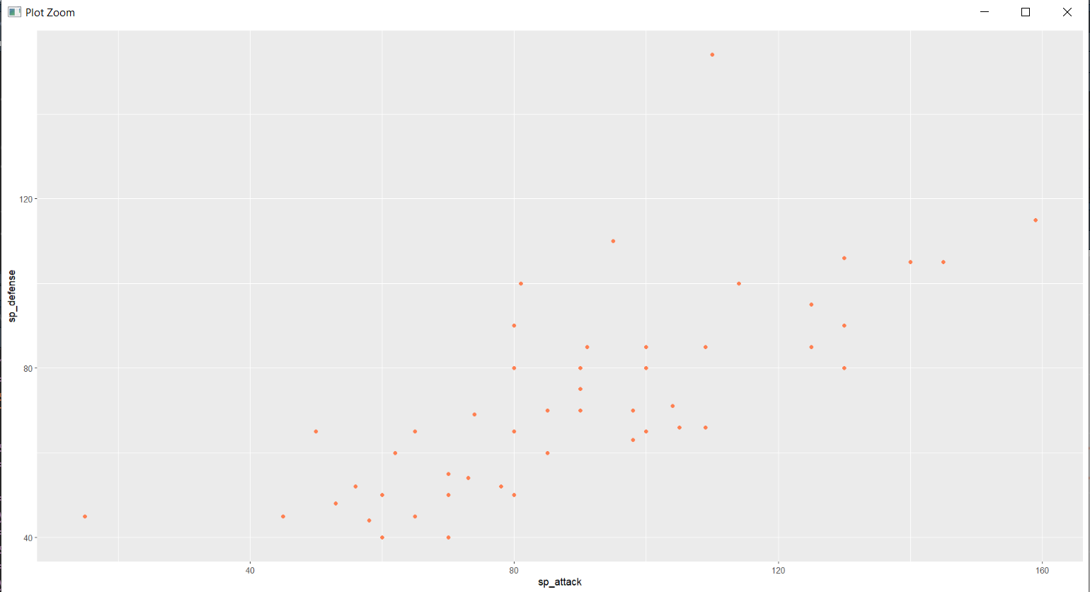

* WATER TYPE POKEMON AGAINST GRASS TYPE



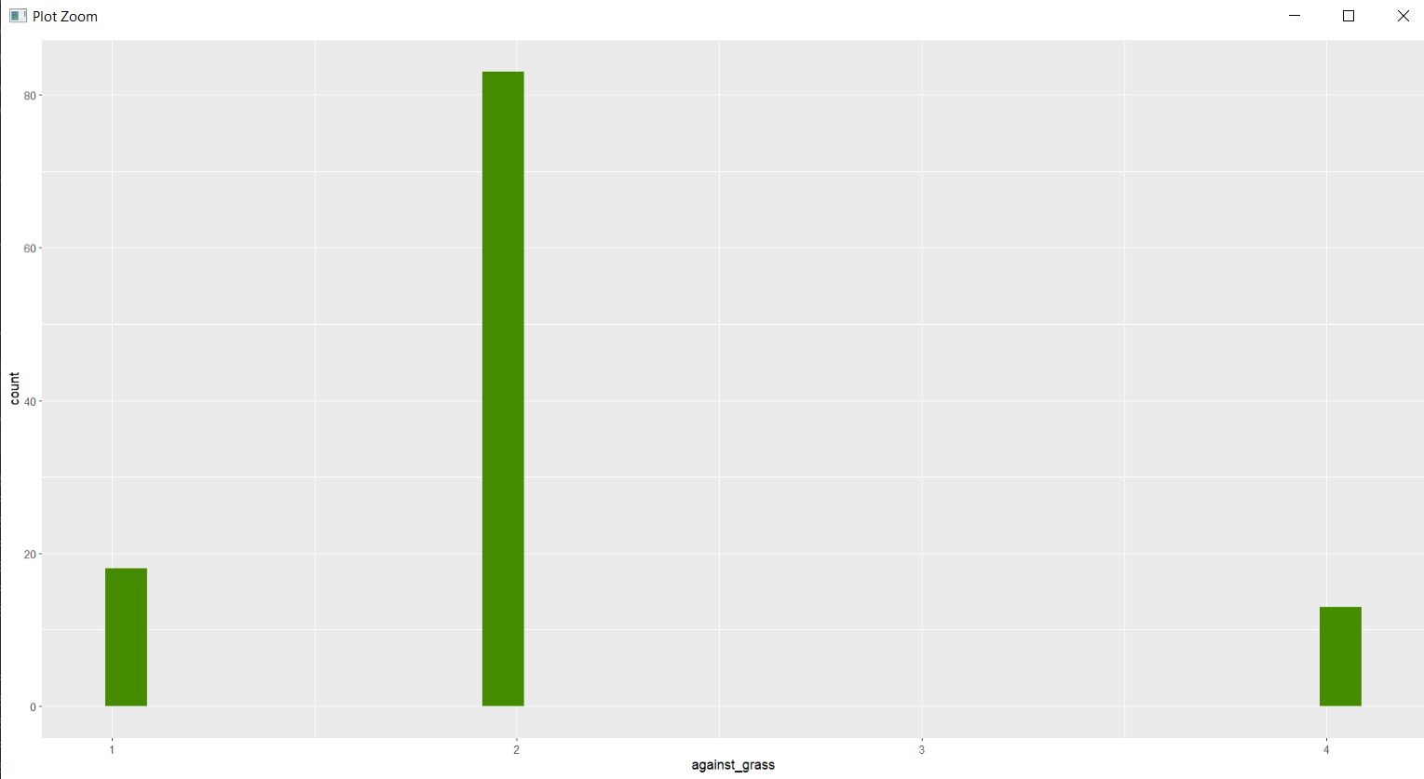

* BASE TOTAL OF MYSTIC TYPE POKEMON



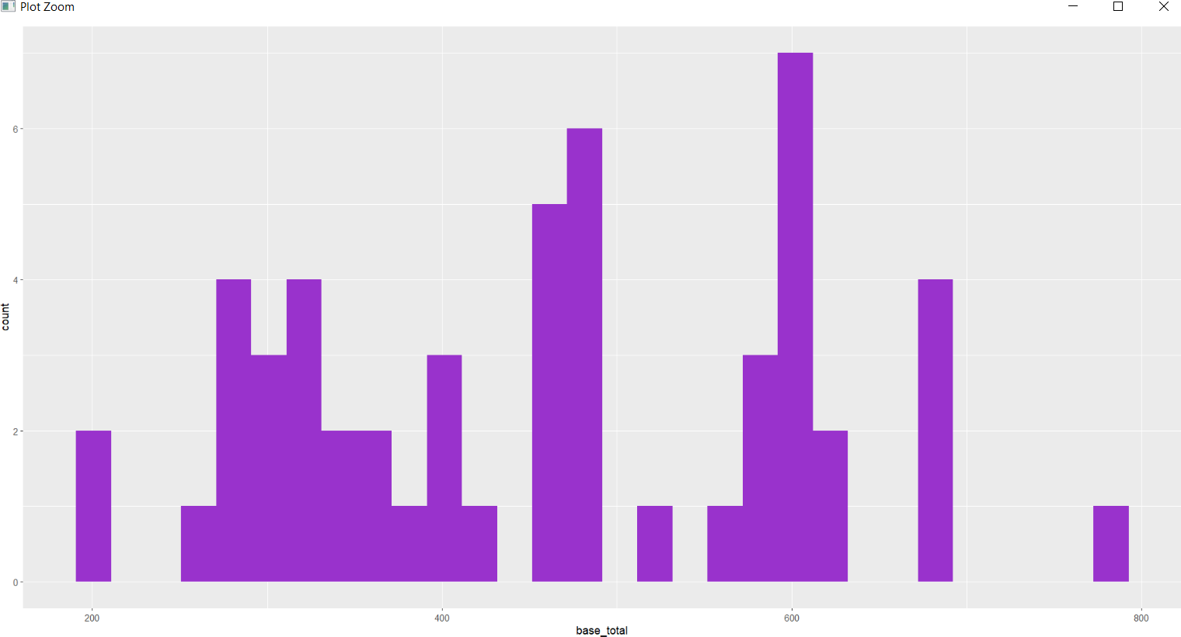

* SPECIAL DEFENSE AND GENERATION BOXPLOT OF MYSTIC TYPE



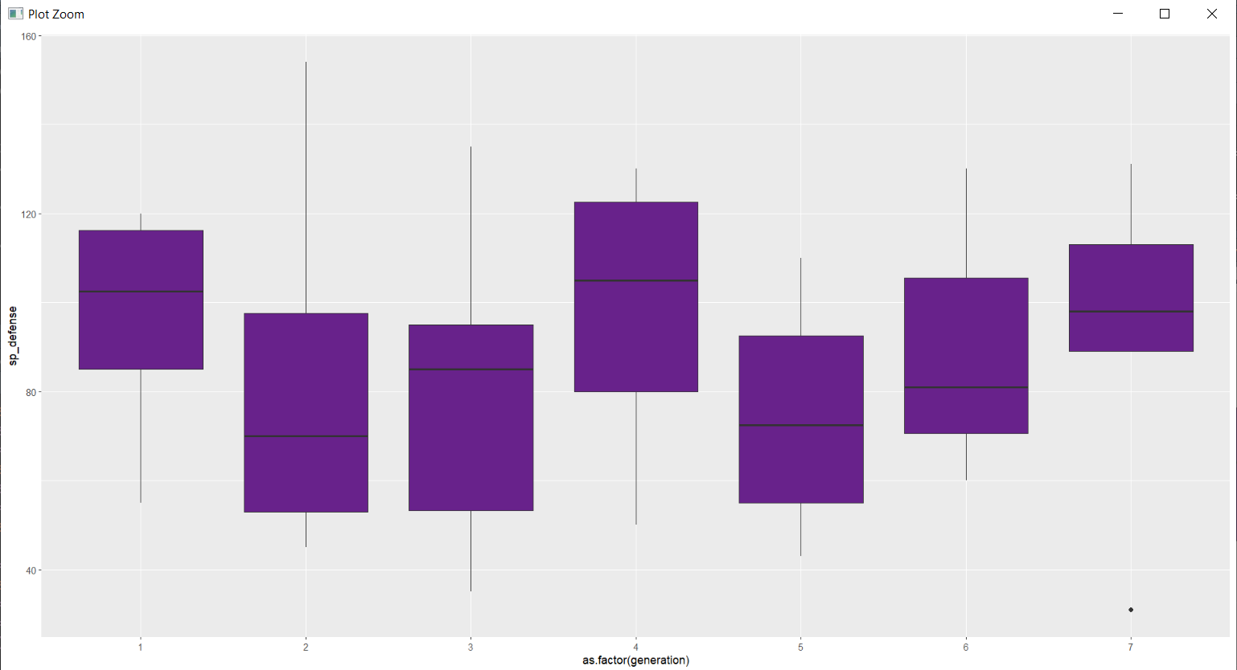

* LEGENDARY TYPE POKEMON IN MYSTIC TYPE



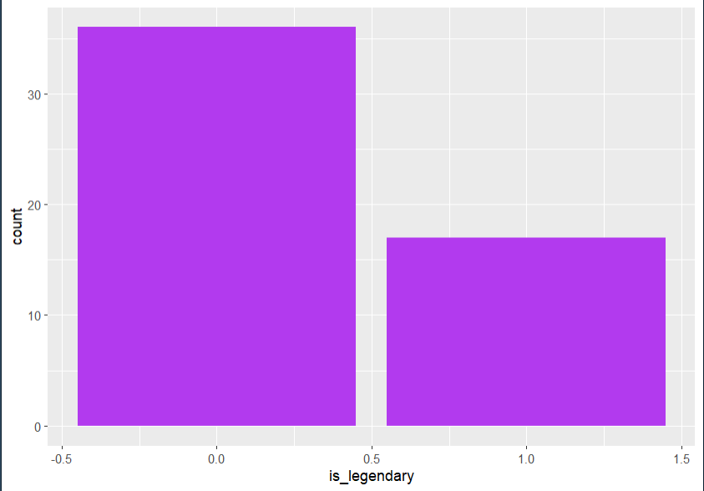SOURCE CODE:

abilities,against_bug,against_dark,against_dragon,against_electric,against_fairy,against_fight,against_fire,against_flying,against_ghost,against_grass,against_ground,against_ice,against_normal,against_poison,against_psychic,against_rock,against_steel,against_water,attack,base_egg_steps,base_happiness,base_total,capture_rate,classfication,defense,experience_growth,height_m,hp,japanese_name,name,percentage_male,pokedex_number,sp_attack,sp_defense,speed,type1,type2,weight_kg,generation,is_legendary

"['Overgrow', 'Chlorophyll']",1,1,1,0.5,0.5,0.5,2,2,1,0.25,1,2,1,1,2,1,1,0.5,49,5120,70,318,45,Seed PokÃ©mon,49,1059860,0.7,45,Fushigidaneãã·ã®ãã,Bulbasaur,88.1,1,65,65,45,grass,poison,6.9,1,0

"['Overgrow', 'Chlorophyll']",1,1,1,0.5,0.5,0.5,2,2,1,0.25,1,2,1,1,2,1,1,0.5,62,5120,70,405,45,Seed PokÃ©mon,63,1059860,1.0,60,Fushigisouãã·ã®ã½ã¦,Ivysaur,88.1,2,80,80,60,grass,poison,13.0,1,0

"['Overgrow', 'Chlorophyll']",1,1,1,0.5,0.5,0.5,2,2,1,0.25,1,2,1,1,2,1,1,0.5,100,5120,70,625,45,Seed PokÃ©mon,123,1059860,2.0,80,Fushigibanaãã·ã®ãã,Venusaur,88.1,3,122,120,80,grass,poison,100.0,1,0

"['Blaze', 'Solar Power']",0.5,1,1,1,0.5,1,0.5,1,1,0.5,2,0.5,1,1,1,2,0.5,2,52,5120,70,309,45,Lizard PokÃ©mon,43,1059860,0.6,39,Hitokageããã«ã²,Charmander,88.1,4,60,50,65,fire,,8.5,1,0

"['Blaze', 'Solar Power']",0.5,1,1,1,0.5,1,0.5,1,1,0.5,2,0.5,1,1,1,2,0.5,2,64,5120,70,405,45,Flame PokÃ©mon,58,1059860,1.1,58,Lizardoãªã¶ã¼ã,Charmeleon,88.1,5,80,65,80,fire,,19.0,1,0

"['Blaze', 'Solar Power']",0.25,1,1,2,0.5,0.5,0.5,1,1,0.25,0,1,1,1,1,4,0.5,2,104,5120,70,634,45,Flame PokÃ©mon,78,1059860,1.7,78,Lizardonãªã¶ã¼ãã³,Charizard,88.1,6,159,115,100,fire,flying,90.5,1,0

"['Torrent', 'Rain Dish']",1,1,1,2,1,1,0.5,1,1,2,1,0.5,1,1,1,1,0.5,0.5,48,5120,70,314,45,Tiny Turtle PokÃ©mon,65,1059860,0.5,44,Zenigameã¼ãã¬ã¡,Squirtle,88.1,7,50,64,43,water,,9.0,1,0

"['Torrent', 'Rain Dish']",1,1,1,2,1,1,0.5,1,1,2,1,0.5,1,1,1,1,0.5,0.5,63,5120,70,405,45,Turtle PokÃ©mon,80,1059860,1.0,59,Kameilã«ã¡ã¼ã«,Wartortle,88.1,8,65,80,58,water,,22.5,1,0

"['Torrent', 'Rain Dish']",1,1,1,2,1,1,0.5,1,1,2,1,0.5,1,1,1,1,0.5,0.5,103,5120,70,630,45,Shellfish PokÃ©mon,120,1059860,1.6,79,Kamexã«ã¡ãã¯ã¹,Blastoise,88.1,9,135,115,78,water,,85.5,1,0

"['Shield Dust', 'Run Away']",1,1,1,1,1,0.5,2,2,1,0.5,0.5,1,1,1,1,2,1,1,30,3840,70,195,255,Worm PokÃ©mon,35,1000000,0.3,45,Caterpieã­ã£ã¿ãã¼,Caterpie,50,10,20,20,45,bug,,2.9,1,0

['Shed Skin'],1,1,1,1,1,0.5,2,2,1,0.5,0.5,1,1,1,1,2,1,1,20,3840,70,205,120,Cocoon PokÃ©mon,55,1000000,0.7,50,Transelãã©ã³ã»ã«,Metapod,50,11,25,25,30,bug,,9.9,1,0

"['Compoundeyes', 'Tinted Lens']",0.5,1,1,2,1,0.25,2,2,1,0.25,0,2,1,1,1,4,1,1,45,3840,70,395,45,Butterfly PokÃ©mon,50,1000000,1.1,60,Butterfreeãã¿ããªã¼,Butterfree,50,12,90,80,70,bug,flying,32.0,1,0

"['Shield Dust', 'Run Away']",0.5,1,1,1,0.5,0.25,2,2,1,0.25,1,1,1,0.5,2,2,1,1,35,3840,70,195,255,Hairy PokÃ©mon,30,1000000,0.3,40,Beedleãã¼ãã«,Weedle,50,13,20,20,50,bug,poison,3.2,1,0

['Shed Skin'],0.5,1,1,1,0.5,0.25,2,2,1,0.25,1,1,1,0.5,2,2,1,1,25,3840,70,205,120,Cocoon PokÃ©mon,50,1000000,0.6,45,Cocoonã³ã¯ã¼ã³,Kakuna,50,14,25,25,35,bug,poison,10.0,1,0

"['Swarm', 'Sniper']",0.5,1,1,1,0.5,0.25,2,2,1,0.25,1,1,1,0.5,2,2,1,1,150,3840,70,495,45,Poison Bee PokÃ©mon,40,1000000,1.0,65,Spearã¹ãã¢ã¼,Beedrill,50,15,15,80,145,bug,poison,29.5,1,0

"['Keen Eye', 'Tangled Feet', 'Big Pecks']",0.5,1,1,2,1,1,1,1,0,0.5,0,2,1,1,1,2,1,1,45,3840,70,251,255,Tiny Bird PokÃ©mon,40,1059860,0.3,40,Poppoããã,Pidgey,50,16,35,35,56,normal,flying,1.8,1,0

"['Keen Eye', 'Tangled Feet', 'Big Pecks']",0.5,1,1,2,1,1,1,1,0,0.5,0,2,1,1,1,2,1,1,60,3840,70,349,120,Bird PokÃ©mon,55,1059860,1.1,63,Pigeonãã¸ã§ã³,Pidgeotto,50,17,50,50,71,normal,flying,30.0,1,0

"['Keen Eye', 'Tangled Feet', 'Big Pecks']",0.5,1,1,2,1,1,1,1,0,0.5,0,2,1,1,1,2,1,1,80,3840,70,579,45,Bird PokÃ©mon,80,1059860,1.5,83,Pigeotãã¸ã§ãã,Pidgeot,50,18,135,80,121,normal,flying,39.5,1,0

"['Run Away', 'Guts', 'Hustle', 'Gluttony', 'Hustle', 'Thick Fat']",1,1,1,1,1,2,1,1,0,1,1,1,1,1,1,1,1,1,56,3840,70,253,255,Mouse PokÃ©mon,35,1000000,,30,Korattaã³ã©ãã¿,Rattata,50,19,25,35,72,normal,dark,,1,0

"['Run Away', 'Guts', 'Hustle', 'Gluttony', 'Hustle', 'Thick Fat']",1,1,1,1,1,2,1,1,0,1,1,1,1,1,1,1,1,1,71,3840,70,413,127,Mouse PokÃ©mon,70,1000000,,75,Rattaã©ãã¿,Raticate,50,20,40,80,77,normal,dark,,1,0

"['Keen Eye', 'Sniper']",0.5,1,1,2,1,1,1,1,0,0.5,0,2,1,1,1,2,1,1,60,3840,70,262,255,Tiny Bird PokÃ©mon,30,1000000,0.3,40,Onisuzumeãªãã¹ãºã¡,Spearow,50,21,31,31,70,normal,flying,2.0,1,0

"['Keen Eye', 'Sniper']",0.5,1,1,2,1,1,1,1,0,0.5,0,2,1,1,1,2,1,1,90,3840,70,442,90,Beak PokÃ©mon,65,1000000,1.2,65,Onidrillãªãããªã«,Fearow,50,22,61,61,100,normal,flying,38.0,1,0

"['Intimidate', 'Shed Skin', 'Unnerve']",0.5,1,1,1,0.5,0.5,1,1,1,0.5,2,1,1,0.5,2,1,1,1,60,5120,70,288,255,Snake PokÃ©mon,44,1000000,2.0,35,Arboã¢ã¼ã,Ekans,50,23,40,54,55,poison,,6.9,1,0

"['Intimidate', 'Shed Skin', 'Unnerve']",0.5,1,1,1,0.5,0.5,1,1,1,0.5,2,1,1,0.5,2,1,1,1,95,5120,70,448,90,Cobra PokÃ©mon,69,1000000,3.5,60,Arbokã¢ã¼ããã¯,Arbok,50,24,65,79,80,poison,,65.0,1,0

"['Static', 'Lightningrod']",1,1,1,0.5,1,1,1,0.5,1,1,2,1,1,1,1,1,0.5,1,55,2560,70,320,190,Mouse PokÃ©mon,40,1000000,0.4,35,Pikachuãã«ãã¥ã¦,Pikachu,50,25,50,50,90,electric,,6.0,1,0

"['Static', 'Lightningrod', 'Surge Surfer']",1,1,1,0.5,1,1,1,0.5,1,1,2,1,1,1,1,1,0.5,1,85,2560,70,485,75,Mouse PokÃ©mon,50,1000000,,60,Raichuã©ã¤ãã¥ã¦,Raichu,50,26,95,85,110,electric,electric,,1,0

"['Sand Veil', 'Sand Rush', 'Snow Cloak', 'Slush Rush']",1,1,1,0,1,1,1,1,1,2,1,2,1,0.5,1,0.5,1,2,75,5120,70,300,255,Mouse PokÃ©mon,90,1000000,,50,Sandãµã³ã,Sandshrew,50,27,10,35,40,ground,ice,,1,0

"['Sand Veil', 'Sand Rush', 'Snow Cloak', 'Slush Rush']",1,1,1,0,1,1,1,1,1,2,1,2,1,0.5,1,0.5,1,2,100,5120,70,450,90,Mouse PokÃ©mon,120,1000000,,75,Sandpanãµã³ããã³,Sandslash,50,28,25,65,65,ground,ice,,1,0

"['Poison Point', 'Rivalry', 'Hustle']",0.5,1,1,1,0.5,0.5,1,1,1,0.5,2,1,1,0.5,2,1,1,1,47,5120,70,275,235,Poison Pin PokÃ©mon,52,1059860,0.4,55,Nidoran?ããã©ã³â,Nidoranâ,0,29,40,40,41,poison,,7.0,1,0

"['Poison Point', 'Rivalry', 'Hustle']",0.5,1,1,1,0.5,0.5,1,1,1,0.5,2,1,1,0.5,2,1,1,1,62,5120,70,365,120,Poison Pin PokÃ©mon,67,1059860,0.8,70,Nidorinaãããªã¼ã,Nidorina,0,30,55,55,56,poison,,20.0,1,0

"['Poison Point', 'Rivalry', 'Sheer Force']",0.5,1,1,0,0.5,0.5,1,1,1,1,2,2,1,0.25,2,0.5,1,2,92,5120,70,505,45,Drill PokÃ©mon,87,1059860,1.3,90,Nidoqueenããã¯ã¤ã³,Nidoqueen,0,31,75,85,76,poison,ground,60.0,1,0

"['Poison Point', 'Rivalry', 'Hustle']",0.5,1,1,1,0.5,0.5,1,1,1,0.5,2,1,1,0.5,2,1,1,1,57,5120,70,273,235,Poison Pin PokÃ©mon,40,1059860,0.5,46,Nidoran?ããã©ã³â,Nidoranâ,100,32,40,40,50,poison,,9.0,1,0

"['Poison Point', 'Rivalry', 'Hustle']",0.5,1,1,1,0.5,0.5,1,1,1,0.5,2,1,1,0.5,2,1,1,1,72,5120,70,365,120,Poison Pin PokÃ©mon,57,1059860,0.9,61,Nidorinoãããªã¼ã,Nidorino,100,33,55,55,65,poison,,19.5,1,0

"['Poison Point', 'Rivalry', 'Sheer Force']",0.5,1,1,0,0.5,0.5,1,1,1,1,2,2,1,0.25,2,0.5,1,2,102,5120,70,505,45,Drill PokÃ©mon,77,1059860,1.4,81,Nidokingããã­ã³ã°,Nidoking,100,34,85,75,85,poison,ground,62.0,1,0

"['Cute Charm', 'Magic Guard', 'Friend Guard']",0.5,0.5,0,1,1,0.5,1,1,1,1,1,1,1,2,1,1,2,1,45,2560,140,323,150,Fairy PokÃ©mon,48,800000,0.6,70,Pippiããã,Clefairy,24.6,35,60,65,35,fairy,,7.5,1,0

"['Cute Charm', 'Magic Guard', 'Unaware']",0.5,0.5,0,1,1,0.5,1,1,1,1,1,1,1,2,1,1,2,1,70,2560,140,483,25,Fairy PokÃ©mon,73,800000,1.3,95,Pixyãã¯ã·ã¼,Clefable,24.6,36,95,90,60,fairy,,40.0,1,0

"['Flash Fire', 'Drought', 'Snow Cloak', 'Snow Warning']",0.5,1,1,1,0.5,1,0.5,1,1,0.5,2,0.5,1,1,1,2,0.5,2,41,5120,70,299,190,Fox PokÃ©mon,40,1000000,,38,Rokonã­ã³ã³,Vulpix,24.6,37,50,65,65,fire,ice,,1,0

"['Flash Fire', 'Drought', 'Snow Cloak', 'Snow Warning']",0.5,1,1,1,0.5,1,0.5,1,1,0.5,2,0.5,1,1,1,2,0.5,2,67,5120,70,505,75,Fox PokÃ©mon,75,1000000,,73,Kyukonã­ã¥ã¦ã³ã³,Ninetales,24.6,38,81,100,109,fire,ice,,1,0

"['Cute Charm', 'Competitive', 'Friend Guard']",0.5,0.5,0,1,1,1,1,1,0,1,1,1,1,2,1,1,2,1,45,2560,70,270,170,Balloon PokÃ©mon,20,800000,0.5,115,Purinããªã³,Jigglypuff,24.6,39,45,25,20,normal,fairy,5.5,1,0

"['Cute Charm', 'Competitive', 'Frisk']",0.5,0.5,0,1,1,1,1,1,0,1,1,1,1,2,1,1,2,1,70,2560,70,435,50,Balloon PokÃ©mon,45,800000,1.0,140,Pukurinãã¯ãªã³,Wigglytuff,24.6,40,85,50,45,normal,fairy,12.0,1,0

"['Inner Focus', 'Infiltrator']",0.25,1,1,2,0.5,0.25,1,1,1,0.25,0,2,1,0.5,2,2,1,1,45,3840,70,245,255,Bat PokÃ©mon,35,1000000,0.8,40,Zubatãºããã,Zubat,50,41,30,40,55,poison,flying,7.5,1,0

"['Inner Focus', 'Infiltrator']",0.25,1,1,2,0.5,0.25,1,1,1,0.25,0,2,1,0.5,2,2,1,1,80,3840,70,455,90,Bat PokÃ©mon,70,1000000,1.6,75,Golbatã´ã«ããã,Golbat,50,42,65,75,90,poison,flying,55.0,1,0

"['Chlorophyll', 'Run Away']",1,1,1,0.5,0.5,0.5,2,2,1,0.25,1,2,1,1,2,1,1,0.5,50,5120,70,320,255,Weed PokÃ©mon,55,1059860,0.5,45,Nazonokusaãã¾ãã¯ãµ,Oddish,50,43,75,65,30,grass,poison,5.4,1,0

"['Chlorophyll', 'Stench']",1,1,1,0.5,0.5,0.5,2,2,1,0.25,1,2,1,1,2,1,1,0.5,65,5120,70,395,120,Weed PokÃ©mon,70,1059860,0.8,60,Kusaihanaã¯ãµã¤ãã,Gloom,50,44,85,75,40,grass,poison,8.6,1,0

"['Chlorophyll', 'Effect Spore']",1,1,1,0.5,0.5,0.5,2,2,1,0.25,1,2,1,1,2,1,1,0.5,80,5120,70,490,45,Flower PokÃ©mon,85,1059860,1.2,75,Ruffresiaã©ãã¬ã·ã¢,Vileplume,50,45,110,90,50,grass,poison,18.6,1,0

"['Effect Spore', 'Dry Skin', 'Damp']",2,1,1,0.5,1,0.5,4,4,1,0.25,0.25,2,1,2,1,2,1,0.5,70,5120,70,285,190,Mushroom PokÃ©mon,55,1000000,0.3,35,Parasãã©ã¹,Paras,50,46,45,55,25,bug,grass,5.4,1,0

"['Effect Spore', 'Dry Skin', 'Damp']",2,1,1,0.5,1,0.5,4,4,1,0.25,0.25,2,1,2,1,2,1,0.5,95,5120,70,405,75,Mushroom PokÃ©mon,80,1000000,1.0,60,Parasectãã©ã»ã¯ã,Parasect,50,47,60,80,30,bug,grass,29.5,1,0

"['Compoundeyes', 'Tinted Lens', 'Run Away']",0.5,1,1,1,0.5,0.25,2,2,1,0.25,1,1,1,0.5,2,2,1,1,55,5120,70,305,190,Insect PokÃ©mon,50,1000000,1.0,60,Kongpangã³ã³ãã³,Venonat,50,48,40,55,45,bug,poison,30.0,1,0

"['Shield Dust', 'Tinted Lens', 'Wonder Skin ']",0.5,1,1,1,0.5,0.25,2,2,1,0.25,1,1,1,0.5,2,2,1,1,65,5120,70,450,75,Poison Moth PokÃ©mon,60,1000000,1.5,70,Morphonã¢ã«ãã©ã³,Venomoth,50,49,90,75,90,bug,poison,12.5,1,0

"['Sand Veil', 'Arena Trap', 'Sand Force', 'Sand Veil', 'Tangling Hair', 'Sand Force']",1,1,1,0,1,1,1,1,1,2,1,2,1,0.5,1,0.5,1,2,55,5120,70,265,255,Mole PokÃ©mon,30,1000000,,10,Digdaãã£ã°ã,Diglett,50,50,35,45,90,ground,ground,,1,0

"['Sand Veil', 'Arena Trap', 'Sand Force', 'Sand Veil', 'Tangling Hair', 'Sand Force']",1,1,1,0,1,1,1,1,1,2,1,2,1,0.5,1,0.5,1,2,100,5120,70,425,50,Mole PokÃ©mon,60,1000000,,35,Dugtrioãã°ããªãª,Dugtrio,50,51,50,70,110,ground,ground,,1,0

"['Pickup', 'Technician', 'Unnerve', 'Pickup', 'Technician', 'Rattled']",1,1,1,1,1,2,1,1,0,1,1,1,1,1,1,1,1,1,35,5120,70,290,255,Scratch Cat PokÃ©mon,35,1000000,,40,Nyarthãã£ã¼ã¹,Meowth,50,52,50,40,90,normal,dark,,1,0

"['Limber', 'Technician', 'Unnerve', 'Fur Coat', 'Technician', 'Rattled']",1,1,1,1,1,2,1,1,0,1,1,1,1,1,1,1,1,1,60,5120,70,440,90,Classy Cat PokÃ©mon,60,1000000,,65,Persianãã«ã·ã¢ã³,Persian,50,53,75,65,115,normal,dark,,1,0

"['Damp', 'Cloud Nine', 'Swift Swim']",1,1,1,2,1,1,0.5,1,1,2,1,0.5,1,1,1,1,0.5,0.5,52,5120,70,320,190,Duck PokÃ©mon,48,1000000,0.8,50,Koduckã³ããã¯,Psyduck,50,54,65,50,55,water,,19.6,1,0

"['Damp', 'Cloud Nine', 'Swift Swim']",1,1,1,2,1,1,0.5,1,1,2,1,0.5,1,1,1,1,0.5,0.5,82,5120,70,500,75,Duck PokÃ©mon,78,1000000,1.7,80,Golduckã´ã«ããã¯,Golduck,50,55,95,80,85,water,,76.6,1,0

"['Vital Spirit', 'Anger Point', 'Defiant']",0.5,0.5,1,1,2,1,1,2,1,1,1,1,1,1,2,0.5,1,1,80,5120,70,305,190,Pig Monkey PokÃ©mon,35,1000000,0.5,40,Mankeyãã³ã­ã¼,Mankey,50,56,35,45,70,fighting,,28.0,1,0

"['Vital Spirit', 'Anger Point', 'Defiant']",0.5,0.5,1,1,2,1,1,2,1,1,1,1,1,1,2,0.5,1,1,105,5120,70,455,75,Pig Monkey PokÃ©mon,60,1000000,1.0,65,Okorizaruãªã³ãªã¶ã«,Primeape,50,57,60,70,95,fighting,,32.0,1,0

"['Intimidate', 'Flash Fire', 'Justified']",0.5,1,1,1,0.5,1,0.5,1,1,0.5,2,0.5,1,1,1,2,0.5,2,70,5120,70,350,190,Puppy PokÃ©mon,45,1250000,0.7,55,Gardieã¬ã¼ãã£,Growlithe,75.4,58,70,50,60,fire,,19.0,1,0

"['Intimidate', 'Flash Fire', 'Justified']",0.5,1,1,1,0.5,1,0.5,1,1,0.5,2,0.5,1,1,1,2,0.5,2,110,5120,70,555,75,Legendary PokÃ©mon,80,1250000,1.9,90,Windieã¦ã¤ã³ãã£,Arcanine,75.4,59,100,80,95,fire,,155.0,1,0

"['Water Absorb', 'Damp', 'Swift Swim']",1,1,1,2,1,1,0.5,1,1,2,1,0.5,1,1,1,1,0.5,0.5,50,5120,70,300,255,Tadpole PokÃ©mon,40,1059860,0.6,40,Nyoromoãã§ã­ã¢,Poliwag,50,60,40,40,90,water,,12.4,1,0

"['Water Absorb', 'Damp', 'Swift Swim']",1,1,1,2,1,1,0.5,1,1,2,1,0.5,1,1,1,1,0.5,0.5,65,5120,70,385,120,Tadpole PokÃ©mon,65,1059860,1.0,65,Nyorozoãã§ã­ã¾,Poliwhirl,50,61,50,50,90,water,,20.0,1,0

"['Water Absorb', 'Damp', 'Swift Swim']",0.5,0.5,1,2,2,1,0.5,2,1,2,1,0.5,1,1,2,0.5,0.5,0.5,95,5120,70,510,45,Tadpole PokÃ©mon,95,1059860,1.3,90,Nyorobonãã§ã­ãã³,Poliwrath,50,62,70,90,70,water,fighting,54.0,1,0

"['Synchronize', 'Inner Focus', 'Magic Guard']",2,2,1,1,1,0.5,1,1,2,1,1,1,1,1,0.5,1,1,1,20,5120,70,310,200,Psi PokÃ©mon,15,1059860,0.9,25,Caseyã±ã¼ã·ã£,Abra,75.4,63,105,55,90,psychic,,19.5,1,0

"['Synchronize', 'Inner Focus', 'Magic Guard']",2,2,1,1,1,0.5,1,1,2,1,1,1,1,1,0.5,1,1,1,35,5120,70,400,100,Psi PokÃ©mon,30,1059860,1.3,40,Yungererã¦ã³ã²ã©ã¼,Kadabra,75.4,64,120,70,105,psychic,,56.5,1,0

"['Synchronize', 'Inner Focus', 'Magic Guard']",2,2,1,1,1,0.5,1,1,2,1,1,1,1,1,0.5,1,1,1,50,5120,70,600,50,Psi PokÃ©mon,65,1059860,1.5,55,Foodinãã¼ãã£ã³,Alakazam,75.4,65,175,105,150,psychic,,48.0,1,0

"['Guts', 'No Guard', 'Steadfast']",0.5,0.5,1,1,2,1,1,2,1,1,1,1,1,1,2,0.5,1,1,80,5120,70,305,180,Superpower PokÃ©mon,50,1059860,0.8,70,Wanrikyã¯ã³ãªã­ã¼,Machop,75.4,66,35,35,35,fighting,,19.5,1,0

"['Guts', 'No Guard', 'Steadfast']",0.5,0.5,1,1,2,1,1,2,1,1,1,1,1,1,2,0.5,1,1,100,5120,70,405,90,Superpower PokÃ©mon,70,1059860,1.5,80,Gorikyã´ã¼ãªã­ã¼,Machoke,75.4,67,50,60,45,fighting,,70.5,1,0

"['Guts', 'No Guard', 'Steadfast']",0.5,0.5,1,1,2,1,1,2,1,1,1,1,1,1,2,0.5,1,1,130,5120,70,505,45,Superpower PokÃ©mon,80,1059860,1.6,90,Kairikyã«ã¤ãªã­ã¼,Machamp,75.4,68,65,85,55,fighting,,130.0,1,0

"['Chlorophyll', 'Gluttony']",1,1,1,0.5,0.5,0.5,2,2,1,0.25,1,2,1,1,2,1,1,0.5,75,5120,70,300,255,Flower PokÃ©mon,35,1059860,0.7,50,Madatsubomiããããã,Bellsprout,50,69,70,30,40,grass,poison,4.0,1,0

"['Chlorophyll', 'Gluttony']",1,1,1,0.5,0.5,0.5,2,2,1,0.25,1,2,1,1,2,1,1,0.5,90,5120,70,390,120,Flycatcher PokÃ©mon,50,1059860,1.0,65,Utsudonã¦ããã³,Weepinbell,50,70,85,45,55,grass,poison,6.4,1,0

"['Chlorophyll', 'Gluttony']",1,1,1,0.5,0.5,0.5,2,2,1,0.25,1,2,1,1,2,1,1,0.5,105,5120,70,490,45,Flycatcher PokÃ©mon,65,1059860,1.7,80,Utsubotã¦ãããã,Victreebel,50,71,100,70,70,grass,poison,15.5,1,0

"['Clear Body', 'Liquid Ooze', 'Rain Dish']",0.5,1,1,2,0.5,0.5,0.5,1,1,1,2,0.5,1,0.5,2,1,0.5,0.5,40,5120,70,335,190,Jellyfish PokÃ©mon,35,1250000,0.9,40,Menokurageã¡ãã¯ã©ã²,Tentacool,50,72,50,100,70,water,poison,45.5,1,0

"['Clear Body', 'Liquid Ooze', 'Rain Dish']",0.5,1,1,2,0.5,0.5,0.5,1,1,1,2,0.5,1,0.5,2,1,0.5,0.5,70,5120,70,515,60,Jellyfish PokÃ©mon,65,1250000,1.6,80,Dokukurageãã¯ã¯ã©ã²,Tentacruel,50,73,80,120,100,water,poison,55.0,1,0

"['Rock Head', 'Sturdy', 'Sand Veil', 'Magnet Pull', 'Sturdy', 'Galvanize']",1,1,1,0,1,2,0.5,0.5,1,4,2,2,0.5,0.25,1,0.5,2,4,80,3840,70,300,255,Rock PokÃ©mon,100,1059860,,40,Isitsubuteã¤ã·ããã,Geodude,50,74,30,30,20,rock,ground,,1,0

"['Rock Head', 'Sturdy', 'Sand Veil', 'Magnet Pull', 'Sturdy', 'Galvanize']",1,1,1,0,1,2,0.5,0.5,1,4,2,2,0.5,0.25,1,0.5,2,4,95,3840,70,390,120,Rock PokÃ©mon,115,1059860,,55,Goloneã´ã­ã¼ã³,Graveler,50,75,45,45,35,rock,ground,,1,0

"['Rock Head', 'Sturdy', 'Sand Veil', 'Magnet Pull', 'Sturdy', 'Galvanize']",1,1,1,0,1,2,0.5,0.5,1,4,2,2,0.5,0.25,1,0.5,2,4,120,3840,70,495,45,Megaton PokÃ©mon,130,1059860,,80,Golonyaã´ã­ã¼ãã£,Golem,50,76,55,65,45,rock,ground,,1,0

"['Run Away', 'Flash Fire', 'Flame Body']",0.5,1,1,1,0.5,1,0.5,1,1,0.5,2,0.5,1,1,1,2,0.5,2,85,5120,70,410,190,Fire Horse PokÃ©mon,55,1000000,1.0,50,Ponytaããã¼ã¿,Ponyta,50,77,65,65,90,fire,,30.0,1,0

"['Run Away', 'Flash Fire', 'Flame Body']",0.5,1,1,1,0.5,1,0.5,1,1,0.5,2,0.5,1,1,1,2,0.5,2,100,5120,70,500,60,Fire Horse PokÃ©mon,70,1000000,1.7,65,Gallopã®ã£ã­ãã,Rapidash,50,78,80,80,105,fire,,95.0,1,0

"['Oblivious', 'Own Tempo', 'Regenerator']",2,2,1,2,1,0.5,0.5,1,2,2,1,0.5,1,1,0.5,1,0.5,0.5,65,5120,70,315,190,Dopey PokÃ©mon,65,1000000,1.2,90,Yadonã¤ãã³,Slowpoke,50,79,40,40,15,water,psychic,36.0,1,0

"['Oblivious', 'Own Tempo', 'Regenerator']",2,2,1,2,1,0.5,0.5,1,2,2,1,0.5,1,1,0.5,1,0.5,0.5,75,5120,70,590,75,Hermit Crab PokÃ©mon,180,1000000,1.6,95,Yadoranã¤ãã©ã³,Slowbro,50,80,130,80,30,water,psychic,78.5,1,0

"['Magnet Pull', 'Sturdy', 'Analytic']",0.5,1,0.5,0.5,0.5,2,2,0.25,1,0.5,4,0.5,0.5,0,0.5,0.5,0.25,1,35,5120,70,325,190,Magnet PokÃ©mon,70,1000000,0.3,25,Coilã³ã¤ã«,Magnemite,,81,95,55,45,electric,steel,6.0,1,0

"['Magnet Pull', 'Sturdy', 'Analytic']",0.5,1,0.5,0.5,0.5,2,2,0.25,1,0.5,4,0.5,0.5,0,0.5,0.5,0.25,1,60,5120,70,465,60,Magnet PokÃ©mon,95,1000000,1.0,50,Rarecoilã¬ã¢ã³ã¤ã«,Magneton,,82,120,70,70,electric,steel,60.0,1,0

"['Keen Eye', 'Inner Focus', 'Defiant']",0.5,1,1,2,1,1,1,1,0,0.5,0,2,1,1,1,2,1,1,90,5120,70,377,45,Wild Duck PokÃ©mon,55,1000000,0.8,52,Kamonegiã«ã¢ãã®,Farfetch'd,50,83,58,62,60,normal,flying,15.0,1,0

"['Run Away', 'Early Bird', 'Tangled Feet']",0.5,1,1,2,1,1,1,1,0,0.5,0,2,1,1,1,2,1,1,85,5120,70,310,190,Twin Bird PokÃ©mon,45,1000000,1.4,35,Dodoãã¼ãã¼,Doduo,50,84,35,35,75,normal,flying,39.2,1,0

"['Run Away', 'Early Bird', 'Tangled Feet']",0.5,1,1,2,1,1,1,1,0,0.5,0,2,1,1,1,2,1,1,110,5120,70,470,45,Triple Bird PokÃ©mon,70,1000000,1.8,60,Dodorioãã¼ããªãª,Dodrio,50,85,60,60,110,normal,flying,85.2,1,0

"['Thick Fat', 'Hydration', 'Ice Body']",1,1,1,2,1,1,0.5,1,1,2,1,0.5,1,1,1,1,0.5,0.5,45,5120,70,325,190,Sea Lion PokÃ©mon,55,1000000,1.1,65,Pawouãã¦ã¯ã¦,Seel,50,86,45,70,45,water,,90.0,1,0

"['Thick Fat', 'Hydration', 'Ice Body']",1,1,1,2,1,2,1,1,1,2,1,0.25,1,1,1,2,1,0.5,70,5120,70,475,75,Sea Lion PokÃ©mon,80,1000000,1.7,90,Jugonã¸ã¥ã´ã³,Dewgong,50,87,70,95,70,water,ice,120.0,1,0

"['Stench', 'Sticky Hold', 'Poison Touch', 'Poison Touch', 'Gluttony', 'Power of Alchemy']",0.5,1,1,1,0.5,0.5,1,1,1,0.5,2,1,1,0.5,2,1,1,1,80,5120,70,325,190,Sludge PokÃ©mon,50,1000000,,80,Betbeterãããã¿ã¼,Grimer,50,88,40,50,25,poison,poison,,1,0

"['Stench', 'Sticky Hold', 'Poison Touch', 'Poison Touch', 'Gluttony', 'Power of Alchemy']",0.5,1,1,1,0.5,0.5,1,1,1,0.5,2,1,1,0.5,2,1,1,1,105,5120,70,500,75,Sludge PokÃ©mon,75,1000000,,105,Betbetonããããã³,Muk,50,89,65,100,50,poison,poison,,1,0

"['Shell Armor', 'Skill Link', 'Overcoat']",1,1,1,2,1,1,0.5,1,1,2,1,0.5,1,1,1,1,0.5,0.5,65,5120,70,305,190,Bivalve PokÃ©mon,100,1250000,0.3,30,Shellderã·ã§ã«ãã¼,Shellder,50,90,45,25,40,water,,4.0,1,0

"['Shell Armor', 'Skill Link', 'Overcoat']",1,1,1,2,1,2,1,1,1,2,1,0.25,1,1,1,2,1,0.5,95,5120,70,525,60,Bivalve PokÃ©mon,180,1250000,1.5,50,Parshenãã«ã·ã§ã³,Cloyster,50,91,85,45,70,water,ice,132.5,1,0

['Levitate'],0.25,2,1,1,0.5,0,1,1,2,0.5,2,1,0,0.25,2,1,1,1,35,5120,70,310,190,Gas PokÃ©mon,30,1059860,1.3,30,Ghosã´ã¼ã¹,Gastly,50,92,100,35,80,ghost,poison,0.1,1,0

['Levitate'],0.25,2,1,1,0.5,0,1,1,2,0.5,2,1,0,0.25,2,1,1,1,50,5120,70,405,90,Gas PokÃ©mon,45,1059860,1.6,45,Ghostã´ã¼ã¹ã,Haunter,50,93,115,55,95,ghost,poison,0.1,1,0

['Cursed Body'],0.25,2,1,1,0.5,0,1,1,2,0.5,2,1,0,0.25,2,1,1,1,65,5120,70,600,45,Shadow PokÃ©mon,80,1059860,1.5,60,Gangarã²ã³ã¬ã¼,Gengar,50,94,170,95,130,ghost,poison,40.5,1,0

"['Rock Head', 'Sturdy', 'Weak Armor']",1,1,1,0,1,2,0.5,0.5,1,4,2,2,0.5,0.25,1,0.5,2,4,45,6400,70,385,45,Rock Snake PokÃ©mon,160,1000000,8.8,35,Iwarkã¤ã¯ã¼ã¯,Onix,50,95,30,45,70,rock,ground,210.0,1,0

"['Insomnia', 'Forewarn', 'Inner Focus']",2,2,1,1,1,0.5,1,1,2,1,1,1,1,1,0.5,1,1,1,48,5120,70,328,190,Hypnosis PokÃ©mon,45,1000000,1.0,60,Sleepeã¹ãªã¼ã,Drowzee,50,96,43,90,42,psychic,,32.4,1,0

"['Insomnia', 'Forewarn', 'Inner Focus']",2,2,1,1,1,0.5,1,1,2,1,1,1,1,1,0.5,1,1,1,73,5120,70,483,75,Hypnosis PokÃ©mon,70,1000000,1.6,85,Sleeperã¹ãªã¼ãã¼,Hypno,50,97,73,115,67,psychic,,75.6,1,0

"['Hyper Cutter', 'Shell Armor', 'Sheer Force']",1,1,1,2,1,1,0.5,1,1,2,1,0.5,1,1,1,1,0.5,0.5,105,5120,70,325,225,River Crab PokÃ©mon,90,1000000,0.4,30,Crabã¯ã©ã,Krabby,50,98,25,25,50,water,,6.5,1,0

"['Hyper Cutter', 'Shell Armor', 'Sheer Force']",1,1,1,2,1,1,0.5,1,1,2,1,0.5,1,1,1,1,0.5,0.5,130,5120,70,475,60,Pincer PokÃ©mon,115,1000000,1.3,55,Kinglerã­ã³ã°ã©ã¼,Kingler,50,99,50,50,75,water,,60.0,1,0

"['Soundproof', 'Static', 'Aftermath']",1,1,1,0.5,1,1,1,0.5,1,1,2,1,1,1,1,1,0.5,1,30,5120,70,330,190,Ball PokÃ©mon,50,1000000,0.5,40,Biriridamaããªãªãã,Voltorb,,100,55,55,100,electric,,10.4,1,0

"['Soundproof', 'Static', 'Aftermath']",1,1,1,0.5,1,1,1,0.5,1,1,2,1,1,1,1,1,0.5,1,50,5120,70,490,60,Ball PokÃ©mon,70,1000000,1.2,60,Marumineãã«ãã¤ã³,Electrode,,101,80,80,150,electric,,66.6,1,0

"['Chlorophyll', 'Harvest']",4,2,1,0.5,1,0.5,2,2,2,0.5,0.5,2,1,2,0.5,1,1,0.5,40,5120,70,325,90,Egg PokÃ©mon,80,1250000,0.4,60,Tamatamaã¿ãã¿ã,Exeggcute,50,102,60,45,40,grass,psychic,2.5,1,0

"['Chlorophyll', 'Harvest', 'Frisk', 'Harvest']",4,2,1,0.5,1,0.5,2,2,2,0.5,0.5,2,1,2,0.5,1,1,0.5,105,5120,70,530,45,Coconut PokÃ©mon,85,1250000,,95,Nassyããã·ã¼,Exeggutor,50,103,125,75,45,grass,psychic,,1,0

"['Rock Head', 'Lightningrod', 'Battle Armor']",1,1,1,0,1,1,1,1,1,2,1,2,1,0.5,1,0.5,1,2,50,5120,70,320,190,Lonely PokÃ©mon,95,1000000,0.4,50,Karakaraã«ã©ã«ã©,Cubone,50,104,40,50,35,ground,,6.5,1,0

"['Rock Head', 'Lightningrod', 'Battle Armor', 'Cursed Body', 'Lightningrod', 'Rock Head']",1,1,1,0,1,1,1,1,1,2,1,2,1,0.5,1,0.5,1,2,80,5120,70,425,75,Bone Keeper PokÃ©mon,110,1000000,,60,Garagaraã¬ã©ã¬ã©,Marowak,50,105,50,80,45,ground,fire,,1,0

"['Limber', 'Reckless', 'Unburden']",0.5,0.5,1,1,2,1,1,2,1,1,1,1,1,1,2,0.5,1,1,120,6400,70,455,45,Kicking PokÃ©mon,53,1000000,1.5,50,Sawamularãµã¯ã ã©ã¼,Hitmonlee,100,106,35,110,87,fighting,,49.8,1,0

"['Keen Eye', 'Iron Fist', 'Inner Focus']",0.5,0.5,1,1,2,1,1,2,1,1,1,1,1,1,2,0.5,1,1,105,6400,70,455,45,Punching PokÃ©mon,79,1000000,1.4,50,Ebiwalarã¨ãã¯ã©ã¼,Hitmonchan,100,107,35,110,76,fighting,,50.2,1,0

"['Own Tempo', 'Oblivious', 'Cloud Nine']",1,1,1,1,1,2,1,1,0,1,1,1,1,1,1,1,1,1,55,5120,70,385,45,Licking PokÃ©mon,75,1000000,1.2,90,Beroringaãã­ãªã³ã¬,Lickitung,50,108,60,75,30,normal,,65.5,1,0

['Levitate'],0.5,1,1,1,0.5,0.5,1,1,1,0.5,2,1,1,0.5,2,1,1,1,65,5120,70,340,190,Poison Gas PokÃ©mon,95,1000000,0.6,40,Dogarsãã¬ã¼ã¹,Koffing,50,109,60,45,35,poison,,1.0,1,0

['Levitate'],0.5,1,1,1,0.5,0.5,1,1,1,0.5,2,1,1,0.5,2,1,1,1,90,5120,70,490,60,Poison Gas PokÃ©mon,120,1000000,1.2,65,Matadogasãã¿ãã¬ã¹,Weezing,50,110,85,70,60,poison,,9.5,1,0

"['Lightningrod', 'Rock Head', 'Reckless']",1,1,1,0,1,2,0.5,0.5,1,4,2,2,0.5,0.25,1,0.5,2,4,85,5120,70,345,120,Spikes PokÃ©mon,95,1250000,1.0,80,Sihornãµã¤ãã¼ã³,Rhyhorn,50,111,30,30,25,ground,rock,115.0,1,0

"['Lightningrod', 'Rock Head', 'Reckless']",1,1,1,0,1,2,0.5,0.5,1,4,2,2,0.5,0.25,1,0.5,2,4,130,5120,70,485,60,Drill PokÃ©mon,120,1250000,1.9,105,Sidonãµã¤ãã³,Rhydon,50,112,45,45,40,ground,rock,120.0,1,0

"['Natural Cure', 'Serene Grace', 'Healer']",1,1,1,1,1,2,1,1,0,1,1,1,1,1,1,1,1,1,5,10240,140,450,30,Egg PokÃ©mon,5,800000,1.1,250,Luckyã©ãã­ã¼,Chansey,0,113,35,105,50,normal,,34.6,1,0

"['Chlorophyll', 'Leaf Guard', 'Regenerator']",2,1,1,0.5,1,1,2,2,1,0.5,0.5,2,1,2,1,1,1,0.5,55,5120,70,435,45,Vine PokÃ©mon,115,1000000,1.0,65,Monjaraã¢ã³ã¸ã£ã©,Tangela,50,114,100,40,60,grass,,35.0,1,0

"['Early Bird', 'Scrappy', 'Inner Focus']",1,1,1,1,1,2,1,1,0,1,1,1,1,1,1,1,1,1,125,5120,70,590,45,Parent PokÃ©mon,100,1000000,2.2,105,Garuraã¬ã«ã¼ã©,Kangaskhan,0,115,60,100,100,normal,,80.0,1,0

"['Swift Swim', 'Sniper', 'Damp']",1,1,1,2,1,1,0.5,1,1,2,1,0.5,1,1,1,1,0.5,0.5,40,5120,70,295,225,Dragon PokÃ©mon,70,1000000,0.4,30,Tattuã¿ããã¼,Horsea,50,116,70,25,60,water,,8.0,1,0

"['Poison Point', 'Sniper', 'Damp']",1,1,1,2,1,1,0.5,1,1,2,1,0.5,1,1,1,1,0.5,0.5,65,5120,70,440,75,Dragon PokÃ©mon,95,1000000,1.2,55,Seadraã·ã¼ãã©,Seadra,50,117,95,45,85,water,,25.0,1,0

"['Swift Swim', 'Water Veil', 'Lightningrod']",1,1,1,2,1,1,0.5,1,1,2,1,0.5,1,1,1,1,0.5,0.5,67,5120,70,320,225,Goldfish PokÃ©mon,60,1000000,0.6,45,Tosakintoããµã­ã³ã,Goldeen,50,118,35,50,63,water,,15.0,1,0

"['Swift Swim', 'Water Veil', 'Lightningrod']",1,1,1,2,1,1,0.5,1,1,2,1,0.5,1,1,1,1,0.5,0.5,92,5120,70,450,60,Goldfish PokÃ©mon,65,1000000,1.3,80,Azumaoã¢ãºããªã¦,Seaking,50,119,65,80,68,water,,39.0,1,0

"['Illuminate', 'Natural Cure', 'Analytic']",1,1,1,2,1,1,0.5,1,1,2,1,0.5,1,1,1,1,0.5,0.5,45,5120,70,340,225,Starshape PokÃ©mon,55,1250000,0.8,30,Hitodemanããããã³,Staryu,,120,70,55,85,water,,34.5,1,0

"['Illuminate', 'Natural Cure', 'Analytic']",2,2,1,2,1,0.5,0.5,1,2,2,1,0.5,1,1,0.5,1,0.5,0.5,75,5120,70,520,60,Mysterious PokÃ©mon,85,1250000,1.1,60,Starmieã¹ã¿ã¼ãã¼,Starmie,,121,100,85,115,water,psychic,80.0,1,0

"['Soundproof', 'Filter', 'Technician']",1,1,0,1,1,0.25,1,1,2,1,1,1,1,2,0.5,1,2,1,45,6400,70,460,45,Barrier PokÃ©mon,65,1000000,1.3,40,Barrierdããªã¤ã¼ã,Mr. Mime,50,122,100,120,90,psychic,fairy,54.5,1,0

"['Swarm', 'Technician', 'Steadfast']",0.5,1,1,2,1,0.25,2,2,1,0.25,0,2,1,1,1,4,1,1,110,6400,70,500,45,Mantis PokÃ©mon,80,1000000,1.5,70,Strikeã¹ãã©ã¤ã¯,Scyther,50,123,55,80,105,bug,flying,56.0,1,0

"['Oblivious', 'Forewarn', 'Dry Skin']",2,2,1,1,1,1,2,1,2,1,1,0.5,1,1,0.5,2,2,1,50,6400,70,455,45,Humanshape PokÃ©mon,35,1000000,1.4,65,Rougelaã«ã¼ã¸ã¥ã©,Jynx,0,124,115,95,95,ice,psychic,40.6,1,0

"['Static', 'Vital Spirit']",1,1,1,0.5,1,1,1,0.5,1,1,2,1,1,1,1,1,0.5,1,83,6400,70,490,45,Electric PokÃ©mon,57,1000000,1.1,65,Elebooã¨ã¬ãã¼,Electabuzz,75.4,125,95,85,105,electric,,30.0,1,0

"['Flame Body', 'Vital Spirit']",0.5,1,1,1,0.5,1,0.5,1,1,0.5,2,0.5,1,1,1,2,0.5,2,95,6400,70,495,45,Spitfire PokÃ©mon,57,1000000,1.3,65,Booberãã¼ãã¼,Magmar,75.4,126,100,85,93,fire,,44.5,1,0

"['Hyper Cutter', 'Mold Breaker', 'Moxie']",1,1,1,1,1,0.5,2,2,1,0.5,0.5,1,1,1,1,2,1,1,155,6400,70,600,45,Stagbeetle PokÃ©mon,120,1250000,1.5,65,Kailiosã«ã¤ã­ã¹,Pinsir,50,127,65,90,105,bug,,55.0,1,0

"['Intimidate', 'Anger Point', 'Sheer Force']",1,1,1,1,1,2,1,1,0,1,1,1,1,1,1,1,1,1,100,5120,70,490,45,Wild Bull PokÃ©mon,95,1250000,1.4,75,Kentaurosã±ã³ã¿ã­ã¹,Tauros,100,128,40,70,110,normal,,88.4,1,0

"['Swift Swim', 'Rattled']",1,1,1,2,1,1,0.5,1,1,2,1,0.5,1,1,1,1,0.5,0.5,10,1280,70,200,255,Fish PokÃ©mon,55,1250000,0.9,20,Koikingã³ã¤ã­ã³ã°,Magikarp,50,129,15,20,80,water,,10.0,1,0

"['Intimidate', 'Moxie']",0.5,1,1,4,1,0.5,0.5,1,1,1,0,1,1,1,1,2,0.5,0.5,155,1280,70,640,45,Atrocious PokÃ©mon,109,1250000,6.5,95,Gyaradosã®ã£ã©ãã¹,Gyarados,50,130,70,130,81,water,flying,235.0,1,0

"['Water Absorb', 'Shell Armor', 'Hydration']",1,1,1,2,1,2,1,1,1,2,1,0.25,1,1,1,2,1,0.5,85,10240,70,535,45,Transport PokÃ©mon,80,1250000,2.5,130,Laplaceã©ãã©ã¹,Lapras,50,131,85,95,60,water,ice,220.0,1,0

"['Limber', 'Imposter']",1,1,1,1,1,2,1,1,0,1,1,1,1,1,1,1,1,1,48,5120,70,288,35,Transform PokÃ©mon,48,1000000,0.3,48,Metamonã¡ã¿ã¢ã³,Ditto,,132,48,48,48,normal,,4.0,1,0

"['Run Away', 'Adaptability', 'Anticipation']",1,1,1,1,1,2,1,1,0,1,1,1,1,1,1,1,1,1,55,8960,70,325,45,Evolution PokÃ©mon,50,1000000,0.3,55,Eievuiã¤ã¼ãã¤,Eevee,88.1,133,45,65,55,normal,,6.5,1,0

"['Water Absorb', 'Hydration']",1,1,1,2,1,1,0.5,1,1,2,1,0.5,1,1,1,1,0.5,0.5,65,8960,70,525,45,Bubble Jet PokÃ©mon,60,1000000,1.0,130,Showersã·ã£ã¯ã¼ãº,Vaporeon,88.1,134,110,95,65,water,,29.0,1,0

"['Volt Absorb', 'Quick Feet']",1,1,1,0.5,1,1,1,0.5,1,1,2,1,1,1,1,1,0.5,1,65,8960,70,525,45,Lightning PokÃ©mon,60,1000000,0.8,65,Thundersãµã³ãã¼ã¹,Jolteon,88.1,135,110,95,130,electric,,24.5,1,0

"['Flash Fire', 'Guts']",0.5,1,1,1,0.5,1,0.5,1,1,0.5,2,0.5,1,1,1,2,0.5,2,130,8960,70,525,45,Flame PokÃ©mon,60,1000000,0.9,65,Boosterãã¼ã¹ã¿ã¼,Flareon,88.1,136,95,110,65,fire,,25.0,1,0

"['Trace', 'Download', 'Analytic']",1,1,1,1,1,2,1,1,0,1,1,1,1,1,1,1,1,1,60,5120,70,395,45,Virtual PokÃ©mon,70,1000000,0.8,65,Porygonããªã´ã³,Porygon,,137,85,75,40,normal,,36.5,1,0

"['Swift Swim', 'Shell Armor', 'Weak Armor']",1,1,1,2,1,2,0.25,0.5,1,4,2,0.5,0.5,0.5,1,1,1,1,40,7680,70,355,45,Spiral PokÃ©mon,100,1000000,0.4,35,Omniteãªã ãã¤ã,Omanyte,88.1,138,90,55,35,rock,water,7.5,1,0

"['Swift Swim', 'Shell Armor', 'Weak Armor']",1,1,1,2,1,2,0.25,0.5,1,4,2,0.5,0.5,0.5,1,1,1,1,60,7680,70,495,45,Spiral PokÃ©mon,125,1000000,1.0,70,Omstarãªã ã¹ã¿ã¼,Omastar,88.1,139,115,70,55,rock,water,35.0,1,0

"['Swift Swim', 'Battle Armor', 'Weak Armor']",1,1,1,2,1,2,0.25,0.5,1,4,2,0.5,0.5,0.5,1,1,1,1,80,7680,70,355,45,Shellfish PokÃ©mon,90,1000000,0.5,30,Kabutoã«ãã,Kabuto,88.1,140,55,45,55,rock,water,11.5,1,0

"['Swift Swim', 'Battle Armor', 'Weak Armor']",1,1,1,2,1,2,0.25,0.5,1,4,2,0.5,0.5,0.5,1,1,1,1,115,7680,70,495,45,Shellfish PokÃ©mon,105,1000000,1.3,60,Kabutopsã«ãããã¹,Kabutops,88.1,141,65,70,80,rock,water,40.5,1,0

"['Rock Head', 'Pressure', 'Unnerve']",0.5,1,1,2,1,1,0.5,0.5,1,1,0,2,0.5,0.5,1,2,2,2,135,8960,70,615,45,Fossil PokÃ©mon,85,1250000,1.8,80,Pteraããã©,Aerodactyl,88.1,142,70,95,150,rock,flying,59.0,1,0

"['Immunity', 'Thick Fat', 'Gluttony']",1,1,1,1,1,2,1,1,0,1,1,1,1,1,1,1,1,1,110,10240,70,540,25,Sleeping PokÃ©mon,65,1250000,2.1,160,Kabigonã«ãã´ã³,Snorlax,88.1,143,65,110,30,normal,,460.0,1,0

"['Pressure', 'Snow Cloak']",0.5,1,1,2,1,1,2,1,1,0.5,0,1,1,1,1,4,2,1,85,20480,35,580,3,Freeze PokÃ©mon,100,1250000,1.7,90,Freezerããªã¼ã¶ã¼,Articuno,,144,95,125,85,ice,flying,55.4,1,1

"['Pressure', 'Static']",0.5,1,1,1,1,0.5,1,0.5,1,0.5,0,2,1,1,1,2,0.5,1,90,20480,35,580,3,Electric PokÃ©mon,85,1250000,1.6,90,Thunderãµã³ãã¼,Zapdos,,145,125,90,100,electric,flying,52.6,1,1

"['Pressure', 'Flame Body']",0.25,1,1,2,0.5,0.5,0.5,1,1,0.25,0,1,1,1,1,4,0.5,2,100,20480,35,580,3,Flame PokÃ©mon,90,1250000,2.0,90,Fireãã¡ã¤ã¤ã¼,Moltres,,146,125,85,90,fire,flying,60.0,1,1

"['Shed Skin', 'Marvel Scale']",1,1,2,0.5,2,1,0.5,1,1,0.5,1,2,1,1,1,1,1,0.5,64,10240,35,300,45,Dragon PokÃ©mon,45,1250000,1.8,41,Miniryuãããªã¥ã¦,Dratini,50,147,50,50,50,dragon,,3.3,1,0

"['Shed Skin', 'Marvel Scale']",1,1,2,0.5,2,1,0.5,1,1,0.5,1,2,1,1,1,1,1,0.5,84,10240,35,420,45,Dragon PokÃ©mon,65,1250000,4.0,61,Hakuryuãã¯ãªã¥ã¼,Dragonair,50,148,70,70,70,dragon,,16.5,1,0

"['Inner Focus', 'Multiscale']",0.5,1,2,1,2,0.5,0.5,1,1,0.25,0,4,1,1,1,2,1,0.5,134,10240,35,600,45,Dragon PokÃ©mon,95,1250000,2.2,91,Kairyuã«ã¤ãªã¥ã¼,Dragonite,50,149,100,100,80,dragon,flying,210.0,1,0

"['Pressure', 'Unnerve']",2,2,1,1,1,0.5,1,1,2,1,1,1,1,1,0.5,1,1,1,150,30720,0,780,3,Genetic PokÃ©mon,70,1250000,2.0,106,Mewtwoãã¥ã¦ãã¼,Mewtwo,,150,194,120,140,psychic,,122.0,1,1

['Synchronize'],2,2,1,1,1,0.5,1,1,2,1,1,1,1,1,0.5,1,1,1,100,30720,100,600,45,New Species PokÃ©mon,100,1059860,0.4,100,Mewãã¥ã¦,Mew,,151,100,100,100,psychic,,4.0,1,1

"['Overgrow', 'Leaf Guard']",2,1,1,0.5,1,1,2,2,1,0.5,0.5,2,1,2,1,1,1,0.5,49,5120,70,318,45,Leaf PokÃ©mon,65,1059860,0.9,45,Chicoritaãã³ãªã¼ã¿,Chikorita,88.1,152,49,65,45,grass,,6.4,2,0

"['Overgrow', 'Leaf Guard']",2,1,1,0.5,1,1,2,2,1,0.5,0.5,2,1,2,1,1,1,0.5,62,5120,70,405,45,Leaf PokÃ©mon,80,1059860,1.2,60,Bayleafãã¤ãªã¼ã,Bayleef,88.1,153,63,80,60,grass,,15.8,2,0

"['Overgrow', 'Leaf Guard']",2,1,1,0.5,1,1,2,2,1,0.5,0.5,2,1,2,1,1,1,0.5,82,5120,70,525,45,Herb PokÃ©mon,100,1059860,1.8,80,Meganiumã¡ã¬ãã¦ã ,Meganium,88.1,154,83,100,80,grass,,100.5,2,0

"['Blaze', 'Flash Fire']",0.5,1,1,1,0.5,1,0.5,1,1,0.5,2,0.5,1,1,1,2,0.5,2,52,5120,70,309,45,Fire Mouse PokÃ©mon,43,1059860,0.5,39,Hinoarashiããã¢ã©ã·,Cyndaquil,88.1,155,60,50,65,fire,,7.9,2,0

"['Blaze', 'Flash Fire']",0.5,1,1,1,0.5,1,0.5,1,1,0.5,2,0.5,1,1,1,2,0.5,2,64,5120,70,405,45,Volcano PokÃ©mon,58,1059860,0.9,58,Magmarashiãã°ãã©ã·,Quilava,88.1,156,80,65,80,fire,,19.0,2,0

"['Blaze', 'Flash Fire']",0.5,1,1,1,0.5,1,0.5,1,1,0.5,2,0.5,1,1,1,2,0.5,2,84,5120,70,534,45,Volcano PokÃ©mon,78,1059860,1.7,78,Bakphoonãã¯ãã¼ã³,Typhlosion,88.1,157,109,85,100,fire,,79.5,2,0

"['Torrent', 'Sheer Force']",1,1,1,2,1,1,0.5,1,1,2,1,0.5,1,1,1,1,0.5,0.5,65,5120,70,314,45,Big Jaw PokÃ©mon,64,1059860,0.6,50,Waninokoã¯ããã³,Totodile,88.1,158,44,48,43,water,,9.5,2,0

"['Torrent', 'Sheer Force']",1,1,1,2,1,1,0.5,1,1,2,1,0.5,1,1,1,1,0.5,0.5,80,5120,70,405,45,Big Jaw PokÃ©mon,80,1059860,1.1,65,Alligatesã¢ãªã²ã¤ã,Croconaw,88.1,159,59,63,58,water,,25.0,2,0

"['Torrent', 'Sheer Force']",1,1,1,2,1,1,0.5,1,1,2,1,0.5,1,1,1,1,0.5,0.5,105,5120,70,530,45,Big Jaw PokÃ©mon,100,1059860,2.3,85,Ordileãªã¼ãã¤ã«,Feraligatr,88.1,160,79,83,78,water,,88.8,2,0

"['Run Away', 'Keen Eye', 'Frisk']",1,1,1,1,1,2,1,1,0,1,1,1,1,1,1,1,1,1,46,3840,70,215,255,Scout PokÃ©mon,34,1000000,0.8,35,Otachiãªã¿ã,Sentret,50,161,35,45,20,normal,,6.0,2,0

"['Run Away', 'Keen Eye', 'Frisk']",1,1,1,1,1,2,1,1,0,1,1,1,1,1,1,1,1,1,76,3840,70,415,90,Long Body PokÃ©mon,64,1000000,1.8,85,Ootachiãªãªã¿ã,Furret,50,162,45,55,90,normal,,32.5,2,0

"['Insomnia', 'Keen Eye', 'Tinted Lens']",0.5,1,1,2,1,1,1,1,0,0.5,0,2,1,1,1,2,1,1,30,3840,70,262,255,Owl PokÃ©mon,30,1000000,0.7,60,Hohoãã¼ãã¼,Hoothoot,50,163,36,56,50,normal,flying,21.2,2,0

"['Insomnia', 'Keen Eye', 'Tinted Lens']",0.5,1,1,2,1,1,1,1,0,0.5,0,2,1,1,1,2,1,1,50,3840,70,452,90,Owl PokÃ©mon,50,1000000,1.6,100,Yorunozukuã¨ã«ããºã¯,Noctowl,50,164,86,96,70,normal,flying,40.8,2,0

"['Swarm', 'Early Bird', 'Rattled']",0.5,1,1,2,1,0.25,2,2,1,0.25,0,2,1,1,1,4,1,1,20,3840,70,265,255,Five Star PokÃ©mon,30,800000,1.0,40,Redibaã¬ãã£ã,Ledyba,50,165,40,80,55,bug,flying,10.8,2,0

"['Swarm', 'Early Bird', 'Iron Fist']",0.5,1,1,2,1,0.25,2,2,1,0.25,0,2,1,1,1,4,1,1,35,3840,70,390,90,Five Star PokÃ©mon,50,800000,1.4,55,Redianã¬ãã£ã¢ã³,Ledian,50,166,55,110,85,bug,flying,35.6,2,0

"['Swarm', 'Insomnia', 'Sniper']",0.5,1,1,1,0.5,0.25,2,2,1,0.25,1,1,1,0.5,2,2,1,1,60,3840,70,250,255,String Spit PokÃ©mon,40,800000,0.5,40,Itomaruã¤ããã«,Spinarak,50,167,40,40,30,bug,poison,8.5,2,0

"['Swarm', 'Insomnia', 'Sniper']",0.5,1,1,1,0.5,0.25,2,2,1,0.25,1,1,1,0.5,2,2,1,1,90,3840,70,400,90,Long Leg PokÃ©mon,70,800000,1.1,70,Ariadosã¢ãªã¢ãã¹,Ariados,50,168,60,70,40,bug,poison,33.5,2,0

"['Inner Focus', 'Infiltrator']",0.25,1,1,2,0.5,0.25,1,1,1,0.25,0,2,1,0.5,2,2,1,1,90,3840,70,535,90,Bat PokÃ©mon,80,1000000,1.8,85,Crobatã¯ã­ããã,Crobat,50,169,70,80,130,poison,flying,75.0,2,0

"['Volt Absorb', 'Illuminate', 'Water Absorb']",1,1,1,1,1,1,0.5,0.5,1,2,2,0.5,1,1,1,1,0.25,0.5,38,5120,70,330,190,Angler PokÃ©mon,38,1250000,0.5,75,Chonchieãã§ã³ãã¼,Chinchou,50,170,56,56,67,water,electric,12.0,2,0

"['Volt Absorb', 'Illuminate', 'Water Absorb']",1,1,1,1,1,1,0.5,0.5,1,2,2,0.5,1,1,1,1,0.25,0.5,58,5120,70,460,75,Light PokÃ©mon,58,1250000,1.2,125,Lanternã©ã³ã¿ã¼ã³,Lanturn,50,171,76,76,67,water,electric,22.5,2,0

"['Static', 'Lightningrod']",1,1,1,0.5,1,1,1,0.5,1,1,2,1,1,1,1,1,0.5,1,40,2560,70,205,190,Tiny Mouse PokÃ©mon,15,1000000,0.3,20,Pichuããã¥ã¼,Pichu,50,172,35,35,60,electric,,2.0,2,0

"['Cute Charm', 'Magic Guard', 'Friend Guard']",0.5,0.5,0,1,1,0.5,1,1,1,1,1,1,1,2,1,1,2,1,25,2560,140,218,150,Star Shape PokÃ©mon,28,800000,0.3,50,Pyãã£,Cleffa,24.6,173,45,55,15,fairy,,3.0,2,0

"['Cute Charm', 'Competitive', 'Friend Guard']",0.5,0.5,0,1,1,1,1,1,0,1,1,1,1,2,1,1,2,1,30,2560,70,210,170,Balloon PokÃ©mon,15,800000,0.3,90,Pupurinãããªã³,Igglybuff,24.6,174,40,20,15,normal,fairy,1.0,2,0

"['Hustle', 'Serene Grace', 'Super Luck']",0.5,0.5,0,1,1,0.5,1,1,1,1,1,1,1,2,1,1,2,1,20,2560,70,245,190,Spike Ball PokÃ©mon,65,800000,0.3,35,Togepyãã²ãã¼,Togepi,88.1,175,40,65,20,fairy,,1.5,2,0

"['Hustle', 'Serene Grace', 'Super Luck']",0.25,0.5,0,2,1,0.25,1,1,1,0.5,0,2,1,2,1,2,2,1,40,2560,70,405,75,Happiness PokÃ©mon,85,800000,0.6,55,Togechickãã²ããã¯,Togetic,88.1,176,80,105,40,fairy,flying,3.2,2,0

"['Synchronize', 'Early Bird', 'Magic Bounce']",1,2,1,2,1,0.25,1,1,2,0.5,0,2,1,1,0.5,2,1,1,50,5120,70,320,190,Little Bird PokÃ©mon,45,1000000,0.2,40,Natyãã¤ãã£,Natu,50,177,70,45,70,psychic,flying,2.0,2,0

"['Synchronize', 'Early Bird', 'Magic Bounce']",1,2,1,2,1,0.25,1,1,2,0.5,0,2,1,1,0.5,2,1,1,75,5120,70,470,75,Mystic PokÃ©mon,70,1000000,1.5,65,Natioãã¤ãã£ãª,Xatu,50,178,95,70,95,psychic,flying,15.0,2,0

"['Static', 'Plus']",1,1,1,0.5,1,1,1,0.5,1,1,2,1,1,1,1,1,0.5,1,40,5120,70,280,235,Wool PokÃ©mon,40,1059860,0.6,55,Merriepã¡ãªã¼ã,Mareep,50,179,65,45,35,electric,,7.8,2,0

"['Static', 'Plus']",1,1,1,0.5,1,1,1,0.5,1,1,2,1,1,1,1,1,0.5,1,55,5120,70,365,120,Wool PokÃ©mon,55,1059860,0.8,70,Mokokoã¢ã³ã³,Flaaffy,50,180,80,60,45,electric,,13.3,2,0

"['Static', 'Plus']",1,1,1,0.5,1,1,1,0.5,1,1,2,1,1,1,1,1,0.5,1,95,5120,70,610,45,Light PokÃ©mon,105,1059860,1.4,90,Denryuãã³ãªã¥ã¦,Ampharos,50,181,165,110,45,electric,,61.5,2,0

"['Chlorophyll', 'Healer']",2,1,1,0.5,1,1,2,2,1,0.5,0.5,2,1,2,1,1,1,0.5,80,5120,70,490,45,Flower PokÃ©mon,95,1059860,0.4,75,Kireihanaã­ã¬ã¤ãã,Bellossom,50,182,90,100,50,grass,,5.8,2,0

"['Thick Fat', 'Huge Power', 'Sap Sipper']",0.5,0.5,0,2,1,0.5,0.5,1,1,2,1,0.5,1,2,1,1,1,0.5,20,2560,70,250,190,Aquamouse PokÃ©mon,50,800000,0.4,70,Marilããªã«,Marill,50,183,20,50,40,water,fairy,8.5,2,0

"['Thick Fat', 'Huge Power', 'Sap Sipper']",0.5,0.5,0,2,1,0.5,0.5,1,1,2,1,0.5,1,2,1,1,1,0.5,50,2560,70,420,75,Aquarabbit PokÃ©mon,80,800000,0.8,100,Marilliããªã«ãª,Azumarill,50,184,60,80,50,water,fairy,28.5,2,0

"['Sturdy', 'Rock Head', 'Rattled']",1,1,1,1,1,2,0.5,0.5,1,2,2,1,0.5,0.5,1,1,2,2,100,5120,70,410,65,Imitation PokÃ©mon,115,1000000,1.2,70,Usokkieã¦ã½ãã­ã¼,Sudowoodo,50,185,30,65,30,rock,,38.0,2,0

"['Water Absorb', 'Damp', 'Drizzle']",1,1,1,2,1,1,0.5,1,1,2,1,0.5,1,1,1,1,0.5,0.5,75,5120,70,500,45,Frog PokÃ©mon,75,1059860,1.1,90,Nyorotonoãã§ã­ãã,Politoed,50,186,90,100,70,water,,33.9,2,0

"['Chlorophyll', 'Leaf Guard', 'Infiltrator']",1,1,1,1,1,0.5,2,2,1,0.25,0,4,1,2,1,2,1,0.5,35,5120,70,250,255,Cottonweed PokÃ©mon,40,1059860,0.4,35,Haneccoãããã³,Hoppip,50,187,35,55,50,grass,flying,0.5,2,0

"['Chlorophyll', 'Leaf Guard', 'Infiltrator']",1,1,1,1,1,0.5,2,2,1,0.25,0,4,1,2,1,2,1,0.5,45,5120,70,340,120,Cottonweed PokÃ©mon,50,1059860,0.6,55,Popoccoãããã³,Skiploom,50,188,45,65,80,grass,flying,1.0,2,0

"['Chlorophyll', 'Leaf Guard', 'Infiltrator']",1,1,1,1,1,0.5,2,2,1,0.25,0,4,1,2,1,2,1,0.5,55,5120,70,460,45,Cottonweed PokÃ©mon,70,1059860,0.8,75,Wataccoã¯ã¿ãã³,Jumpluff,50,189,55,95,110,grass,flying,3.0,2,0

"['Run Away', 'Pickup', 'Skill Link']",1,1,1,1,1,2,1,1,0,1,1,1,1,1,1,1,1,1,70,5120,70,360,45,Long Tail PokÃ©mon,55,800000,0.8,55,Eipamã¨ã¤ãã ,Aipom,50,190,40,55,85,normal,,11.5,2,0

"['Chlorophyll', 'Solar Power', 'Early Bird']",2,1,1,0.5,1,1,2,2,1,0.5,0.5,2,1,2,1,1,1,0.5,30,5120,70,180,235,Seed PokÃ©mon,30,1059860,0.3,30,Himanutsããããã,Sunkern,50,191,30,30,30,grass,,1.8,2,0

"['Chlorophyll', 'Solar Power', 'Early Bird']",2,1,1,0.5,1,1,2,2,1,0.5,0.5,2,1,2,1,1,1,0.5,75,5120,70,425,120,Sun PokÃ©mon,55,1059860,0.8,75,Kimawariã­ãã¯ãª,Sunflora,50,192,105,85,30,grass,,8.5,2,0

"['Speed Boost', 'Compoundeyes', 'Frisk']",0.5,1,1,2,1,0.25,2,2,1,0.25,0,2,1,1,1,4,1,1,65,5120,70,390,75,Clear Wing PokÃ©mon,45,1000000,1.2,65,Yanyanmaã¤ã³ã¤ã³ã,Yanma,50,193,75,45,95,bug,flying,38.0,2,0

"['Damp', 'Water Absorb', 'Unaware']",1,1,1,0,1,1,0.5,1,1,4,1,1,1,0.5,1,0.5,0.5,1,45,5120,70,210,255,Water Fish PokÃ©mon,45,1000000,0.4,55,Upahã¦ãã¼,Wooper,50,194,25,25,15,water,ground,8.5,2,0

"['Damp', 'Water Absorb', 'Unaware']",1,1,1,0,1,1,0.5,1,1,4,1,1,1,0.5,1,0.5,0.5,1,85,5120,70,430,90,Water Fish PokÃ©mon,85,1000000,1.4,95,Nuohããªã¼,Quagsire,50,195,65,65,35,water,ground,75.0,2,0

"['Synchronize', 'Magic Bounce']",2,2,1,1,1,0.5,1,1,2,1,1,1,1,1,0.5,1,1,1,65,8960,70,525,45,Sun PokÃ©mon,60,1000000,0.9,65,Eifieã¨ã¼ãã£,Espeon,88.1,196,130,95,110,psychic,,26.5,2,0

"['Synchronize', 'Inner Focus']",2,0.5,1,1,2,2,1,1,0.5,1,1,1,1,1,0,1,1,1,65,8960,35,525,45,Moonlight PokÃ©mon,110,1000000,1.0,95,Blackyãã©ãã­ã¼,Umbreon,88.1,197,60,130,65,dark,,27.0,2,0

"['Insomnia', 'Super Luck', 'Prankster']",1,0.5,1,2,2,1,1,1,0.5,0.5,0,2,1,1,0,2,1,1,85,5120,35,405,30,Darkness PokÃ©mon,42,1059860,0.5,60,Yamikarasuã¤ãã«ã©ã¹,Murkrow,50,198,85,42,91,dark,flying,2.1,2,0

"['Oblivious', 'Own Tempo', 'Regenerator']",2,2,1,2,1,0.5,0.5,1,2,2,1,0.5,1,1,0.5,1,0.5,0.5,75,5120,70,490,70,Royal PokÃ©mon,80,1000000,2.0,95,Yadokingã¤ãã­ã³ã°,Slowking,50,199,100,110,30,water,psychic,79.5,2,0

['Levitate'],0.5,2,1,1,1,0,1,1,2,1,1,1,0,0.5,1,1,1,1,60,6400,35,435,45,Screech PokÃ©mon,60,800000,0.7,60,Mumaã ã¦ã,Misdreavus,50,200,85,85,85,ghost,,1.0,2,0

['Levitate'],2,2,1,1,1,0.5,1,1,2,1,1,1,1,1,0.5,1,1,1,72,10240,70,336,225,Symbol PokÃ©mon,48,1000000,0.5,48,Unknownã¢ã³ãã¼ã³,Unown,,201,72,48,48,psychic,,5.0,2,0

"['Shadow Tag', 'Telepathy']",2,2,1,1,1,0.5,1,1,2,1,1,1,1,1,0.5,1,1,1,33,5120,70,405,45,Patient PokÃ©mon,58,1000000,1.3,190,Sonansã½ã¼ãã³ã¹,Wobbuffet,50,202,33,58,33,psychic,,28.5,2,0

"['Inner Focus', 'Early Bird', 'Sap Sipper']",2,2,1,1,1,1,1,1,0,1,1,1,1,1,0.5,1,1,1,80,5120,70,455,60,Long Neck PokÃ©mon,65,1000000,1.5,70,Kirinrikiã­ãªã³ãªã­,Girafarig,50,203,90,65,85,normal,psychic,41.5,2,0

"['Sturdy', 'Overcoat']",1,1,1,1,1,0.5,2,2,1,0.5,0.5,1,1,1,1,2,1,1,65,5120,70,290,190,Bagworm PokÃ©mon,90,1000000,0.6,50,Kunugidamaã¯ãã®ãã,Pineco,50,204,35,35,15,bug,,7.2,2,0

"['Sturdy', 'Overcoat']",0.5,1,0.5,1,0.5,1,4,1,1,0.25,1,0.5,0.5,0,0.5,1,0.5,1,90,5120,70,465,75,Bagworm PokÃ©mon,140,1000000,1.2,75,Foretosãã©ã¬ãã¹,Forretress,50,205,60,60,40,bug,steel,125.8,2,0

"['Serene Grace', 'Run Away', 'Rattled']",1,1,1,1,1,2,1,1,0,1,1,1,1,1,1,1,1,1,70,5120,70,415,190,Land Snake PokÃ©mon,70,1000000,1.5,100,Nokocchiãã³ãã,Dunsparce,50,206,65,65,45,normal,,14.0,2,0

"['Hyper Cutter', 'Sand Veil', 'Immunity']",0.5,1,1,0,1,0.5,1,1,1,1,0,4,1,0.5,1,1,1,2,75,5120,70,430,60,Flyscorpion PokÃ©mon,105,1059860,1.1,65,Gligerã°ã©ã¤ã¬ã¼,Gligar,50,207,35,65,85,ground,flying,64.8,2,0

"['Rock Head', 'Sturdy', 'Sheer Force']",0.5,1,0.5,0,0.5,2,2,0.5,1,1,2,1,0.5,0,0.5,0.25,0.5,2,125,6400,70,610,25,Iron Snake PokÃ©mon,230,1000000,9.2,75,Haganeilãã¬ãã¼ã«,Steelix,50,208,55,95,30,steel,ground,400.0,2,0

"['Intimidate', 'Run Away', 'Rattled']",0.5,0.5,0,1,1,0.5,1,1,1,1,1,1,1,2,1,1,2,1,80,5120,70,300,190,Fairy PokÃ©mon,50,800000,0.6,60,Buluãã«ã¼,Snubbull,24.6,209,40,40,30,fairy,,7.8,2,0

"['Intimidate', 'Quick Feet', 'Rattled']",0.5,0.5,0,1,1,0.5,1,1,1,1,1,1,1,2,1,1,2,1,120,5120,70,450,75,Fairy PokÃ©mon,75,800000,1.4,90,Granbuluã°ã©ã³ãã«,Granbull,24.6,210,60,60,45,fairy,,48.7,2,0

"['Poison Point', 'Swift Swim', 'Intimidate']",0.5,1,1,2,0.5,0.5,0.5,1,1,1,2,0.5,1,0.5,2,1,0.5,0.5,95,5120,70,440,45,Balloon PokÃ©mon,85,1000000,0.5,65,Harysenããªã¼ã»ã³,Qwilfish,50,211,55,55,85,water,poison,3.9,2,0

"['Swarm', 'Technician', 'Light Metal']",0.5,1,0.5,1,0.5,1,4,1,1,0.25,1,0.5,0.5,0,0.5,1,0.5,1,150,6400,70,600,25,Pincer PokÃ©mon,140,1000000,1.8,70,Hassamãããµã ,Scizor,50,212,65,100,75,bug,steel,118.0,2,0

"['Sturdy', 'Gluttony', 'Contrary']",1,1,1,1,1,1,1,1,1,1,1,1,0.5,0.5,1,2,2,2,10,5120,70,505,190,Mold PokÃ©mon,230,1059860,0.6,20,Tsubotsuboãããã,Shuckle,50,213,10,230,5,bug,rock,20.5,2,0

"['Swarm', 'Guts', 'Moxie']",0.5,0.5,1,1,2,0.5,2,4,1,0.5,0.5,1,1,1,2,1,1,1,185,6400,70,600,45,Singlehorn PokÃ©mon,115,1250000,1.5,80,Heracrosãã©ã¯ã­ã¹,Heracross,50,214,40,105,75,bug,fighting,54.0,2,0

"['Inner Focus', 'Keen Eye', 'Pickpocket']",2,0.5,1,1,2,4,2,1,0.5,1,1,0.5,1,1,0,2,2,1,95,5120,35,430,60,Sharp Claw PokÃ©mon,55,1059860,0.9,55,Nyulaãã¥ã¼ã©,Sneasel,50,215,35,75,115,dark,ice,28.0,2,0

"['Pickup', 'Quick Feet', 'Honey Gather']",1,1,1,1,1,2,1,1,0,1,1,1,1,1,1,1,1,1,80,5120,70,330,120,Little Bear PokÃ©mon,50,1000000,0.6,60,Himegumaãã¡ã°ã,Teddiursa,50,216,50,50,40,normal,,8.8,2,0

"['Guts', 'Quick Feet', 'Unnerve']",1,1,1,1,1,2,1,1,0,1,1,1,1,1,1,1,1,1,130,5120,70,500,60,Hibernator PokÃ©mon,75,1000000,1.8,90,Ringumaãªã³ã°ã,Ursaring,50,217,75,75,55,normal,,125.8,2,0

"['Magma Armor', 'Flame Body', 'Weak Armor']",0.5,1,1,1,0.5,1,0.5,1,1,0.5,2,0.5,1,1,1,2,0.5,2,40,5120,70,250,190,Lava PokÃ©mon,40,1000000,0.7,40,Magmagãã°ããã°,Slugma,50,218,70,40,20,fire,,35.0,2,0

"['Magma Armor', 'Flame Body', 'Weak Armor']",0.5,1,1,1,0.5,2,0.25,0.5,1,1,4,0.5,0.5,0.5,1,2,1,4,50,5120,70,430,75,Lava PokÃ©mon,120,1000000,0.8,60,Magcargotãã°ã«ã«ã´,Magcargo,50,219,90,80,30,fire,rock,55.0,2,0

"['Oblivious', 'Snow Cloak', 'Thick Fat']",1,1,1,0,1,2,2,1,1,2,1,1,1,0.5,1,1,2,2,50,5120,70,250,225,Pig PokÃ©mon,40,1250000,0.4,50,Urimooã¦ãªã ã¼,Swinub,50,220,30,30,50,ice,ground,6.5,2,0

"['Oblivious', 'Snow Cloak', 'Thick Fat']",1,1,1,0,1,2,2,1,1,2,1,1,1,0.5,1,1,2,2,100,5120,70,450,75,Swine PokÃ©mon,80,1250000,1.1,100,Inomooã¤ãã ã¼,Piloswine,50,221,60,60,50,ice,ground,55.8,2,0

"['Hustle', 'Natural Cure', 'Regenerator']",1,1,1,2,1,2,0.25,0.5,1,4,2,0.5,0.5,0.5,1,1,1,1,55,5120,70,410,60,Coral PokÃ©mon,95,800000,0.6,65,Sunnygoãµãã¼ã´,Corsola,24.6,222,65,95,35,water,rock,5.0,2,0

"['Hustle', 'Sniper', 'Moody']",1,1,1,2,1,1,0.5,1,1,2,1,0.5,1,1,1,1,0.5,0.5,65,5120,70,300,190,Jet PokÃ©mon,35,1000000,0.6,35,Teppouoãããã¦ãª,Remoraid,50,223,65,35,65,water,,12.0,2,0

"['Suction Cups', 'Sniper', 'Moody']",1,1,1,2,1,1,0.5,1,1,2,1,0.5,1,1,1,1,0.5,0.5,105,5120,70,480,75,Jet PokÃ©mon,75,1000000,0.9,75,Okutankãªã¯ã¿ã³,Octillery,50,224,105,75,45,water,,28.5,2,0

"['Vital Spirit', 'Hustle', 'Insomnia']",0.5,1,1,2,1,1,2,1,1,0.5,0,1,1,1,1,4,2,1,55,5120,70,330,45,Delivery PokÃ©mon,45,800000,0.9,45,Delibirdããªãã¼ã,Delibird,50,225,65,45,75,ice,flying,16.0,2,0

"['Swift Swim', 'Water Absorb', 'Water Veil']",0.5,1,1,4,1,0.5,0.5,1,1,1,0,1,1,1,1,2,0.5,0.5,40,6400,70,485,25,Kite PokÃ©mon,70,1250000,2.1,85,Mantainãã³ã¿ã¤ã³,Mantine,50,226,80,140,70,water,flying,220.0,2,0

"['Keen Eye', 'Sturdy', 'Weak Armor']",0.25,1,0.5,2,0.5,1,2,0.5,1,0.25,0,1,0.5,0,0.5,1,0.5,1,80,6400,70,465,25,Armor Bird PokÃ©mon,140,1250000,1.7,65,Airmdã¨ã¢ã¼ã ã,Skarmory,50,227,40,70,70,steel,flying,50.5,2,0

"['Early Bird', 'Flash Fire', 'Unnerve']",1,0.5,1,1,1,2,0.5,1,0.5,0.5,2,0.5,1,1,0,2,0.5,2,60,5120,35,330,120,Dark PokÃ©mon,30,1250000,0.6,45,Delvilãã«ãã«,Houndour,50,228,80,50,65,dark,fire,10.8,2,0

"['Early Bird', 'Flash Fire', 'Unnerve']",1,0.5,1,1,1,2,0.5,1,0.5,0.5,2,0.5,1,1,0,2,0.5,2,90,5120,35,600,45,Dark PokÃ©mon,90,1250000,1.4,75,Hellgarãã«ã¬ã¼,Houndoom,50,229,140,90,115,dark,fire,35.0,2,0

"['Swift Swim', 'Sniper', 'Damp']",1,1,2,1,2,1,0.25,1,1,1,1,1,1,1,1,1,0.5,0.25,95,5120,70,540,45,Dragon PokÃ©mon,95,1000000,1.8,75,Kingdraã­ã³ã°ãã©,Kingdra,50,230,95,95,85,water,dragon,152.0,2,0

"['Pickup', 'Sand Veil']",1,1,1,0,1,1,1,1,1,2,1,2,1,0.5,1,0.5,1,2,60,5120,70,330,120,Long Nose PokÃ©mon,60,1000000,0.5,90,Gomazouã´ãã¾ã¦,Phanpy,50,231,40,40,40,ground,,33.5,2,0

"['Sturdy', 'Sand Veil']",1,1,1,0,1,1,1,1,1,2,1,2,1,0.5,1,0.5,1,2,120,5120,70,500,60,Armor PokÃ©mon,120,1000000,1.1,90,Donfanãã³ãã¡ã³,Donphan,50,232,60,60,50,ground,,120.0,2,0

"['Trace', 'Download', 'Analytic']",1,1,1,1,1,2,1,1,0,1,1,1,1,1,1,1,1,1,80,5120,70,515,45,Virtual PokÃ©mon,90,1000000,0.6,85,Porygon2ããªã´ã³ï¼,Porygon2,,233,105,95,60,normal,,32.5,2,0

"['Intimidate', 'Frisk', 'Sap Sipper']",1,1,1,1,1,2,1,1,0,1,1,1,1,1,1,1,1,1,95,5120,70,465,45,Big Horn PokÃ©mon,62,1250000,1.4,73,Odoshishiãªãã·ã·,Stantler,50,234,85,65,85,normal,,71.2,2,0

"['Own Tempo', 'Technician', 'Moody']",1,1,1,1,1,2,1,1,0,1,1,1,1,1,1,1,1,1,20,5120,70,250,45,Painter PokÃ©mon,35,800000,1.2,55,Dobleãã¼ãã«,Smeargle,50,235,20,45,75,normal,,58.0,2,0

"['Guts', 'Steadfast', 'Vital Spirit']",0.5,0.5,1,1,2,1,1,2,1,1,1,1,1,1,2,0.5,1,1,35,6400,70,210,75,Scuffle PokÃ©mon,35,1000000,0.7,35,Balkieãã«ã­ã¼,Tyrogue,100,236,35,35,35,fighting,,21.0,2,0

"['Intimidate', 'Technician', 'Steadfast']",0.5,0.5,1,1,2,1,1,2,1,1,1,1,1,1,2,0.5,1,1,95,6400,70,455,45,Handstand PokÃ©mon,95,1000000,1.4,50,Kapoererã«ãã¨ã©ã¼,Hitmontop,100,237,35,110,70,fighting,,48.0,2,0

"['Oblivious', 'Forewarn', 'Hydration']",2,2,1,1,1,1,2,1,2,1,1,0.5,1,1,0.5,2,2,1,30,6400,70,305,45,Kiss PokÃ©mon,15,1000000,0.4,45,Muchulã ãã¥ã¼ã«,Smoochum,0,238,85,65,65,ice,psychic,6.0,2,0

"['Static', 'Vital Spirit']",1,1,1,0.5,1,1,1,0.5,1,1,2,1,1,1,1,1,0.5,1,63,6400,70,360,45,Electric PokÃ©mon,37,1000000,0.6,45,Elekidã¨ã¬ã­ãã,Elekid,75.4,239,65,55,95,electric,,23.5,2,0

"['Flame Body', 'Vital Spirit']",0.5,1,1,1,0.5,1,0.5,1,1,0.5,2,0.5,1,1,1,2,0.5,2,75,6400,70,365,45,Live Coal PokÃ©mon,37,1000000,0.7,45,Bubyããã£,Magby,75.4,240,70,55,83,fire,,21.4,2,0

"['Thick Fat', 'Scrappy', 'Sap Sipper']",1,1,1,1,1,2,1,1,0,1,1,1,1,1,1,1,1,1,80,5120,70,490,45,Milk Cow PokÃ©mon,105,1250000,1.2,95,Miltankãã«ã¿ã³ã¯,Miltank,0,241,40,70,100,normal,,75.5,2,0

"['Natural Cure', 'Serene Grace', 'Healer']",1,1,1,1,1,2,1,1,0,1,1,1,1,1,1,1,1,1,10,10240,140,540,30,Happiness PokÃ©mon,10,800000,1.5,255,Happinasãããã¹,Blissey,0,242,75,135,55,normal,,46.8,2,0

"['Pressure', 'Inner Focus']",1,1,1,0.5,1,1,1,0.5,1,1,2,1,1,1,1,1,0.5,1,85,20480,35,580,3,Thunder PokÃ©mon,75,1250000,1.9,90,Raikouã©ã¤ã³ã¦,Raikou,,243,115,100,115,electric,,178.0,2,1

"['Pressure', 'Inner Focus']",0.5,1,1,1,0.5,1,0.5,1,1,0.5,2,0.5,1,1,1,2,0.5,2,115,20480,35,580,3,Volcano PokÃ©mon,85,1250000,2.1,115,Enteiã¨ã³ãã¤,Entei,,244,90,75,100,fire,,198.0,2,1

"['Pressure', 'Inner Focus']",1,1,1,2,1,1,0.5,1,1,2,1,0.5,1,1,1,1,0.5,0.5,75,20480,35,580,3,Aurora PokÃ©mon,115,1250000,2.0,100,Suicuneã¹ã¤ã¯ã³,Suicune,,245,90,115,85,water,,187.0,2,1

"['Guts', 'Sand Veil']",1,1,1,0,1,2,0.5,0.5,1,4,2,2,0.5,0.25,1,0.5,2,4,64,10240,35,300,45,Rock Skin PokÃ©mon,50,1250000,0.6,50,Yogirasã¨ã¼ã®ã©ã¹,Larvitar,50,246,45,50,41,rock,ground,72.0,2,0

['Shed Skin'],1,1,1,0,1,2,0.5,0.5,1,4,2,2,0.5,0.25,1,0.5,2,4,84,10240,35,410,45,Hard Shell PokÃ©mon,70,1250000,1.2,70,Sanagirasãµãã®ã©ã¹,Pupitar,50,247,65,70,51,rock,ground,152.0,2,0

"['Sand Stream', 'Unnerve']",2,0.5,1,1,2,4,0.5,0.5,0.5,2,2,1,0.5,0.5,0,1,2,2,164,10240,35,700,45,Armor PokÃ©mon,150,1250000,2.0,100,Bangirasãã³ã®ã©ã¹,Tyranitar,50,248,95,120,71,rock,dark,202.0,2,0

"['Pressure', 'Multiscale']",1,2,1,2,1,0.25,1,1,2,0.5,0,2,1,1,0.5,2,1,1,90,30720,0,680,3,Diving PokÃ©mon,130,1250000,5.2,106,Lugiaã«ã®ã¢,Lugia,,249,90,154,110,psychic,flying,216.0,2,1

"['Pressure', 'Regenerator']",0.25,1,1,2,0.5,0.5,0.5,1,1,0.25,0,1,1,1,1,4,0.5,2,130,30720,0,680,3,Rainbow PokÃ©mon,90,1250000,3.8,106,Hououãã¦ãªã¦,Ho-Oh,,250,110,154,90,fire,flying,199.0,2,1

['Natural Cure'],4,2,1,0.5,1,0.5,2,2,2,0.5,0.5,2,1,2,0.5,1,1,0.5,100,30720,100,600,45,Time Travel PokÃ©mon,100,1059860,0.6,100,Celebiã»ã¬ãã£,Celebi,,251,100,100,100,psychic,grass,5.0,2,1

"['Overgrow', 'Unburden']",2,1,1,0.5,1,1,2,2,1,0.5,0.5,2,1,2,1,1,1,0.5,45,5120,70,310,45,Wood Gecko PokÃ©mon,35,1059860,0.5,40,Kimoriã­ã¢ãª,Treecko,88.1,252,65,55,70,grass,,5.0,3,0

"['Overgrow', 'Unburden']",2,1,1,0.5,1,1,2,2,1,0.5,0.5,2,1,2,1,1,1,0.5,65,5120,70,405,45,Wood Gecko PokÃ©mon,45,1059860,0.9,50,Juptileã¸ã¥ããã«,Grovyle,88.1,253,85,65,95,grass,,21.6,3,0

"['Overgrow', 'Unburden']",2,1,1,0.5,1,1,2,2,1,0.5,0.5,2,1,2,1,1,1,0.5,110,5120,70,630,45,Forest PokÃ©mon,75,1059860,1.7,70,Jukainã¸ã¥ã«ã¤ã³,Sceptile,88.1,254,145,85,145,grass,,52.2,3,0

"['Blaze', 'Speed Boost']",0.5,1,1,1,0.5,1,0.5,1,1,0.5,2,0.5,1,1,1,2,0.5,2,60,5120,70,310,45,Chick PokÃ©mon,40,1059860,0.4,45,Achamoã¢ãã£ã¢,Torchic,88.1,255,70,50,45,fire,,2.5,3,0

"['Blaze', 'Speed Boost']",0.25,0.5,1,1,1,1,0.5,2,1,0.5,2,0.5,1,1,2,1,0.5,2,85,5120,70,405,45,Young Fowl PokÃ©mon,60,1059860,0.9,60,Wakasyamoã¯ã«ã·ã£ã¢,Combusken,88.1,256,85,60,55,fire,fighting,19.5,3,0

"['Blaze', 'Speed Boost']",0.25,0.5,1,1,1,1,0.5,2,1,0.5,2,0.5,1,1,2,1,0.5,2,160,5120,70,630,45,Blaze PokÃ©mon,80,1059860,1.9,80,Bursyamoãã·ã£ã¼ã¢,Blaziken,88.1,257,130,80,100,fire,fighting,52.0,3,0

"['Torrent', 'Damp']",1,1,1,2,1,1,0.5,1,1,2,1,0.5,1,1,1,1,0.5,0.5,70,5120,70,310,45,Mud Fish PokÃ©mon,50,1059860,0.4,50,Mizugorouããºã´ã­ã¦,Mudkip,88.1,258,50,50,40,water,,7.6,3,0

"['Torrent', 'Damp']",1,1,1,0,1,1,0.5,1,1,4,1,1,1,0.5,1,0.5,0.5,1,85,5120,70,405,45,Mud Fish PokÃ©mon,70,1059860,0.7,70,Numacrawããã¯ã­ã¼,Marshtomp,88.1,259,60,70,50,water,ground,28.0,3,0

"['Torrent', 'Damp']",1,1,1,0,1,1,0.5,1,1,4,1,1,1,0.5,1,0.5,0.5,1,150,5120,70,635,45,Mud Fish PokÃ©mon,110,1059860,1.5,100,Laglargeã©ã°ã©ã¼ã¸,Swampert,88.1,260,95,110,70,water,ground,81.9,3,0

"['Run Away', 'Quick Feet', 'Rattled']",2,0.5,1,1,2,2,1,1,0.5,1,1,1,1,1,0,1,1,1,55,3840,70,220,255,Bite PokÃ©mon,35,1000000,0.5,35,Pochienaããã¨ã,Poochyena,50,261,30,30,35,dark,,13.6,3,0

"['Intimidate', 'Quick Feet', 'Moxie']",2,0.5,1,1,2,2,1,1,0.5,1,1,1,1,1,0,1,1,1,90,3840,70,420,127,Bite PokÃ©mon,70,1000000,1.0,70,Graenaã°ã©ã¨ã,Mightyena,50,262,60,60,70,dark,,37.0,3,0

"['Pickup', 'Gluttony', 'Quick Feet']",1,1,1,1,1,2,1,1,0,1,1,1,1,1,1,1,1,1,30,3840,70,240,255,Tiny Racoon PokÃ©mon,41,1000000,0.4,38,Jiguzagumaã¸ã°ã¶ã°ã,Zigzagoon,50,263,30,41,60,normal,,17.5,3,0

"['Pickup', 'Gluttony', 'Quick Feet']",1,1,1,1,1,2,1,1,0,1,1,1,1,1,1,1,1,1,70,3840,70,420,90,Rush PokÃ©mon,61,1000000,0.5,78,Massugumaããã¹ã°ã,Linoone,50,264,50,61,100,normal,,32.5,3,0

"['Shield Dust', 'Run Away']",1,1,1,1,1,0.5,2,2,1,0.5,0.5,1,1,1,1,2,1,1,45,3840,70,195,255,Worm PokÃ©mon,35,1000000,0.3,45,Kemussoã±ã ãã½,Wurmple,50,265,20,30,20,bug,,3.6,3,0

['Shed Skin'],1,1,1,1,1,0.5,2,2,1,0.5,0.5,1,1,1,1,2,1,1,35,3840,70,205,120,Cocoon PokÃ©mon,55,1000000,0.6,50,Karasalisã«ã©ãµãªã¹,Silcoon,50,266,25,25,15,bug,,10.0,3,0

"['Swarm', 'Rivalry']",0.5,1,1,2,1,0.25,2,2,1,0.25,0,2,1,1,1,4,1,1,70,3840,70,395,45,Butterfly PokÃ©mon,50,1000000,1.0,60,Agehuntã¢ã²ãã³ã,Beautifly,50,267,100,50,65,bug,flying,28.4,3,0

['Shed Skin'],1,1,1,1,1,0.5,2,2,1,0.5,0.5,1,1,1,1,2,1,1,35,3840,70,205,120,Cocoon PokÃ©mon,55,1000000,0.7,50,Mayuldãã¦ã«ã,Cascoon,50,268,25,25,15,bug,,11.5,3,0

"['Shield Dust', 'Compoundeyes']",0.5,1,1,1,0.5,0.25,2,2,1,0.25,1,1,1,0.5,2,2,1,1,50,3840,70,385,45,Poison Moth PokÃ©mon,70,1000000,1.2,60,Dokucaleãã¯ã±ã¤ã«,Dustox,50,269,50,90,65,bug,poison,31.6,3,0

"['Swift Swim', 'Rain Dish', 'Own Tempo']",2,1,1,1,1,1,1,2,1,1,0.5,1,1,2,1,1,0.5,0.25,30,3840,70,220,255,Water Weed PokÃ©mon,30,1059860,0.5,40,Hassbohãã¹ãã¼,Lotad,50,270,40,50,30,water,grass,2.6,3,0

"['Swift Swim', 'Rain Dish', 'Own Tempo']",2,1,1,1,1,1,1,2,1,1,0.5,1,1,2,1,1,0.5,0.25,50,3840,70,340,120,Jolly PokÃ©mon,50,1059860,1.2,60,Hasubreroãã¹ãã¬ã­,Lombre,50,271,60,70,50,water,grass,32.5,3,0

"['Swift Swim', 'Rain Dish', 'Own Tempo']",2,1,1,1,1,1,1,2,1,1,0.5,1,1,2,1,1,0.5,0.25,70,3840,70,480,45,Carefree PokÃ©mon,70,1059860,1.5,80,Runpappaã«ã³ããã,Ludicolo,50,272,90,100,70,water,grass,55.0,3,0

"['Chlorophyll', 'Early Bird', 'Pickpocket']",2,1,1,0.5,1,1,2,2,1,0.5,0.5,2,1,2,1,1,1,0.5,40,3840,70,220,255,Acorn PokÃ©mon,50,1059860,0.5,40,Tanebohã¿ããã¼,Seedot,50,273,30,30,30,grass,,4.0,3,0

"['Chlorophyll', 'Early Bird', 'Pickpocket']",4,0.5,1,0.5,2,2,2,2,0.5,0.5,0.5,2,1,2,0,1,1,0.5,70,3840,70,340,120,Wily PokÃ©mon,40,1059860,1.0,70,Konohanaã³ããã,Nuzleaf,50,274,60,40,60,grass,dark,28.0,3,0

"['Chlorophyll', 'Early Bird', 'Pickpocket']",4,0.5,1,0.5,2,2,2,2,0.5,0.5,0.5,2,1,2,0,1,1,0.5,100,3840,70,480,45,Wickid PokÃ©mon,60,1059860,1.3,90,Dirtengãã¼ãã³ã°,Shiftry,50,275,90,60,80,grass,dark,59.6,3,0

"['Guts', 'Scrappy']",0.5,1,1,2,1,1,1,1,0,0.5,0,2,1,1,1,2,1,1,55,3840,70,270,200,TinySwallow PokÃ©mon,30,1059860,0.3,40,Subameã¹ãã¡,Taillow,50,276,30,30,85,normal,flying,2.3,3,0

"['Guts', 'Scrappy']",0.5,1,1,2,1,1,1,1,0,0.5,0,2,1,1,1,2,1,1,85,3840,70,455,45,Swallow PokÃ©mon,60,1059860,0.7,60,Ohsubameãªãªã¹ãã¡,Swellow,50,277,75,50,125,normal,flying,19.8,3,0

"['Keen Eye', 'Hydration', 'Rain Dish']",0.5,1,1,4,1,0.5,0.5,1,1,1,0,1,1,1,1,2,0.5,0.5,30,5120,70,270,190,Seagull PokÃ©mon,30,1000000,0.6,40,Camomeã­ã£ã¢ã¡,Wingull,50,278,55,30,85,water,flying,9.5,3,0

"['Keen Eye', 'Drizzle', 'Rain Dish']",0.5,1,1,4,1,0.5,0.5,1,1,1,0,1,1,1,1,2,0.5,0.5,50,5120,70,440,45,Water Bird PokÃ©mon,100,1000000,1.2,60,Pelipperããªããã¼,Pelipper,50,279,95,70,65,water,flying,28.0,3,0

"['Synchronize', 'Trace', 'Telepathy']",1,1,0,1,1,0.25,1,1,2,1,1,1,1,2,0.5,1,2,1,25,5120,35,198,235,Feeling PokÃ©mon,25,1250000,0.4,28,Raltsã©ã«ãã¹,Ralts,50,280,45,35,40,psychic,fairy,6.6,3,0

"['Synchronize', 'Trace', 'Telepathy']",1,1,0,1,1,0.25,1,1,2,1,1,1,1,2,0.5,1,2,1,35,5120,35,278,120,Emotion PokÃ©mon,35,1250000,0.8,38,Kirliaã­ã«ãªã¢,Kirlia,50,281,65,55,50,psychic,fairy,20.2,3,0

"['Synchronize', 'Trace', 'Telepathy']",1,1,0,1,1,0.25,1,1,2,1,1,1,1,2,0.5,1,2,1,85,5120,35,618,45,Embrace PokÃ©mon,65,1250000,1.6,68,Sirnightãµã¼ãã¤ã,Gardevoir,50,282,165,135,100,psychic,fairy,48.4,3,0

"['Swift Swim', 'Rain Dish']",1,1,1,2,1,0.5,1,2,1,1,0.5,0.5,1,1,1,2,0.5,0.5,30,3840,70,269,200,Pond Skater PokÃ©mon,32,1000000,0.5,40,Ametamaã¢ã¡ã¿ã,Surskit,50,283,50,52,65,bug,water,1.7,3,0

"['Intimidate', 'Unnerve']",0.5,1,1,2,1,0.25,2,2,1,0.25,0,2,1,1,1,4,1,1,60,3840,70,454,75,Eyeball PokÃ©mon,62,1000000,0.8,70,Amemothã¢ã¡ã¢ã¼ã¹,Masquerain,50,284,100,82,80,bug,flying,3.6,3,0

"['Effect Spore', 'Poison Heal', 'Quick Feet']",2,1,1,0.5,1,1,2,2,1,0.5,0.5,2,1,2,1,1,1,0.5,40,3840,70,295,255,Mushroom PokÃ©mon,60,1640000,0.4,60,Kinococoã­ãã³ã³,Shroomish,50,285,40,60,35,grass,,4.5,3,0

"['Effect Spore', 'Poison Heal', 'Technician']",1,0.5,1,0.5,2,1,2,4,1,0.5,0.5,2,1,2,2,0.5,1,0.5,130,3840,70,460,90,Mushroom PokÃ©mon,80,1640000,1.2,60,Kinogassaã­ãã¬ããµ,Breloom,50,286,60,60,70,grass,fighting,39.2,3,0

['Truant'],1,1,1,1,1,2,1,1,0,1,1,1,1,1,1,1,1,1,60,3840,70,280,255,Slacker PokÃ©mon,60,1250000,0.8,60,Namakeroããã±ã­,Slakoth,50,287,35,35,30,normal,,24.0,3,0

['Vital Spirit'],1,1,1,1,1,2,1,1,0,1,1,1,1,1,1,1,1,1,80,3840,70,440,120,Wild Monkey PokÃ©mon,80,1250000,1.4,80,Yarukimonoã¤ã«ã­ã¢ã,Vigoroth,50,288,55,55,90,normal,,46.5,3,0

['Truant'],1,1,1,1,1,2,1,1,0,1,1,1,1,1,1,1,1,1,160,3840,70,670,45,Lazy PokÃ©mon,100,1250000,2.0,150,Kekkingã±ãã­ã³ã°,Slaking,50,289,95,65,100,normal,,130.5,3,0

"['Compoundeyes', 'Run Away']",1,1,1,0,1,0.5,2,2,1,1,0.5,2,1,0.5,1,1,1,2,45,3840,70,266,255,Trainee PokÃ©mon,90,600000,0.5,31,Tutininãããã³,Nincada,50,290,30,30,40,bug,ground,5.5,3,0

"['Speed Boost', 'Infiltrator']",0.5,1,1,2,1,0.25,2,2,1,0.25,0,2,1,1,1,4,1,1,90,3840,70,456,120,Ninja PokÃ©mon,45,600000,0.8,61,Tekkaninããã«ãã³,Ninjask,50,291,50,50,160,bug,flying,12.0,3,0

['Wonder Guard'],0.5,2,1,1,1,0,2,2,2,0.5,0.5,1,0,0.5,1,2,1,1,90,3840,70,236,45,Shed PokÃ©mon,45,600000,0.8,1,Nukeninãã±ãã³,Shedinja,,292,30,30,40,bug,ghost,1.2,3,0

"['Soundproof', 'Rattled']",1,1,1,1,1,2,1,1,0,1,1,1,1,1,1,1,1,1,51,5120,70,240,190,Whisper PokÃ©mon,23,1059860,0.6,64,Gonyonyoã´ãã§ãã§,Whismur,50,293,51,23,28,normal,,16.3,3,0

"['Soundproof', 'Scrappy']",1,1,1,1,1,2,1,1,0,1,1,1,1,1,1,1,1,1,71,5120,70,360,120,Big Voice PokÃ©mon,43,1059860,1.0,84,Dogohmbãã´ã¼ã ,Loudred,50,294,71,43,48,normal,,40.5,3,0

"['Soundproof', 'Scrappy']",1,1,1,1,1,2,1,1,0,1,1,1,1,1,1,1,1,1,91,5120,70,490,45,Loud Noise PokÃ©mon,63,1059860,1.5,104,Bakuongãã¯ãªã³ã°,Exploud,50,295,91,73,68,normal,,84.0,3,0

"['Thick Fat', 'Guts', 'Sheer Force']",0.5,0.5,1,1,2,1,1,2,1,1,1,1,1,1,2,0.5,1,1,60,5120,70,237,180,Guts PokÃ©mon,30,1640000,1.0,72,Makunoshitaãã¯ãã·ã¿,Makuhita,75.4,296,20,30,25,fighting,,86.4,3,0

"['Thick Fat', 'Guts', 'Sheer Force']",0.5,0.5,1,1,2,1,1,2,1,1,1,1,1,1,2,0.5,1,1,120,5120,70,474,200,Arm Thrust PokÃ©mon,60,1640000,2.3,144,Hariteyamaããªãã¤ã,Hariyama,75.4,297,40,60,50,fighting,,253.8,3,0

"['Thick Fat', 'Huge Power', 'Sap Sipper']",0.5,0.5,0,1,1,1,1,1,0,1,1,1,1,2,1,1,2,1,20,2560,70,190,150,Polka Dot PokÃ©mon,40,800000,0.2,50,Ruririã«ãªãª,Azurill,24.6,298,20,40,20,normal,fairy,2.0,3,0

"['Sturdy', 'Magnet Pull', 'Sand Force']",1,1,1,1,1,2,0.5,0.5,1,2,2,1,0.5,0.5,1,1,2,2,45,5120,70,375,255,Compass PokÃ©mon,135,1000000,1.0,30,Nosepassããºãã¹,Nosepass,50,299,45,90,30,rock,,97.0,3,0

"['Cute Charm', 'Normalize', 'Wonder Skin ']",1,1,1,1,1,2,1,1,0,1,1,1,1,1,1,1,1,1,45,3840,70,260,255,Kitten PokÃ©mon,45,800000,0.6,50,Enecoã¨ãã³,Skitty,24.6,300,35,35,50,normal,,11.0,3,0

"['Cute Charm', 'Normalize', 'Wonder Skin ']",1,1,1,1,1,2,1,1,0,1,1,1,1,1,1,1,1,1,65,3840,70,400,60,Prim PokÃ©mon,65,800000,1.1,70,Enekororoã¨ãã³ã­ã­,Delcatty,24.6,301,55,55,90,normal,,32.6,3,0

"['Keen Eye', 'Stall', 'Prankster']",1,1,1,1,2,0,1,1,1,1,1,1,0,0.5,0,1,1,1,85,6400,35,480,45,Darkness PokÃ©mon,125,1059860,0.5,50,Yamiramiã¤ãã©ã,Sableye,50,302,85,115,20,dark,ghost,11.0,3,0

"['Hyper Cutter', 'Intimidate', 'Sheer Force']",0.25,0.5,0,1,0.5,1,2,0.5,1,0.5,2,0.5,0.5,0,0.5,0.5,1,1,105,5120,70,480,45,Deceiver PokÃ©mon,125,800000,0.6,50,Kucheatã¯ãã¼ã,Mawile,50,303,55,95,50,steel,fairy,11.5,3,0

"['Sturdy', 'Rock Head', 'Heavy Metal']",0.5,1,0.5,1,0.5,4,1,0.25,1,1,4,0.5,0.25,0,0.5,0.5,1,2,70,8960,35,330,180,Iron Armor PokÃ©mon,100,1250000,0.4,50,Cokodoraã³ã³ãã©,Aron,50,304,40,40,30,steel,rock,60.0,3,0

"['Sturdy', 'Rock Head', 'Heavy Metal']",0.5,1,0.5,1,0.5,4,1,0.25,1,1,4,0.5,0.25,0,0.5,0.5,1,2,90,8960,35,430,90,Iron Armor PokÃ©mon,140,1250000,0.9,60,Kodoraã³ãã©,Lairon,50,305,50,50,40,steel,rock,120.0,3,0

"['Sturdy', 'Rock Head', 'Heavy Metal']",0.5,1,0.5,1,0.5,4,1,0.25,1,1,4,0.5,0.25,0,0.5,0.5,1,2,140,8960,35,630,45,Iron Armor PokÃ©mon,230,1250000,2.1,70,Bossgodoraãã¹ã´ãã©,Aggron,50,306,60,80,50,steel,rock,360.0,3,0

"['Pure Power', 'Telepathy']",1,1,1,1,2,0.5,1,2,2,1,1,1,1,1,1,0.5,1,1,40,5120,70,280,180,Meditate PokÃ©mon,55,1000000,0.6,30,Asananã¢ãµãã³,Meditite,50,307,40,55,60,fighting,psychic,11.2,3,0

"['Pure Power', 'Telepathy']",1,1,1,1,2,0.5,1,2,2,1,1,1,1,1,1,0.5,1,1,100,5120,70,510,90,Meditate PokÃ©mon,85,1000000,1.3,60,Charemãã£ã¼ã¬ã ,Medicham,50,308,80,85,100,fighting,psychic,31.5,3,0

"['Static', 'Lightningrod', 'Minus']",1,1,1,0.5,1,1,1,0.5,1,1,2,1,1,1,1,1,0.5,1,45,5120,70,295,120,Lightning PokÃ©mon,40,1250000,0.6,40,Rakuraiã©ã¯ã©ã¤,Electrike,50,309,65,40,65,electric,,15.2,3,0

"['Static', 'Lightningrod', 'Minus']",1,1,1,0.5,1,1,1,0.5,1,1,2,1,1,1,1,1,0.5,1,75,5120,70,575,45,Discharge PokÃ©mon,80,1250000,1.5,70,Livoltã©ã¤ãã«ã,Manectric,50,310,135,80,135,electric,,40.2,3,0

"['Plus', 'Lightningrod']",1,1,1,0.5,1,1,1,0.5,1,1,2,1,1,1,1,1,0.5,1,50,5120,70,405,200,Cheering PokÃ©mon,40,1000000,0.4,60,Prasleãã©ã¹ã«,Plusle,50,311,85,75,95,electric,,4.2,3,0

"['Minus', 'Volt Absorb']",1,1,1,0.5,1,1,1,0.5,1,1,2,1,1,1,1,1,0.5,1,40,5120,70,405,200,Cheering PokÃ©mon,50,1000000,0.4,60,Minunãã¤ãã³,Minun,50,312,75,85,95,electric,,4.2,3,0

"['Illuminate', 'Swarm', 'Prankster']",1,1,1,1,1,0.5,2,2,1,0.5,0.5,1,1,1,1,2,1,1,73,3840,70,430,150,Firefly PokÃ©mon,75,600000,0.7,65,Barubeatãã«ãã¼ã,Volbeat,100,313,47,85,85,bug,,17.7,3,0

"['Oblivious', 'Tinted Lens', 'Prankster']",1,1,1,1,1,0.5,2,2,1,0.5,0.5,1,1,1,1,2,1,1,47,3840,70,430,150,Firefly PokÃ©mon,75,1640000,0.6,65,Illumiseã¤ã«ãã¼ã¼,Illumise,0,314,73,85,85,bug,,17.7,3,0

"['Natural Cure', 'Poison Point', 'Leaf Guard']",1,1,1,0.5,0.5,0.5,2,2,1,0.25,1,2,1,1,2,1,1,0.5,60,5120,70,400,150,Thorn PokÃ©mon,45,1059860,0.3,50,Roseliaã­ã¼ãªã¢,Roselia,50,315,100,80,65,grass,poison,2.0,3,0

"['Liquid Ooze', 'Sticky Hold', 'Gluttony']",0.5,1,1,1,0.5,0.5,1,1,1,0.5,2,1,1,0.5,2,1,1,1,43,5120,70,302,225,Stomach PokÃ©mon,53,1640000,0.4,70,Gokulinã´ã¯ãªã³,Gulpin,50,316,43,53,40,poison,,10.3,3,0

"['Liquid Ooze', 'Sticky Hold', 'Gluttony']",0.5,1,1,1,0.5,0.5,1,1,1,0.5,2,1,1,0.5,2,1,1,1,73,5120,70,467,75,Poison Bag PokÃ©mon,83,1640000,1.7,100,Marunoomãã«ãã¼ã ,Swalot,50,317,73,83,55,poison,,80.0,3,0

"['Rough Skin', 'Speed Boost']",2,0.5,1,2,2,2,0.5,1,0.5,2,1,0.5,1,1,0,1,0.5,0.5,90,5120,35,305,225,Savage PokÃ©mon,20,1250000,0.8,45,Kibanhaã­ããã¢,Carvanha,50,318,65,20,65,water,dark,20.8,3,0

"['Rough Skin', 'Speed Boost']",2,0.5,1,2,2,2,0.5,1,0.5,2,1,0.5,1,1,0,1,0.5,0.5,140,5120,35,560,60,Brutal PokÃ©mon,70,1250000,1.8,70,Samehaderãµã¡ããã¼,Sharpedo,50,319,110,65,105,water,dark,88.8,3,0

"['Water Veil', 'Oblivious', 'Pressure']",1,1,1,2,1,1,0.5,1,1,2,1,0.5,1,1,1,1,0.5,0.5,70,10240,70,400,125,Ball Whale PokÃ©mon,35,1640000,2.0,130,Hoerukoãã¨ã«ã³,Wailmer,50,320,70,35,60,water,,130.0,3,0

"['Water Veil', 'Oblivious', 'Pressure']",1,1,1,2,1,1,0.5,1,1,2,1,0.5,1,1,1,1,0.5,0.5,90,10240,70,500,60,Float Whale PokÃ©mon,45,1640000,14.5,170,Whalohãã¨ã«ãªã¼,Wailord,50,321,90,45,60,water,,398.0,3,0

"['Oblivious', 'Simple', 'Own Tempo']",0.5,1,1,0,0.5,1,0.5,1,1,1,2,1,1,0.5,1,1,0.5,4,60,5120,70,305,255,Numb PokÃ©mon,40,1000000,0.7,60,Donmelãã³ã¡ã«,Numel,50,322,65,45,35,fire,ground,24.0,3,0

"['Magma Armor', 'Solid Rock', 'Anger Point']",0.5,1,1,0,0.5,1,0.5,1,1,1,2,1,1,0.5,1,1,0.5,4,120,5120,70,560,150,Eruption PokÃ©mon,100,1000000,1.9,70,Bakuudaãã¯ã¼ã,Camerupt,50,323,145,105,20,fire,ground,220.0,3,0

"['White Smoke', 'Drought', 'Shell Armor']",0.5,1,1,1,0.5,1,0.5,1,1,0.5,2,0.5,1,1,1,2,0.5,2,85,5120,70,470,90,Coal PokÃ©mon,140,1000000,0.5,70,Cotoiseã³ã¼ã¿ã¹,Torkoal,50,324,85,70,20,fire,,80.4,3,0

"['Thick Fat', 'Own Tempo', 'Gluttony']",2,2,1,1,1,0.5,1,1,2,1,1,1,1,1,0.5,1,1,1,25,5120,70,330,255,Bounce PokÃ©mon,35,800000,0.7,60,Banebooãããã¼,Spoink,50,325,70,80,60,psychic,,30.6,3,0

"['Thick Fat', 'Own Tempo', 'Gluttony']",2,2,1,1,1,0.5,1,1,2,1,1,1,1,1,0.5,1,1,1,45,5120,70,470,60,Manipulate PokÃ©mon,65,800000,0.9,80,Boopigãã¼ããã°,Grumpig,50,326,90,110,80,psychic,,71.5,3,0

"['Own Tempo', 'Tangled Feet', 'Contrary']",1,1,1,1,1,2,1,1,0,1,1,1,1,1,1,1,1,1,60,3840,70,360,255,Spot Panda PokÃ©mon,60,800000,1.1,60,Patcheelãããã¼ã«,Spinda,50,327,60,60,60,normal,,5.0,3,0

"['Hyper Cutter', 'Arena Trap', 'Sheer Force']",1,1,1,0,1,1,1,1,1,2,1,2,1,0.5,1,0.5,1,2,100,5120,70,290,255,Ant Pit PokÃ©mon,45,1059860,0.7,45,Nuckrarããã¯ã©ã¼,Trapinch,50,328,45,45,10,ground,,15.0,3,0

['Levitate'],1,1,2,0,2,1,0.5,1,1,1,1,4,1,0.5,1,0.5,1,1,70,5120,70,340,120,Vibration PokÃ©mon,50,1059860,1.1,50,Vibravaããã©ã¼ã,Vibrava,50,329,50,50,70,ground,dragon,15.3,3,0

['Levitate'],1,1,2,0,2,1,0.5,1,1,1,1,4,1,0.5,1,0.5,1,1,100,5120,70,520,45,Mystic PokÃ©mon,80,1059860,2.0,80,Flygonãã©ã¤ã´ã³,Flygon,50,330,80,80,100,ground,dragon,82.0,3,0

"['Sand Veil', 'Water Absorb']",2,1,1,0.5,1,1,2,2,1,0.5,0.5,2,1,2,1,1,1,0.5,85,5120,35,335,190,Cactus PokÃ©mon,40,1059860,0.4,50,Saboneaãµããã¢,Cacnea,50,331,85,40,35,grass,,51.3,3,0

"['Sand Veil', 'Water Absorb']",4,0.5,1,0.5,2,2,2,2,0.5,0.5,0.5,2,1,2,0,1,1,0.5,115,5120,35,475,60,Scarecrow PokÃ©mon,60,1059860,1.3,70,Noctusãã¯ã¿ã¹,Cacturne,50,332,115,60,55,grass,dark,77.4,3,0

"['Natural Cure', 'Cloud Nine']",0.5,1,1,2,1,1,1,1,0,0.5,0,2,1,1,1,2,1,1,40,5120,70,310,255,Cotton Bird PokÃ©mon,60,600000,0.4,45,Tylttoãã«ãã,Swablu,50,333,40,75,50,normal,flying,1.2,3,0

"['Natural Cure', 'Cloud Nine']",0.5,1,2,1,2,0.5,0.5,1,1,0.25,0,4,1,1,1,2,1,0.5,110,5120,70,590,45,Humming PokÃ©mon,110,600000,1.1,75,Tyltalisãã«ã¿ãªã¹,Altaria,50,334,110,105,80,dragon,flying,20.6,3,0

"['Immunity', 'Toxic Boost']",1,1,1,1,1,2,1,1,0,1,1,1,1,1,1,1,1,1,115,5120,70,458,90,Cat Ferret PokÃ©mon,60,600000,1.3,73,Zangooseã¶ã³ã°ã¼ã¹,Zangoose,50,335,60,60,90,normal,,40.3,3,0

"['Shed Skin', 'Infiltrator']",0.5,1,1,1,0.5,0.5,1,1,1,0.5,2,1,1,0.5,2,1,1,1,100,5120,70,458,90,Fang Snake PokÃ©mon,60,1640000,2.7,73,Habunakeãããã¼ã¯,Seviper,50,336,100,60,65,poison,,52.5,3,0

['Levitate'],2,2,1,1,1,1,0.5,0.5,2,2,2,1,0.5,0.5,0.5,1,2,2,55,6400,70,460,45,Meteorite PokÃ©mon,65,800000,1.0,90,Lunatoneã«ããã¼ã³,Lunatone,,337,95,85,70,rock,psychic,168.0,3,0

['Levitate'],2,2,1,1,1,1,0.5,0.5,2,2,2,1,0.5,0.5,0.5,1,2,2,95,6400,70,460,45,Meteorite PokÃ©mon,85,800000,1.2,90,Solrockã½ã«ã­ãã¯,Solrock,,338,55,65,70,rock,psychic,154.0,3,0

"['Oblivious', 'Anticipation', 'Hydration']",1,1,1,0,1,1,0.5,1,1,4,1,1,1,0.5,1,0.5,0.5,1,48,5120,70,288,190,Whiskers PokÃ©mon,43,1000000,0.4,50,Dojoachãã¸ã§ãã,Barboach,50,339,46,41,60,water,ground,1.9,3,0

"['Oblivious', 'Anticipation', 'Hydration']",1,1,1,0,1,1,0.5,1,1,4,1,1,1,0.5,1,0.5,0.5,1,78,5120,70,468,75,Whiskers PokÃ©mon,73,1000000,0.9,110,Namazunãããºã³,Whiscash,50,340,76,71,60,water,ground,23.6,3,0

"['Hyper Cutter', 'Shell Armor', 'Adaptability']",1,1,1,2,1,1,0.5,1,1,2,1,0.5,1,1,1,1,0.5,0.5,80,3840,70,308,205,Ruffian PokÃ©mon,65,1640000,0.6,43,Heiganiãã¤ã¬ã,Corphish,50,341,50,35,35,water,,11.5,3,0

"['Hyper Cutter', 'Shell Armor', 'Adaptability']",2,0.5,1,2,2,2,0.5,1,0.5,2,1,0.5,1,1,0,1,0.5,0.5,120,3840,70,468,155,Rogue PokÃ©mon,85,1640000,1.1,63,Shizarigerã·ã¶ãªã¬ã¼,Crawdaunt,50,342,90,55,55,water,dark,32.8,3,0

['Levitate'],2,2,1,0,1,0.5,1,1,2,2,1,2,1,0.5,0.5,0.5,1,2,40,5120,70,300,255,Clay Doll PokÃ©mon,55,1000000,0.5,40,Yajilonã¤ã¸ã­ã³,Baltoy,,343,40,70,55,ground,psychic,21.5,3,0

['Levitate'],2,2,1,0,1,0.5,1,1,2,2,1,2,1,0.5,0.5,0.5,1,2,70,5120,70,500,90,Clay Doll PokÃ©mon,105,1000000,1.5,60,Nendollãã³ãã¼ã«,Claydol,,344,70,120,75,ground,psychic,108.0,3,0

"['Suction Cups', 'Storm Drain']",2,1,1,0.5,1,2,1,1,1,1,1,2,0.5,1,1,1,2,1,41,7680,70,355,45,Sea Lily PokÃ©mon,77,600000,1.0,66,Lilylaãªãªã¼ã©,Lileep,88.1,345,61,87,23,rock,grass,23.8,3,0

"['Suction Cups', 'Storm Drain']",2,1,1,0.5,1,2,1,1,1,1,1,2,0.5,1,1,1,2,1,81,7680,70,495,45,Barnacle PokÃ©mon,97,600000,1.5,86,Yuradleã¦ã¬ã¤ãã«,Cradily,88.1,346,81,107,43,rock,grass,60.4,3,0

"['Battle Armor', 'Swift Swim']",1,1,1,1,1,1,1,1,1,1,1,1,0.5,0.5,1,2,2,2,95,7680,70,355,45,Old Shrimp PokÃ©mon,50,600000,0.7,45,Anopthã¢ããã¹,Anorith,88.1,347,40,50,75,rock,bug,12.5,3,0

"['Battle Armor', 'Swift Swim']",1,1,1,1,1,1,1,1,1,1,1,1,0.5,0.5,1,2,2,2,125,7680,70,495,45,Plate PokÃ©mon,100,600000,1.5,75,Armaldoã¢ã¼ãã«ã,Armaldo,88.1,348,70,80,45,rock,bug,68.2,3,0

"['Swift Swim', 'Oblivious', 'Adaptability']",1,1,1,2,1,1,0.5,1,1,2,1,0.5,1,1,1,1,0.5,0.5,15,5120,70,200,255,Fish PokÃ©mon,20,600000,0.6,20,Hinbassãã³ãã¹,Feebas,50,349,10,55,80,water,,7.4,3,0

"['Marvel Scale', 'Competitive', 'Cute Charm']",1,1,1,2,1,1,0.5,1,1,2,1,0.5,1,1,1,1,0.5,0.5,60,5120,70,540,60,Tender PokÃ©mon,79,600000,6.2,95,Milokarossãã­ã«ã­ã¹,Milotic,50,350,100,125,81,water,,162.0,3,0

['Forecast'],1,1,1,1,1,2,1,1,0,1,1,1,1,1,1,1,1,1,70,6400,70,420,45,Weather PokÃ©mon,70,1000000,0.3,70,Powalenãã¯ã«ã³,Castform,50,351,70,70,70,normal,,0.8,3,0

"['Color Change', 'Protean']",1,1,1,1,1,2,1,1,0,1,1,1,1,1,1,1,1,1,90,5120,70,440,200,Color Swap PokÃ©mon,70,1059860,1.0,60,Kakureonã«ã¯ã¬ãªã³,Kecleon,50,352,60,120,40,normal,,22.0,3,0

"['Insomnia', 'Frisk', 'Cursed Body']",0.5,2,1,1,1,0,1,1,2,1,1,1,0,0.5,1,1,1,1,75,6400,35,295,225,Puppet PokÃ©mon,35,800000,0.6,44,Kagebouzuã«ã²ãã¦ãº,Shuppet,50,353,63,33,45,ghost,,2.3,3,0

"['Insomnia', 'Frisk', 'Cursed Body']",0.5,2,1,1,1,0,1,1,2,1,1,1,0,0.5,1,1,1,1,165,6400,35,555,45,Marionette PokÃ©mon,75,800000,1.1,64,Juppetaã¸ã¥ããã¿,Banette,50,354,93,83,75,ghost,,12.5,3,0

"['Levitate', 'Frisk']",0.5,2,1,1,1,0,1,1,2,1,1,1,0,0.5,1,1,1,1,40,6400,35,295,190,Requiem PokÃ©mon,90,800000,0.8,20,Yomawaruã¨ãã¯ã«,Duskull,50,355,30,90,25,ghost,,15.0,3,0

"['Pressure', 'Frisk']",0.5,2,1,1,1,0,1,1,2,1,1,1,0,0.5,1,1,1,1,70,6400,35,455,90,Beckon PokÃ©mon,130,800000,1.6,40,Samayouruãµãã¨ã¼ã«,Dusclops,50,356,60,130,25,ghost,,30.6,3,0

"['Chlorophyll', 'Solar Power', 'Harvest']",1,1,1,1,1,0.5,2,2,1,0.25,0,4,1,2,1,2,1,0.5,68,6400,70,460,200,Fruit PokÃ©mon,83,1250000,2.0,99,Tropiusãã­ãã¦ã¹,Tropius,50,357,72,87,51,grass,flying,100.0,3,0

['Levitate'],2,2,1,1,1,0.5,1,1,2,1,1,1,1,1,0.5,1,1,1,50,6400,70,455,45,Wind Chime PokÃ©mon,80,800000,0.6,75,Chireanããªã¼ã³,Chimecho,50,358,95,90,65,psychic,,1.0,3,0

"['Pressure', 'Super Luck', 'Justified']",2,0.5,1,1,2,2,1,1,0.5,1,1,1,1,1,0,1,1,1,150,6400,35,565,30,Disaster PokÃ©mon,60,1059860,1.2,65,Absolã¢ãã½ã«,Absol,50,359,115,60,115,dark,,47.0,3,0

"['Shadow Tag', 'Telepathy']",2,2,1,1,1,0.5,1,1,2,1,1,1,1,1,0.5,1,1,1,23,5120,70,260,125,Bright PokÃ©mon,48,1000000,0.6,95,Sohnanoã½ã¼ãã,Wynaut,50,360,23,48,23,psychic,,14.0,3,0

"['Inner Focus', 'Ice Body', 'Moody']",1,1,1,1,1,2,2,1,1,1,1,0.5,1,1,1,2,2,1,50,5120,70,300,190,Snow Hat PokÃ©mon,50,1000000,0.7,50,Yukiwarashiã¦ã­ã¯ã©ã·,Snorunt,50,361,50,50,50,ice,,16.8,3,0

"['Inner Focus', 'Ice Body', 'Moody']",1,1,1,1,1,2,2,1,1,1,1,0.5,1,1,1,2,2,1,120,5120,70,580,75,Face PokÃ©mon,80,1000000,1.5,80,Onigohriãªãã´ã¼ãª,Glalie,50,362,120,80,100,ice,,256.5,3,0

"['Thick Fat', 'Ice Body', 'Oblivious']",1,1,1,2,1,2,1,1,1,2,1,0.25,1,1,1,2,1,0.5,40,5120,70,290,255,Clap PokÃ©mon,50,1059860,0.8,70,Tamazarashiã¿ãã¶ã©ã·,Spheal,50,363,55,50,25,ice,water,39.5,3,0

"['Thick Fat', 'Ice Body', 'Oblivious']",1,1,1,2,1,2,1,1,1,2,1,0.25,1,1,1,2,1,0.5,60,5120,70,410,120,Ball Roll PokÃ©mon,70,1059860,1.1,90,Todogglerããã°ã©ã¼,Sealeo,50,364,75,70,45,ice,water,87.6,3,0

"['Thick Fat', 'Ice Body', 'Oblivious']",1,1,1,2,1,2,1,1,1,2,1,0.25,1,1,1,2,1,0.5,80,5120,70,530,45,Ice Break PokÃ©mon,90,1059860,1.4,110,Todoserugaããã¼ã«ã¬,Walrein,50,365,95,90,65,ice,water,150.6,3,0

"['Shell Armor', 'Rattled']",1,1,1,2,1,1,0.5,1,1,2,1,0.5,1,1,1,1,0.5,0.5,64,5120,70,345,255,Bivalve PokÃ©mon,85,600000,0.4,35,Pearluluãã¼ã«ã«,Clamperl,50,366,74,55,32,water,,52.5,3,0

"['Swift Swim', 'Water Veil']",1,1,1,2,1,1,0.5,1,1,2,1,0.5,1,1,1,1,0.5,0.5,104,5120,70,485,60,Deep Sea PokÃ©mon,105,600000,1.7,55,Huntailãã³ãã¼ã«,Huntail,50,367,94,75,52,water,,27.0,3,0

"['Swift Swim', 'Hydration']",1,1,1,2,1,1,0.5,1,1,2,1,0.5,1,1,1,1,0.5,0.5,84,5120,70,485,60,South Sea PokÃ©mon,105,600000,1.8,55,Sakurabyssãµã¯ã©ãã¹,Gorebyss,50,368,114,75,52,water,,22.6,3,0

"['Swift Swim', 'Rock Head', 'Sturdy']",1,1,1,2,1,2,0.25,0.5,1,4,2,0.5,0.5,0.5,1,1,1,1,90,10240,70,485,25,Longevity PokÃ©mon,130,1250000,1.0,100,Glanthã¸ã¼ã©ã³ã¹,Relicanth,88.1,369,45,65,55,water,rock,23.4,3,0

"['Swift Swim', 'Hydration']",1,1,1,2,1,1,0.5,1,1,2,1,0.5,1,1,1,1,0.5,0.5,30,5120,70,330,225,Rendezvous PokÃ©mon,55,800000,0.6,43,Lovecusã©ãã«ã¹,Luvdisc,24.6,370,40,65,97,water,,8.7,3,0

"['Rock Head', 'Sheer Force']",1,1,2,0.5,2,1,0.5,1,1,0.5,1,2,1,1,1,1,1,0.5,75,10240,35,300,45,Rock Head PokÃ©mon,60,1250000,0.6,45,Tatsubayã¿ããã¤,Bagon,50,371,40,30,50,dragon,,42.1,3,0

"['Rock Head', 'Overcoat']",1,1,2,0.5,2,1,0.5,1,1,0.5,1,2,1,1,1,1,1,0.5,95,10240,35,420,45,Endurance PokÃ©mon,100,1250000,1.1,65,Komoruuã³ã¢ã«ã¼,Shelgon,50,372,60,50,50,dragon,,110.5,3,0

"['Intimidate', 'Moxie']",0.5,1,2,1,2,0.5,0.5,1,1,0.25,0,4,1,1,1,2,1,0.5,145,10240,35,700,45,Dragon PokÃ©mon,130,1250000,1.5,95,Bohmanderãã¼ãã³ã,Salamence,50,373,120,90,120,dragon,flying,102.6,3,0

"['Clear Body', 'Light Metal']",1,2,0.5,1,0.5,1,2,0.5,2,0.5,2,0.5,0.5,0,0.25,0.5,0.5,1,55,10240,35,300,3,Iron Ball PokÃ©mon,80,1250000,0.6,40,Dumbberãã³ãã«,Beldum,,374,35,60,30,steel,psychic,95.2,3,0

"['Clear Body', 'Light Metal']",1,2,0.5,1,0.5,1,2,0.5,2,0.5,2,0.5,0.5,0,0.25,0.5,0.5,1,75,10240,35,420,3,Iron Claw PokÃ©mon,100,1250000,1.2,60,Metangã¡ã¿ã³ã°,Metang,,375,55,80,50,steel,psychic,202.5,3,0

"['Clear Body', 'Light Metal']",1,2,0.5,1,0.5,1,2,0.5,2,0.5,2,0.5,0.5,0,0.25,0.5,0.5,1,145,10240,35,700,3,Iron Leg PokÃ©mon,150,1250000,1.6,80,Metagrossã¡ã¿ã°ã­ã¹,Metagross,,376,105,110,110,steel,psychic,550.0,3,0

"['Clear Body', 'Sturdy']",1,1,1,1,1,2,0.5,0.5,1,2,2,1,0.5,0.5,1,1,2,2,100,20480,35,580,3,Rock Peak PokÃ©mon,200,1250000,1.7,80,Regirockã¬ã¸ã­ãã¯,Regirock,,377,50,100,50,rock,,230.0,3,1

"['Clear Body', 'Ice Body']",1,1,1,1,1,2,2,1,1,1,1,0.5,1,1,1,2,2,1,50,20480,35,580,3,Iceberg PokÃ©mon,100,1250000,1.8,80,Regiceã¬ã¸ã¢ã¤ã¹,Regice,,378,100,200,50,ice,,175.0,3,1

"['Clear Body', 'Light Metal']",0.5,1,0.5,1,0.5,2,2,0.5,1,0.5,2,0.5,0.5,0,0.5,0.5,0.5,1,75,20480,35,580,3,Iron PokÃ©mon,150,1250000,1.9,80,Registeelã¬ã¸ã¹ãã«,Registeel,,379,75,150,50,steel,,205.0,3,1

['Levitate'],2,2,2,0.5,2,0.5,0.5,1,2,0.5,1,2,1,1,0.5,1,1,0.5,100,30720,90,700,3,Eon PokÃ©mon,120,1250000,1.4,80,Latiasã©ãã£ã¢ã¹,Latias,0,380,140,150,110,dragon,psychic,40.0,3,1

['Levitate'],2,2,2,0.5,2,0.5,0.5,1,2,0.5,1,2,1,1,0.5,1,1,0.5,130,30720,90,700,3,Eon PokÃ©mon,100,1250000,2.0,80,Latiosã©ãã£ãªã¹,Latios,100,381,160,120,110,dragon,psychic,60.0,3,1

['Drizzle'],1,1,1,2,1,1,0.5,1,1,2,1,0.5,1,1,1,1,0.5,0.5,150,30720,0,770,3,Sea Basin PokÃ©mon,90,1250000,4.5,100,Kyogreã«ã¤ãªã¼ã¬,Kyogre,,382,180,160,90,water,,352.0,3,1

['Drought'],1,1,1,0,1,1,1,1,1,2,1,2,1,0.5,1,0.5,1,2,180,30720,0,770,3,Continent PokÃ©mon,160,1250000,3.5,100,Groudonã°ã©ã¼ãã³,Groudon,,383,150,90,90,ground,,950.0,3,1

['Air Lock'],0.5,1,2,1,2,0.5,0.5,1,1,0.25,0,4,1,1,1,2,1,0.5,180,30720,0,780,45,Sky High PokÃ©mon,100,1250000,7.0,105,Rayquazaã¬ãã¯ã¦ã¶,Rayquaza,,384,180,100,115,dragon,flying,206.5,3,1

['Serene Grace'],1,2,0.5,1,0.5,1,2,0.5,2,0.5,2,0.5,0.5,0,0.25,0.5,0.5,1,100,30720,100,600,3,Wish PokÃ©mon,100,1250000,0.3,100,Jirachiã¸ã©ã¼ã,Jirachi,,385,100,100,100,steel,psychic,1.1,3,1

['Pressure'],2,2,1,1,1,0.5,1,1,2,1,1,1,1,1,0.5,1,1,1,95,30720,0,600,3,DNA PokÃ©mon,90,1250000,1.7,50,Deoxysããªã­ã·ã¹,Deoxys,,386,95,90,180,psychic,,60.8,3,1

"['Overgrow', 'Shell Armor']",2,1,1,0.5,1,1,2,2,1,0.5,0.5,2,1,2,1,1,1,0.5,68,5120,70,318,45,Tiny Leaf PokÃ©mon,64,1059860,0.4,55,Naetleãã¨ãã«,Turtwig,88.1,387,45,55,31,grass,,10.2,4,0

"['Overgrow', 'Shell Armor']",2,1,1,0.5,1,1,2,2,1,0.5,0.5,2,1,2,1,1,1,0.5,89,5120,70,405,45,Grove PokÃ©mon,85,1059860,1.1,75,Hayashigameãã¤ã·ã¬ã¡,Grotle,88.1,388,55,65,36,grass,,97.0,4,0

"['Overgrow', 'Shell Armor']",2,1,1,0,1,1,2,2,1,1,0.5,4,1,1,1,0.5,1,1,109,5120,70,525,45,Continent PokÃ©mon,105,1059860,2.2,95,Dodaitoseããã¤ãã¹,Torterra,88.1,389,75,85,56,grass,ground,310.0,4,0

"['Blaze', 'Iron Fist']",0.5,1,1,1,0.5,1,0.5,1,1,0.5,2,0.5,1,1,1,2,0.5,2,58,5120,70,309,45,Chimp PokÃ©mon,44,1059860,0.5,44,Hikozaruãã³ã¶ã«,Chimchar,88.1,390,58,44,61,fire,,6.2,4,0

"['Blaze', 'Iron Fist']",0.25,0.5,1,1,1,1,0.5,2,1,0.5,2,0.5,1,1,2,1,0.5,2,78,5120,70,405,45,Playful PokÃ©mon,52,1059860,0.9,64,Moukazaruã¢ã¦ã«ã¶ã«,Monferno,88.1,391,78,52,81,fire,fighting,22.0,4,0

"['Blaze', 'Iron Fist']",0.25,0.5,1,1,1,1,0.5,2,1,0.5,2,0.5,1,1,2,1,0.5,2,104,5120,70,534,45,Flame PokÃ©mon,71,1059860,1.2,76,Goukazaruã´ã¦ã«ã¶ã«,Infernape,88.1,392,104,71,108,fire,fighting,55.0,4,0

"['Torrent', 'Defiant']",1,1,1,2,1,1,0.5,1,1,2,1,0.5,1,1,1,1,0.5,0.5,51,5120,70,314,45,Penguin PokÃ©mon,53,1059860,0.4,53,Pochamaãããã£ã,Piplup,88.1,393,61,56,40,water,,5.2,4,0

"['Torrent', 'Defiant']",1,1,1,2,1,1,0.5,1,1,2,1,0.5,1,1,1,1,0.5,0.5,66,5120,70,405,45,Penguin PokÃ©mon,68,1059860,0.8,64,Pottaishiããã¿ã¤ã·,Prinplup,88.1,394,81,76,50,water,,23.0,4,0

"['Torrent', 'Defiant']",0.5,1,0.5,2,0.5,2,1,0.5,1,1,2,0.25,0.5,0,0.5,0.5,0.25,0.5,86,5120,70,530,45,Emperor PokÃ©mon,88,1059860,1.7,84,Emperteã¨ã³ãã«ã,Empoleon,88.1,395,111,101,60,water,steel,84.5,4,0

"['Keen Eye', 'Reckless']",0.5,1,1,2,1,1,1,1,0,0.5,0,2,1,1,1,2,1,1,55,3840,70,245,255,Starling PokÃ©mon,30,1059860,0.3,40,Mukkuruã ãã¯ã«,Starly,50,396,30,30,60,normal,flying,2.0,4,0

"['Intimidate', 'Reckless']",0.5,1,1,2,1,1,1,1,0,0.5,0,2,1,1,1,2,1,1,75,3840,70,340,120,Starling PokÃ©mon,50,1059860,0.6,55,Mukubirdã ã¯ãã¼ã,Staravia,50,397,40,40,80,normal,flying,15.5,4,0

"['Intimidate', 'Reckless']",0.5,1,1,2,1,1,1,1,0,0.5,0,2,1,1,1,2,1,1,120,3840,70,485,45,Predator PokÃ©mon,70,1059860,1.2,85,Mukuhawkã ã¯ãã¼ã¯,Staraptor,50,398,50,60,100,normal,flying,24.9,4,0

"['Simple', 'Unaware', 'Moody']",1,1,1,1,1,2,1,1,0,1,1,1,1,1,1,1,1,1,45,3840,70,250,255,Plump Mouse PokÃ©mon,40,1000000,0.5,59,Bippaããã,Bidoof,50,399,35,40,31,normal,,20.0,4,0

"['Simple', 'Unaware', 'Moody']",1,1,1,2,1,2,0.5,1,0,2,1,0.5,1,1,1,1,0.5,0.5,85,3840,70,410,127,Beaver PokÃ©mon,60,1000000,1.0,79,Beadaruãã¼ãã«,Bibarel,50,400,55,60,71,normal,water,31.5,4,0

"['Shed Skin', 'Run Away']",1,1,1,1,1,0.5,2,2,1,0.5,0.5,1,1,1,1,2,1,1,25,3840,70,194,255,Cricket PokÃ©mon,41,1059860,0.3,37,Korobohshiã³ã­ãã¼ã·,Kricketot,50,401,25,41,25,bug,,2.2,4,0

"['Swarm', 'Technician']",1,1,1,1,1,0.5,2,2,1,0.5,0.5,1,1,1,1,2,1,1,85,3840,70,384,45,Cricket PokÃ©mon,51,1059860,1.0,77,Korotockã³ã­ããã¯,Kricketune,50,402,55,51,65,bug,,25.5,4,0

"['Rivalry', 'Intimidate', 'Guts']",1,1,1,0.5,1,1,1,0.5,1,1,2,1,1,1,1,1,0.5,1,65,5120,70,263,235,Flash PokÃ©mon,34,1059860,0.5,45,Kolinkã³ãªã³ã¯,Shinx,50,403,40,34,45,electric,,9.5,4,0

"['Rivalry', 'Intimidate', 'Guts']",1,1,1,0.5,1,1,1,0.5,1,1,2,1,1,1,1,1,0.5,1,85,5120,100,363,120,Spark PokÃ©mon,49,1059860,0.9,60,Luxioã«ã¯ã·ãª,Luxio,50,404,60,49,60,electric,,30.5,4,0

"['Rivalry', 'Intimidate', 'Guts']",1,1,1,0.5,1,1,1,0.5,1,1,2,1,1,1,1,1,0.5,1,120,5120,70,523,45,Gleam Eyes PokÃ©mon,79,1059860,1.4,80,Rentorarã¬ã³ãã©ã¼,Luxray,50,405,95,79,70,electric,,42.0,4,0

"['Natural Cure', 'Poison Point', 'Leaf Guard']",1,1,1,0.5,0.5,0.5,2,2,1,0.25,1,2,1,1,2,1,1,0.5,30,5120,70,280,255,Bud PokÃ©mon,35,1059860,0.2,40,Subomieã¹ããã¼,Budew,50,406,50,70,55,grass,poison,1.2,4,0

"['Natural Cure', 'Poison Point', 'Technician']",1,1,1,0.5,0.5,0.5,2,2,1,0.25,1,2,1,1,2,1,1,0.5,70,5120,70,515,75,Bouquet PokÃ©mon,65,1059860,0.9,60,Roseradeã­ãºã¬ã¤ã,Roserade,50,407,125,105,90,grass,poison,14.5,4,0

"['Mold Breaker', 'Sheer Force']",1,1,1,1,1,2,0.5,0.5,1,2,2,1,0.5,0.5,1,1,2,2,125,7680,70,350,45,Head Butt PokÃ©mon,40,600000,0.9,67,Zugaidosãºã¬ã¤ãã¹,Cranidos,88.1,408,30,30,58,rock,,31.5,4,0

"['Mold Breaker', 'Sheer Force']",1,1,1,1,1,2,0.5,0.5,1,2,2,1,0.5,0.5,1,1,2,2,165,7680,70,495,45,Head Butt PokÃ©mon,60,600000,1.6,97,Rampaldã©ã ãã«ã,Rampardos,88.1,409,65,50,58,rock,,102.5,4,0

"['Sturdy', 'Soundproof']",0.5,1,0.5,1,0.5,4,1,0.25,1,1,4,0.5,0.25,0,0.5,0.5,1,2,42,7680,70,350,45,Shield PokÃ©mon,118,600000,0.5,30,Tatetopsã¿ãããã¹,Shieldon,88.1,410,42,88,30,rock,steel,57.0,4,0

"['Sturdy', 'Soundproof']",0.5,1,0.5,1,0.5,4,1,0.25,1,1,4,0.5,0.25,0,0.5,0.5,1,2,52,7680,70,495,45,Shield PokÃ©mon,168,600000,1.3,60,Toridepsããªããã¹,Bastiodon,88.1,411,47,138,30,rock,steel,149.5,4,0

"['Shed Skin', 'Overcoat']",1,1,1,1,1,0.5,2,2,1,0.5,0.5,1,1,1,1,2,1,1,29,3840,70,224,120,Bagworm PokÃ©mon,45,1000000,0.2,40,Minomucchiããã ãã,Burmy,50,412,29,45,36,bug,,3.4,4,0

"['Anticipation', 'Overcoat']",2,1,1,0.5,1,0.5,4,4,1,0.25,0.25,2,1,2,1,2,1,0.5,69,3840,70,424,45,Bagworm PokÃ©mon,95,1000000,0.5,60,Minomadam (kusaki No Mino)ããããã ,Wormadam,0,413,69,95,36,bug,grass,6.5,4,0

"['Swarm', 'Tinted Lens']",0.5,1,1,2,1,0.25,2,2,1,0.25,0,2,1,1,1,4,1,1,94,3840,70,424,45,Moth PokÃ©mon,50,1000000,0.9,70,Gamaleã¬ã¼ã¡ã¤ã«,Mothim,100,414,94,50,66,bug,flying,23.3,4,0

"['Honey Gather', 'Hustle']",0.5,1,1,2,1,0.25,2,2,1,0.25,0,2,1,1,1,4,1,1,30,3840,70,244,120,Tiny Bee PokÃ©mon,42,1059860,0.3,30,Mitsuhoneyããããã¼,Combee,88.1,415,30,42,70,bug,flying,5.5,4,0

"['Pressure', 'Unnerve']",0.5,1,1,2,1,0.25,2,2,1,0.25,0,2,1,1,1,4,1,1,80,3840,70,474,45,Beehive PokÃ©mon,102,1059860,1.2,70,Beequenãã¼ã¯ã¤ã³,Vespiquen,0,416,80,102,40,bug,flying,38.5,4,0

"['Run Away', 'Pickup', 'Volt Absorb']",1,1,1,0.5,1,1,1,0.5,1,1,2,1,1,1,1,1,0.5,1,45,2560,100,405,200,EleSquirrel PokÃ©mon,70,1000000,0.4,60,Pachirisuãããªã¹,Pachirisu,50,417,45,90,95,electric,,3.9,4,0

"['Swift Swim', 'Water Veil']",1,1,1,2,1,1,0.5,1,1,2,1,0.5,1,1,1,1,0.5,0.5,65,5120,70,330,190,Sea Weasel PokÃ©mon,35,1000000,0.7,55,Buoyselãã¤ã¼ã«,Buizel,50,418,60,30,85,water,,29.5,4,0

"['Swift Swim', 'Water Veil']",1,1,1,2,1,1,0.5,1,1,2,1,0.5,1,1,1,1,0.5,0.5,105,5120,70,495,75,Sea Weasel PokÃ©mon,55,1000000,1.1,85,Floazelãã­ã¼ã¼ã«,Floatzel,50,419,85,50,115,water,,33.5,4,0

['Chlorophyll'],2,1,1,0.5,1,1,2,2,1,0.5,0.5,2,1,2,1,1,1,0.5,35,5120,70,275,190,Cherry PokÃ©mon,45,1000000,0.4,45,Cherinboãã§ãªã³ã,Cherubi,50,420,62,53,35,grass,,3.3,4,0

['Flower Gift'],2,1,1,0.5,1,1,2,2,1,0.5,0.5,2,1,2,1,1,1,0.5,60,5120,70,450,75,Blossom PokÃ©mon,70,1000000,0.5,70,Cherrimãã§ãªã ,Cherrim,50,421,87,78,85,grass,,9.3,4,0

"['Sticky Hold', 'Storm Drain', 'Sand Force']",1,1,1,2,1,1,0.5,1,1,2,1,0.5,1,1,1,1,0.5,0.5,48,5120,70,325,190,Sea Slug PokÃ©mon,48,1000000,0.3,76,Karanakushiã«ã©ãã¯ã·,Shellos,50,422,57,62,34,water,,6.3,4,0

"['Sticky Hold', 'Storm Drain', 'Sand Force']",1,1,1,0,1,1,0.5,1,1,4,1,1,1,0.5,1,0.5,0.5,1,83,5120,70,475,75,Sea Slug PokÃ©mon,68,1000000,0.9,111,Tritodonããªããã³,Gastrodon,50,423,92,82,39,water,ground,29.9,4,0

"['Technician', 'Pickup', 'Skill Link']",1,1,1,1,1,2,1,1,0,1,1,1,1,1,1,1,1,1,100,5120,100,482,45,Long Tail PokÃ©mon,66,800000,1.2,75,Etebothã¨ããã¼ã¹,Ambipom,50,424,60,66,115,normal,,20.3,4,0

"['Aftermath', 'Unburden', 'Flare Boost']",0.25,2,1,2,1,0,1,1,2,0.5,0,2,0,0.5,1,2,1,1,50,7680,70,348,125,Balloon PokÃ©mon,34,1640000,0.4,90,Fuwanteãã¯ã³ã,Drifloon,50,425,60,44,70,ghost,flying,1.2,4,0

"['Aftermath', 'Unburden', 'Flare Boost']",0.25,2,1,2,1,0,1,1,2,0.5,0,2,0,0.5,1,2,1,1,80,7680,70,498,60,Blimp PokÃ©mon,44,1640000,1.2,150,Fuwarideãã¯ã©ã¤ã,Drifblim,50,426,90,54,80,ghost,flying,15.0,4,0

"['Run Away', 'Klutz', 'Limber']",1,1,1,1,1,2,1,1,0,1,1,1,1,1,1,1,1,1,66,5120,0,350,190,Rabbit PokÃ©mon,44,1000000,0.4,55,Mimirolããã­ã«,Buneary,50,427,44,56,85,normal,,5.5,4,0

"['Cute Charm', 'Klutz', 'Limber']",1,1,1,1,1,2,1,1,0,1,1,1,1,1,1,1,1,1,136,5120,140,580,60,Rabbit PokÃ©mon,94,1000000,1.2,65,Mimilopããã­ãã,Lopunny,50,428,54,96,135,normal,,33.3,4,0

['Levitate'],0.5,2,1,1,1,0,1,1,2,1,1,1,0,0.5,1,1,1,1,60,6400,35,495,45,Magical PokÃ©mon,60,800000,0.9,60,Mumargiã ã¦ãã¼ã¸,Mismagius,50,429,105,105,105,ghost,,4.4,4,0

"['Insomnia', 'Super Luck', 'Moxie']",1,0.5,1,2,2,1,1,1,0.5,0.5,0,2,1,1,0,2,1,1,125,5120,35,505,30,Big Boss PokÃ©mon,52,1059860,0.9,100,Dongkarasuãã³ã«ã©ã¹,Honchkrow,50,430,105,52,71,dark,flying,27.3,4,0

"['Limber', 'Own Tempo', 'Keen Eye']",1,1,1,1,1,2,1,1,0,1,1,1,1,1,1,1,1,1,55,5120,70,310,190,Catty PokÃ©mon,42,800000,0.5,49,Nyarmarãã£ã«ãã¼,Glameow,24.6,431,42,37,85,normal,,3.9,4,0

"['Thick Fat', 'Own Tempo', 'Defiant']",1,1,1,1,1,2,1,1,0,1,1,1,1,1,1,1,1,1,82,5120,70,452,75,Tiger Cat PokÃ©mon,64,800000,1.0,71,Bunyattoããã£ãã,Purugly,24.6,432,64,59,112,normal,,43.8,4,0

['Levitate'],2,2,1,1,1,0.5,1,1,2,1,1,1,1,1,0.5,1,1,1,30,6400,70,285,120,Bell PokÃ©mon,50,800000,0.2,45,Lisyanãªã¼ã·ã£ã³,Chingling,50,433,65,50,45,psychic,,0.6,4,0

"['Stench', 'Aftermath', 'Keen Eye']",1,0.5,1,1,1,1,1,1,0.5,0.5,2,1,1,0.5,0,1,1,1,63,5120,70,329,225,Skunk PokÃ©mon,47,1000000,0.4,63,Skunpuuã¹ã«ã³ãã¼,Stunky,50,434,41,41,74,poison,dark,19.2,4,0

"['Stench', 'Aftermath', 'Keen Eye']",1,0.5,1,1,1,1,1,1,0.5,0.5,2,1,1,0.5,0,1,1,1,93,5120,70,479,60,Skunk PokÃ©mon,67,1000000,1.0,103,Skutankã¹ã«ã¿ã³ã¯,Skuntank,50,435,71,61,84,poison,dark,38.0,4,0

"['Levitate', 'Heatproof', 'Heavy Metal']",1,2,0.5,1,0.5,1,2,0.5,2,0.5,2,0.5,0.5,0,0.25,0.5,0.5,1,24,5120,70,300,255,Bronze PokÃ©mon,86,1000000,0.5,57,Dohmirrorãã¼ãã©ã¼,Bronzor,,436,24,86,23,steel,psychic,60.5,4,0

"['Levitate', 'Heatproof', 'Heavy Metal']",1,2,0.5,1,0.5,1,2,0.5,2,0.5,2,0.5,0.5,0,0.25,0.5,0.5,1,89,5120,70,500,90,Bronze Bell PokÃ©mon,116,1000000,1.3,67,Dohtakunãã¼ã¿ã¯ã³,Bronzong,,437,79,116,33,steel,psychic,187.0,4,0

"['Sturdy', 'Rock Head', 'Rattled']",1,1,1,1,1,2,0.5,0.5,1,2,2,1,0.5,0.5,1,1,2,2,80,5120,70,290,255,Bonsai PokÃ©mon,95,1000000,0.5,50,Usohachiã¦ã½ãã,Bonsly,50,438,10,45,10,rock,,15.0,4,0

"['Soundproof', 'Filter', 'Technician']",1,1,0,1,1,0.25,1,1,2,1,1,1,1,2,0.5,1,2,1,25,6400,70,310,145,Mime PokÃ©mon,45,1000000,0.6,20,Maneneããã,Mime Jr.,50,439,70,90,60,psychic,fairy,13.0,4,0

"['Natural Cure', 'Serene Grace', 'Friend Guard']",1,1,1,1,1,2,1,1,0,1,1,1,1,1,1,1,1,1,5,10240,140,220,130,Playhouse PokÃ©mon,5,800000,0.6,100,Pinpukuãã³ãã¯,Happiny,0,440,15,65,30,normal,,24.4,4,0

"['Keen Eye', 'Tangled Feet', 'Big Pecks']",0.5,1,1,2,1,1,1,1,0,0.5,0,2,1,1,1,2,1,1,65,5120,35,411,30,Music Note PokÃ©mon,45,1059860,0.5,76,Perapãã©ãã,Chatot,50,441,92,42,91,normal,flying,1.9,4,0

"['Pressure', 'Infiltrator']",1,1,1,1,2,0,1,1,1,1,1,1,0,0.5,0,1,1,1,92,7680,70,485,100,Forbidden PokÃ©mon,108,1000000,1.0,50,Mikarugeãã«ã«ã²,Spiritomb,50,442,92,108,35,ghost,dark,108.0,4,0

"['Sand Veil', 'Rough Skin']",1,1,2,0,2,1,0.5,1,1,1,1,4,1,0.5,1,0.5,1,1,70,10240,70,300,45,Land Shark PokÃ©mon,45,1250000,0.7,58,Fukamaruãã«ãã«,Gible,50,443,40,45,42,dragon,ground,20.5,4,0

"['Sand Veil', 'Rough Skin']",1,1,2,0,2,1,0.5,1,1,1,1,4,1,0.5,1,0.5,1,1,90,10240,70,410,45,Cave PokÃ©mon,65,1250000,1.4,68,Gabiteã¬ãã¤ã,Gabite,50,444,50,55,82,dragon,ground,56.0,4,0

"['Sand Veil', 'Rough Skin']",1,1,2,0,2,1,0.5,1,1,1,1,4,1,0.5,1,0.5,1,1,170,10240,70,700,45,Mach PokÃ©mon,115,1250000,1.9,108,Gaburiasã¬ããªã¢ã¹,Garchomp,50,445,120,95,92,dragon,ground,95.0,4,0

"['Pickup', 'Thick Fat', 'Gluttony']",1,1,1,1,1,2,1,1,0,1,1,1,1,1,1,1,1,1,85,10240,70,390,50,Big Eater PokÃ©mon,40,1250000,0.6,135,Gonbeã´ã³ã,Munchlax,88.1,446,40,85,5,normal,,105.0,4,0

"['Steadfast', 'Inner Focus', 'Prankster']",0.5,0.5,1,1,2,1,1,2,1,1,1,1,1,1,2,0.5,1,1,70,6400,70,285,75,Emanation PokÃ©mon,40,1059860,0.7,40,Rioluãªãªã«,Riolu,88.1,447,35,40,60,fighting,,20.2,4,0

"['Steadfast', 'Inner Focus', 'Justified']",0.25,0.5,0.5,1,1,2,2,1,1,0.5,2,0.5,0.5,0,1,0.25,0.5,1,145,6400,70,625,45,Aura PokÃ©mon,88,1059860,1.2,70,Lucarioã«ã«ãªãª,Lucario,88.1,448,140,70,112,fighting,steel,54.0,4,0

"['Sand Stream', 'Sand Force']",1,1,1,0,1,1,1,1,1,2,1,2,1,0.5,1,0.5,1,2,72,7680,70,330,140,Hippo PokÃ©mon,78,1250000,0.8,68,Hippopotasãããã¿ã¹,Hippopotas,50,449,38,42,32,ground,,49.5,4,0

"['Sand Stream', 'Sand Force']",1,1,1,0,1,1,1,1,1,2,1,2,1,0.5,1,0.5,1,2,112,7680,70,525,60,Heavyweight PokÃ©mon,118,1250000,2.0,108,Kabaldonã«ãã«ãã³,Hippowdon,50,450,68,72,47,ground,,300.0,4,0

"['Battle Armor', 'Sniper', 'Keen Eye']",0.5,1,1,1,0.5,0.25,2,2,1,0.25,1,1,1,0.5,2,2,1,1,50,5120,70,330,120,Scorpion PokÃ©mon,90,1250000,0.8,40,Scorupiã¹ã³ã«ã,Skorupi,50,451,30,55,65,poison,bug,12.0,4,0

"['Battle Armor', 'Sniper', 'Keen Eye']",1,0.5,1,1,1,1,1,1,0.5,0.5,2,1,1,0.5,0,1,1,1,90,5120,70,500,45,Ogre Scorp PokÃ©mon,110,1250000,1.3,70,Dorapionãã©ããªã³,Drapion,50,452,60,75,95,poison,dark,61.5,4,0

"['Anticipation', 'Dry Skin', 'Poison Touch']",0.25,0.5,1,1,1,0.5,1,2,1,0.5,2,1,1,0.5,4,0.5,1,1,61,2560,100,300,140,Toxic Mouth PokÃ©mon,40,1000000,0.7,48,Gureggruã°ã¬ãã°ã«,Croagunk,50,453,61,40,50,poison,fighting,23.0,4,0

"['Anticipation', 'Dry Skin', 'Poison Touch']",0.25,0.5,1,1,1,0.5,1,2,1,0.5,2,1,1,0.5,4,0.5,1,1,106,5120,70,490,75,Toxic Mouth PokÃ©mon,65,1000000,1.3,83,Dokurogãã¯ã­ãã°,Toxicroak,50,454,86,65,85,poison,fighting,44.4,4,0

['Levitate'],2,1,1,0.5,1,1,2,2,1,0.5,0.5,2,1,2,1,1,1,0.5,100,6400,70,454,200,Bug Catcher PokÃ©mon,72,1250000,1.4,74,Muskippaãã¹ã­ãã,Carnivine,50,455,90,72,46,grass,,27.0,4,0

"['Swift Swim', 'Storm Drain', 'Water Veil']",1,1,1,2,1,1,0.5,1,1,2,1,0.5,1,1,1,1,0.5,0.5,49,5120,70,330,190,Wing Fish PokÃ©mon,56,600000,0.4,49,Keikouoã±ã¤ã³ã¦ãª,Finneon,50,456,49,61,66,water,,7.0,4,0

"['Swift Swim', 'Storm Drain', 'Water Veil']",1,1,1,2,1,1,0.5,1,1,2,1,0.5,1,1,1,1,0.5,0.5,69,5120,70,460,75,Neon PokÃ©mon,76,600000,1.2,69,Neolantããªã©ã³ã,Lumineon,50,457,69,86,91,water,,24.0,4,0

"['Swift Swim', 'Water Absorb', 'Water Veil']",0.5,1,1,4,1,0.5,0.5,1,1,1,0,1,1,1,1,2,0.5,0.5,20,6400,70,345,25,Kite PokÃ©mon,50,1250000,1.0,45,Tamantaã¿ãã³ã¿,Mantyke,50,458,60,120,50,water,flying,65.0,4,0

"['Snow Warning', 'Soundproof']",2,1,1,0.5,1,2,4,2,1,0.5,0.5,1,1,2,1,2,2,0.5,62,5120,70,334,120,Frosted Tree PokÃ©mon,50,1250000,1.0,60,Yukikaburiã¦ã­ã«ããª,Snover,50,459,62,60,40,grass,ice,50.5,4,0

"['Snow Warning', 'Soundproof']",2,1,1,0.5,1,2,4,2,1,0.5,0.5,1,1,2,1,2,2,0.5,132,5120,70,594,60,Frosted Tree PokÃ©mon,105,1250000,2.2,90,Yukinoohã¦ã­ããªã¼,Abomasnow,50,460,132,105,30,grass,ice,135.5,4,0

"['Pressure', 'Pickpocket']",2,0.5,1,1,2,4,2,1,0.5,1,1,0.5,1,1,0,2,2,1,120,5120,35,510,45,Sharp Claw PokÃ©mon,65,1059860,1.1,70,Manyulaããã¥ã¼ã©,Weavile,50,461,45,85,125,dark,ice,34.0,4,0

"['Magnet Pull', 'Sturdy', 'Analytic']",0.5,1,0.5,0.5,0.5,2,2,0.25,1,0.5,4,0.5,0.5,0,0.5,0.5,0.25,1,70,5120,70,535,30,Magnet Area PokÃ©mon,115,1000000,1.2,70,Jibacoilã¸ãã³ã¤ã«,Magnezone,,462,130,90,60,electric,steel,180.0,4,0

"['Own Tempo', 'Oblivious', 'Cloud Nine']",1,1,1,1,1,2,1,1,0,1,1,1,1,1,1,1,1,1,85,5120,70,515,30,Licking PokÃ©mon,95,1000000,1.7,110,Berobeltãã­ãã«ã,Lickilicky,50,463,80,95,50,normal,,140.0,4,0

"['Lightningrod', 'Solid Rock', 'Reckless']",1,1,1,0,1,2,0.5,0.5,1,4,2,2,0.5,0.25,1,0.5,2,4,140,5120,70,535,30,Drill PokÃ©mon,130,1250000,2.4,115,Dosidonããµã¤ãã³,Rhyperior,50,464,55,55,40,ground,rock,282.8,4,0

"['Chlorophyll', 'Leaf Guard', 'Regenerator']",2,1,1,0.5,1,1,2,2,1,0.5,0.5,2,1,2,1,1,1,0.5,100,5120,70,535,30,Vine PokÃ©mon,125,1000000,2.0,100,Mojumboã¢ã¸ã£ã³ã,Tangrowth,50,465,110,50,50,grass,,128.6,4,0

"['Motor Drive', 'Vital Spirit']",1,1,1,0.5,1,1,1,0.5,1,1,2,1,1,1,1,1,0.5,1,123,6400,70,540,30,Thunderbolt PokÃ©mon,67,1000000,1.8,75,Elekibleã¨ã¬ã­ãã«,Electivire,75.4,466,95,85,95,electric,,138.6,4,0

"['Flame Body', 'Vital Spirit']",0.5,1,1,1,0.5,1,0.5,1,1,0.5,2,0.5,1,1,1,2,0.5,2,95,6400,70,540,30,Blast PokÃ©mon,67,1000000,1.6,75,Booburnãã¼ãã¼ã³,Magmortar,75.4,467,125,95,83,fire,,68.0,4,0

"['Hustle', 'Serene Grace', 'Super Luck']",0.25,0.5,0,2,1,0.25,1,1,1,0.5,0,2,1,2,1,2,2,1,50,2560,70,545,30,Jubilee PokÃ©mon,95,800000,1.5,85,Togekissãã²ã­ãã¹,Togekiss,88.1,468,120,115,80,fairy,flying,38.0,4,0

"['Speed Boost', 'Tinted Lens', 'Frisk']",0.5,1,1,2,1,0.25,2,2,1,0.25,0,2,1,1,1,4,1,1,76,5120,70,515,30,Ogre Darner PokÃ©mon,86,1000000,1.9,86,Megayanmaã¡ã¬ã¤ã³ã,Yanmega,50,469,116,56,95,bug,flying,51.5,4,0

"['Leaf Guard', 'Chlorophyll']",2,1,1,0.5,1,1,2,2,1,0.5,0.5,2,1,2,1,1,1,0.5,110,8960,35,525,45,Verdant PokÃ©mon,130,1000000,1.0,65,Leafiaãªã¼ãã£ã¢,Leafeon,88.1,470,60,65,95,grass,,25.5,4,0

"['Snow Cloak', 'Ice Body']",1,1,1,1,1,2,2,1,1,1,1,0.5,1,1,1,2,2,1,60,8960,35,525,45,Fresh Snow PokÃ©mon,110,1000000,0.8,65,Glaciaã°ã¬ã¤ã·ã¢,Glaceon,88.1,471,130,95,65,ice,,25.9,4,0

"['Hyper Cutter', 'Sand Veil', 'Poison Heal']",0.5,1,1,0,1,0.5,1,1,1,1,0,4,1,0.5,1,1,1,2,95,5120,70,510,30,Fang Scorp PokÃ©mon,125,1059860,2.0,75,Glionã°ã©ã¤ãªã³,Gliscor,50,472,45,75,95,ground,flying,42.5,4,0

"['Oblivious', 'Snow Cloak', 'Thick Fat']",1,1,1,0,1,2,2,1,1,2,1,1,1,0.5,1,1,2,2,130,5120,70,530,50,Twin Tusk PokÃ©mon,80,1250000,2.5,110,Mammooãã³ã ã¼,Mamoswine,50,473,70,60,80,ice,ground,291.0,4,0

"['Adaptability', 'Download', 'Analytic']",1,1,1,1,1,2,1,1,0,1,1,1,1,1,1,1,1,1,80,5120,70,535,30,Virtual PokÃ©mon,70,1000000,0.9,85,Porygon-zããªã´ã³ï¼º,Porygon-Z,,474,135,75,90,normal,,34.0,4,0

"['Steadfast', 'Justified']",1,1,1,1,2,0.5,1,2,2,1,1,1,1,1,1,0.5,1,1,165,5120,35,618,45,Blade PokÃ©mon,95,1250000,1.6,68,Erureidoã¨ã«ã¬ã¤ã,Gallade,100,475,65,115,110,psychic,fighting,52.0,4,0

"['Sturdy', 'Magnet Pull', 'Sand Force']",0.5,1,0.5,1,0.5,4,1,0.25,1,1,4,0.5,0.25,0,0.5,0.5,1,2,55,5120,70,525,60,Compass PokÃ©mon,145,1000000,1.4,60,Dainoseãã¤ãã¼ãº,Probopass,50,476,75,150,40,rock,steel,340.0,4,0

"['Pressure', 'Frisk']",0.5,2,1,1,1,0,1,1,2,1,1,1,0,0.5,1,1,1,1,100,6400,35,525,45,Gripper PokÃ©mon,135,800000,2.2,45,Yonoirã¨ãã¯ã¼ã«,Dusknoir,50,477,65,135,45,ghost,,106.6,4,0

"['Snow Cloak', 'Cursed Body']",0.5,2,1,1,1,0,2,1,2,1,1,0.5,0,0.5,1,2,2,1,80,5120,70,480,75,Snow Land PokÃ©mon,70,1000000,1.3,70,Yukimenokoã¦ã­ã¡ãã³,Froslass,0,478,80,70,110,ice,ghost,26.6,4,0

['Levitate'],0.5,2,1,0.5,1,0,1,0.5,2,1,2,1,0,0.5,1,1,0.5,1,65,5120,70,520,45,Plasma PokÃ©mon,107,1000000,0.3,50,Rotomã­ãã ,Rotom,,479,105,107,86,electric,ghost,0.3,4,0

['Levitate'],2,2,1,1,1,0.5,1,1,2,1,1,1,1,1,0.5,1,1,1,75,20480,140,580,3,Knowledge PokÃ©mon,130,1250000,0.3,75,Yuxieã¦ã¯ã·ã¼,Uxie,,480,75,130,95,psychic,,0.3,4,1

['Levitate'],2,2,1,1,1,0.5,1,1,2,1,1,1,1,1,0.5,1,1,1,105,20480,140,580,3,Emotion PokÃ©mon,105,1250000,0.3,80,Emritã¨ã ãªãã,Mesprit,,481,105,105,80,psychic,,0.3,4,1

['Levitate'],2,2,1,1,1,0.5,1,1,2,1,1,1,1,1,0.5,1,1,1,125,20480,140,580,3,Willpower PokÃ©mon,70,1250000,0.3,75,Agnomeã¢ã°ãã ,Azelf,,482,125,70,115,psychic,,0.3,4,1

"['Pressure', 'Telepathy']",0.5,1,1,0.5,1,2,1,0.5,1,0.25,2,1,0.5,0,0.5,0.5,0.5,0.5,120,30720,0,680,3,Temporal PokÃ©mon,120,1250000,5.4,100,Dialgaãã£ã¢ã«ã¬,Dialga,,483,150,100,90,steel,dragon,683.0,4,1

"['Pressure', 'Telepathy']",1,1,2,1,2,1,0.25,1,1,1,1,1,1,1,1,1,0.5,0.25,120,30720,0,680,3,Spatial PokÃ©mon,100,1250000,4.2,90,Palkiaãã«ã­ã¢,Palkia,,484,150,120,100,water,dragon,336.0,4,1

"['Flash Fire', 'Flame Body']",0.25,1,0.5,1,0.25,2,1,0.5,1,0.25,4,0.25,0.5,0,0.5,1,0.25,2,90,2560,100,600,3,Lava Dome PokÃ©mon,106,1250000,1.7,91,Heatranãã¼ãã©ã³,Heatran,50,485,130,106,77,fire,steel,430.0,4,1

['Slow Start'],1,1,1,1,1,2,1,1,0,1,1,1,1,1,1,1,1,1,160,30720,0,670,3,Colossal PokÃ©mon,110,1250000,3.7,110,Regigigasã¬ã¸ã®ã¬ã¹,Regigigas,,486,80,110,100,normal,,420.0,4,1

"['Pressure', 'Telepathy', 'Levitate']",0.5,2,2,0.5,2,0,0.5,1,2,0.5,1,2,0,0.5,1,1,1,0.5,120,30720,0,680,3,Renegade PokÃ©mon,100,1250000,4.5,150,Giratina (another Forme)ã®ã©ãã£ã,Giratina,,487,120,100,90,ghost,dragon,750.0,4,1

['Levitate'],2,2,1,1,1,0.5,1,1,2,1,1,1,1,1,0.5,1,1,1,70,30720,100,600,3,Lunar PokÃ©mon,120,1250000,1.5,120,Cresseliaã¯ã¬ã»ãªã¢,Cresselia,0,488,75,130,85,psychic,,85.6,4,1

['Hydration'],1,1,1,2,1,1,0.5,1,1,2,1,0.5,1,1,1,1,0.5,0.5,80,10240,70,480,30,Sea Drifter PokÃ©mon,80,1250000,0.4,80,Phioneãã£ãªã,Phione,,489,80,80,80,water,,3.1,4,0

['Hydration'],1,1,1,2,1,1,0.5,1,1,2,1,0.5,1,1,1,1,0.5,0.5,100,2560,70,600,3,Seafaring PokÃ©mon,100,1250000,0.3,100,Manaphyãããã£,Manaphy,,490,100,100,100,water,,1.4,4,1

['Bad Dreams'],2,0.5,1,1,2,2,1,1,0.5,1,1,1,1,1,0,1,1,1,90,30720,0,600,3,Pitch-Black PokÃ©mon,90,1250000,1.5,70,Darkraiãã¼ã¯ã©ã¤,Darkrai,,491,135,90,125,dark,,50.5,4,1

"['Natural Cure', 'Serene Grace']",2,1,1,0.5,1,1,2,2,1,0.5,0.5,2,1,2,1,1,1,0.5,103,30720,100,600,45,Gratitude PokÃ©mon,75,1059860,0.2,100,Shaymin (sky Forme)ã·ã§ã¤ã,Shaymin,,492,120,75,127,grass,grass,2.1,4,1

['Multitype'],1,1,1,1,1,2,1,1,0,1,1,1,1,1,1,1,1,1,120,30720,0,720,3,Alpha PokÃ©mon,120,1250000,3.2,120,Arceusã¢ã«ã»ã¦ã¹,Arceus,,493,120,120,120,normal,,320.0,4,1

['Victory Star'],1,2,1,1,0.5,0.5,0.5,1,2,0.5,2,0.5,1,1,0.5,2,0.5,2,100,30720,100,600,3,Victory PokÃ©mon,100,1250000,0.4,100,Victiniãã¯ãã£ã,Victini,,494,100,100,100,psychic,fire,4.0,5,1

"['Overgrow', 'Contrary']",2,1,1,0.5,1,1,2,2,1,0.5,0.5,2,1,2,1,1,1,0.5,45,5120,70,308,45,Grass Snake PokÃ©mon,55,1059860,0.6,45,Tsutarjaãã¿ã¼ã¸ã£,Snivy,88.1,495,45,55,63,grass,,8.1,5,0

"['Overgrow', 'Contrary']",2,1,1,0.5,1,1,2,2,1,0.5,0.5,2,1,2,1,1,1,0.5,60,5120,70,413,45,Grass Snake PokÃ©mon,75,1059860,0.8,60,Janovyã¸ã£ããã¼,Servine,88.1,496,60,75,83,grass,,16.0,5,0

"['Overgrow', 'Contrary']",2,1,1,0.5,1,1,2,2,1,0.5,0.5,2,1,2,1,1,1,0.5,75,5120,70,528,45,Regal PokÃ©mon,95,1059860,3.3,75,Jalordaã¸ã£ã­ã¼ã,Serperior,88.1,497,75,95,113,grass,,63.0,5,0

"['Blaze', 'Thick Fat']",0.5,1,1,1,0.5,1,0.5,1,1,0.5,2,0.5,1,1,1,2,0.5,2,63,5120,70,308,45,Fire Pig PokÃ©mon,45,1059860,0.5,65,Pokabuãã«ã,Tepig,88.1,498,45,45,45,fire,,9.9,5,0

"['Blaze', 'Thick Fat']",0.25,0.5,1,1,1,1,0.5,2,1,0.5,2,0.5,1,1,2,1,0.5,2,93,5120,70,418,45,Fire Pig PokÃ©mon,55,1059860,1.0,90,Chaobooãã£ãªãã¼,Pignite,88.1,499,70,55,55,fire,fighting,55.5,5,0

"['Blaze', 'Reckless']",0.25,0.5,1,1,1,1,0.5,2,1,0.5,2,0.5,1,1,2,1,0.5,2,123,5120,70,528,45,Mega Fire Pig PokÃ©mon,65,1059860,1.6,110,Enbuohã¨ã³ããªã¼,Emboar,88.1,500,100,65,65,fire,fighting,150.0,5,0

"['Torrent', 'Shell Armor']",1,1,1,2,1,1,0.5,1,1,2,1,0.5,1,1,1,1,0.5,0.5,55,5120,70,308,45,Sea Otter PokÃ©mon,45,1059860,0.5,55,Mijumaruãã¸ã¥ãã«,Oshawott,88.1,501,63,45,45,water,,5.9,5,0

"['Torrent', 'Shell Armor']",1,1,1,2,1,1,0.5,1,1,2,1,0.5,1,1,1,1,0.5,0.5,75,5120,70,413,45,Discipline PokÃ©mon,60,1059860,0.8,75,Futachimaruãã¿ããã«,Dewott,88.1,502,83,60,60,water,,24.5,5,0

"['Torrent', 'Shell Armor']",1,1,1,2,1,1,0.5,1,1,2,1,0.5,1,1,1,1,0.5,0.5,100,5120,70,528,45,Formidable PokÃ©mon,85,1059860,1.5,95,Daikenkiãã¤ã±ã³ã­,Samurott,88.1,503,108,70,70,water,,94.6,5,0

"['Run Away', 'Keen Eye', 'Analytic']",1,1,1,1,1,2,1,1,0,1,1,1,1,1,1,1,1,1,55,3840,70,255,255,Scout PokÃ©mon,39,1000000,0.5,45,Minezumiãããºã,Patrat,50,504,35,39,42,normal,,11.6,5,0

"['Illuminate', 'Keen Eye', 'Analytic']",1,1,1,1,1,2,1,1,0,1,1,1,1,1,1,1,1,1,85,5120,70,420,255,Lookout PokÃ©mon,69,1000000,1.1,60,Miruhogãã«ããã°,Watchog,50,505,60,69,77,normal,,27.0,5,0

"['Vital Spirit', 'Pickup', 'Run Away']",1,1,1,1,1,2,1,1,0,1,1,1,1,1,1,1,1,1,60,3840,70,275,255,Puppy PokÃ©mon,45,1059860,0.4,45,Yorterrieã¨ã¼ããªã¼,Lillipup,50,506,25,45,55,normal,,4.1,5,0

"['Intimidate', 'Sand Rush', 'Scrappy']",1,1,1,1,1,2,1,1,0,1,1,1,1,1,1,1,1,1,80,3840,70,370,120,Loyal Dog PokÃ©mon,65,1059860,0.9,65,Herderrieãã¼ããªã¢,Herdier,50,507,35,65,60,normal,,14.7,5,0

"['Intimidate', 'Sand Rush', 'Scrappy']",1,1,1,1,1,2,1,1,0,1,1,1,1,1,1,1,1,1,110,3840,70,500,45,Big-Hearted PokÃ©mon,90,1059860,1.2,85,Moolandã ã¼ã©ã³ã,Stoutland,50,508,45,90,80,normal,,61.0,5,0

"['Limber', 'Unburden', 'Prankster']",2,0.5,1,1,2,2,1,1,0.5,1,1,1,1,1,0,1,1,1,50,5120,70,281,255,Devious PokÃ©mon,37,1000000,0.4,41,Choronekoãã§ã­ãã³,Purrloin,50,509,50,37,66,dark,,10.1,5,0

"['Limber', 'Unburden', 'Prankster']",2,0.5,1,1,2,2,1,1,0.5,1,1,1,1,1,0,1,1,1,88,5120,70,446,90,Cruel PokÃ©mon,50,1000000,1.1,64,Lepardasã¬ãã«ãã¹,Liepard,50,510,88,50,106,dark,,37.5,5,0

"['Gluttony', 'Overgrow']",2,1,1,0.5,1,1,2,2,1,0.5,0.5,2,1,2,1,1,1,0.5,53,5120,70,316,190,Grass Monkey PokÃ©mon,48,1000000,0.6,50,Yanappuã¤ããã,Pansage,88.1,511,53,48,64,grass,,10.5,5,0

"['Gluttony', 'Overgrow']",2,1,1,0.5,1,1,2,2,1,0.5,0.5,2,1,2,1,1,1,0.5,98,5120,70,498,75,Thorn Monkey PokÃ©mon,63,1000000,1.1,75,Yanakkieã¤ããã­ã¼,Simisage,88.1,512,98,63,101,grass,,30.5,5,0

"['Gluttony', 'Blaze']",0.5,1,1,1,0.5,1,0.5,1,1,0.5,2,0.5,1,1,1,2,0.5,2,53,5120,70,316,190,High Temp PokÃ©mon,48,1000000,0.6,50,Baoppuããªãã,Pansear,88.1,513,53,48,64,fire,,11.0,5,0

"['Gluttony', 'Blaze']",0.5,1,1,1,0.5,1,0.5,1,1,0.5,2,0.5,1,1,1,2,0.5,2,98,5120,70,498,75,Ember PokÃ©mon,63,1000000,1.0,75,Baokkieããªãã­ã¼,Simisear,88.1,514,98,63,101,fire,,28.0,5,0

"['Gluttony', 'Torrent']",1,1,1,2,1,1,0.5,1,1,2,1,0.5,1,1,1,1,0.5,0.5,53,5120,70,316,190,Spray PokÃ©mon,48,1000000,0.6,50,Hiyappuãã¤ãã,Panpour,88.1,515,53,48,64,water,,13.5,5,0

"['Gluttony', 'Torrent']",1,1,1,2,1,1,0.5,1,1,2,1,0.5,1,1,1,1,0.5,0.5,98,5120,70,498,75,Geyser PokÃ©mon,63,1000000,1.0,75,Hiyakkieãã¤ãã­ã¼,Simipour,88.1,516,98,63,101,water,,29.0,5,0

"['Forewarn', 'Synchronize', 'Telepathy']",2,2,1,1,1,0.5,1,1,2,1,1,1,1,1,0.5,1,1,1,25,2560,70,292,190,Dream Eater PokÃ©mon,45,800000,0.6,76,Munnaã ã³ã,Munna,50,517,67,55,24,psychic,,23.3,5,0

"['Forewarn', 'Synchronize', 'Telepathy']",2,2,1,1,1,0.5,1,1,2,1,1,1,1,1,0.5,1,1,1,55,2560,70,487,75,Drowsing PokÃ©mon,85,800000,1.1,116,Musharnaã ã·ã£ã¼ã,Musharna,50,518,107,95,29,psychic,,60.5,5,0

"['Big Pecks', 'Super Luck', 'Rivalry']",0.5,1,1,2,1,1,1,1,0,0.5,0,2,1,1,1,2,1,1,55,3840,70,264,255,Tiny Pigeon PokÃ©mon,50,1059860,0.3,50,Mamepatoãã¡ãã,Pidove,50,519,36,30,43,normal,flying,2.1,5,0

"['Big Pecks', 'Super Luck', 'Rivalry']",0.5,1,1,2,1,1,1,1,0,0.5,0,2,1,1,1,2,1,1,77,3840,70,358,120,Wild Pigeon PokÃ©mon,62,1059860,0.6,62,Hatobohããã¼ãã¼,Tranquill,50,520,50,42,65,normal,flying,15.0,5,0

"['Big Pecks', 'Super Luck', 'Rivalry']",0.5,1,1,2,1,1,1,1,0,0.5,0,2,1,1,1,2,1,1,115,3840,70,488,45,Proud PokÃ©mon,80,1059860,1.2,80,Kenhallowã±ã³ãã­ã¦,Unfezant,50,521,65,55,93,normal,flying,29.0,5,0

"['Lightningrod', 'Motor Drive', 'Sap Sipper']",1,1,1,0.5,1,1,1,0.5,1,1,2,1,1,1,1,1,0.5,1,60,5120,70,295,190,Electrified PokÃ©mon,32,1000000,0.8,45,Shimamaã·ãã,Blitzle,50,522,50,32,76,electric,,29.8,5,0

"['Lightningrod', 'Motor Drive', 'Sap Sipper']",1,1,1,0.5,1,1,1,0.5,1,1,2,1,1,1,1,1,0.5,1,100,5120,70,497,75,Thunderbolt PokÃ©mon,63,1000000,1.6,75,Zebraikaã¼ãã©ã¤ã«,Zebstrika,50,523,80,63,116,electric,,79.5,5,0

"['Sturdy', 'Weak Armor', 'Sand Force']",1,1,1,1,1,2,0.5,0.5,1,2,2,1,0.5,0.5,1,1,2,2,75,3840,70,280,255,Mantle PokÃ©mon,85,1059860,0.4,55,Dangoroãã³ã´ã­,Roggenrola,50,524,25,25,15,rock,,18.0,5,0

"['Sturdy', 'Weak Armor', 'Sand Force']",1,1,1,1,1,2,0.5,0.5,1,2,2,1,0.5,0.5,1,1,2,2,105,3840,70,390,120,Ore PokÃ©mon,105,1059860,0.9,70,Gantleã¬ã³ãã«,Boldore,50,525,50,40,20,rock,,102.0,5,0

"['Sturdy', 'Sand Stream', 'Sand Force']",1,1,1,1,1,2,0.5,0.5,1,2,2,1,0.5,0.5,1,1,2,2,135,3840,70,515,45,Compressed PokÃ©mon,130,1059860,1.7,85,Gigaiathã®ã¬ã¤ã¢ã¹,Gigalith,50,526,60,80,25,rock,,260.0,5,0

"['Unaware', 'Klutz', 'Simple']",1,2,1,2,1,0.25,1,1,2,0.5,0,2,1,1,0.5,2,1,1,45,3840,70,323,190,Bat PokÃ©mon,43,1000000,0.4,65,Koromoriã³ã­ã¢ãª,Woobat,50,527,55,43,72,psychic,flying,2.1,5,0

"['Unaware', 'Klutz', 'Simple']",1,2,1,2,1,0.25,1,1,2,0.5,0,2,1,1,0.5,2,1,1,57,3840,70,425,45,Courting PokÃ©mon,55,1000000,0.9,67,Kokoromoriã³ã³ã­ã¢ãª,Swoobat,50,528,77,55,114,psychic,flying,10.5,5,0

"['Sand Rush', 'Sand Force', 'Mold Breaker']",1,1,1,0,1,1,1,1,1,2,1,2,1,0.5,1,0.5,1,2,85,5120,70,328,120,Mole PokÃ©mon,40,1000000,0.3,60,Mogurewã¢ã°ãªã¥ã¼,Drilbur,50,529,30,45,68,ground,,8.5,5,0

"['Sand Rush', 'Sand Force', 'Mold Breaker']",0.5,1,0.5,0,0.5,2,2,0.5,1,1,2,1,0.5,0,0.5,0.25,0.5,2,135,5120,70,508,60,Subterrene PokÃ©mon,60,1000000,0.7,110,Doryuzuããªã¥ã¦ãº,Excadrill,50,530,50,65,88,ground,steel,40.4,5,0

"['Healer', 'Regenerator', 'Klutz']",1,1,1,1,1,2,1,1,0,1,1,1,1,1,1,1,1,1,60,5120,70,545,255,Hearing PokÃ©mon,126,800000,1.1,103,Tabunneã¿ãã³ã,Audino,50,531,80,126,50,normal,,31.0,5,0

"['Guts', 'Sheer Force', 'Iron Fist']",0.5,0.5,1,1,2,1,1,2,1,1,1,1,1,1,2,0.5,1,1,80,5120,70,305,180,Muscular PokÃ©mon,55,1059860,0.6,75,Dokkorerããã³ã©ã¼,Timburr,75.4,532,25,35,35,fighting,,12.5,5,0

"['Guts', 'Sheer Force', 'Iron Fist']",0.5,0.5,1,1,2,1,1,2,1,1,1,1,1,1,2,0.5,1,1,105,5120,70,405,90,Muscular PokÃ©mon,85,1059860,1.2,85,Dotekkotsuãããã³ã,Gurdurr,75.4,533,40,50,40,fighting,,40.0,5,0

"['Guts', 'Sheer Force', 'Iron Fist']",0.5,0.5,1,1,2,1,1,2,1,1,1,1,1,1,2,0.5,1,1,140,5120,70,505,45,Muscular PokÃ©mon,95,1059860,1.4,105,Roubushinã­ã¼ãã·ã³,Conkeldurr,75.4,534,55,65,45,fighting,,87.0,5,0

"['Swift Swim', 'Hydration', 'Water Absorb']",1,1,1,2,1,1,0.5,1,1,2,1,0.5,1,1,1,1,0.5,0.5,50,5120,70,294,255,Tadpole PokÃ©mon,40,1059860,0.5,50,Otamaroãªã¿ãã­,Tympole,50,535,50,40,64,water,,4.5,5,0

"['Swift Swim', 'Hydration', 'Water Absorb']",1,1,1,0,1,1,0.5,1,1,4,1,1,1,0.5,1,0.5,0.5,1,65,5120,70,384,120,Vibration PokÃ©mon,55,1059860,0.8,75,Gamagaruã¬ãã¬ã«,Palpitoad,50,536,65,55,69,water,ground,17.0,5,0

"['Swift Swim', 'Poison Touch', 'Water Absorb']",1,1,1,0,1,1,0.5,1,1,4,1,1,1,0.5,1,0.5,0.5,1,95,5120,70,509,45,Vibration PokÃ©mon,75,1059860,1.5,105,Gamagerogeã¬ãã²ã­ã²,Seismitoad,50,537,85,75,74,water,ground,62.0,5,0

"['Guts', 'Inner Focus', 'Mold Breaker']",0.5,0.5,1,1,2,1,1,2,1,1,1,1,1,1,2,0.5,1,1,100,5120,70,465,45,Judo PokÃ©mon,85,1000000,1.3,120,Nagekiãã²ã­,Throh,100,538,30,85,45,fighting,,55.5,5,0

"['Sturdy', 'Inner Focus', 'Mold Breaker']",0.5,0.5,1,1,2,1,1,2,1,1,1,1,1,1,2,0.5,1,1,125,5120,70,465,45,Karate PokÃ©mon,75,1000000,1.4,75,Dagekiãã²ã­,Sawk,100,539,30,75,85,fighting,,51.0,5,0

"['Swarm', 'Chlorophyll', 'Overcoat']",2,1,1,0.5,1,0.5,4,4,1,0.25,0.25,2,1,2,1,2,1,0.5,53,3840,70,310,255,Sewing PokÃ©mon,70,1059860,0.3,45,Kurumiruã¯ã«ãã«,Sewaddle,50,540,40,60,42,bug,grass,2.5,5,0

"['Leaf Guard', 'Chlorophyll', 'Overcoat']",2,1,1,0.5,1,0.5,4,4,1,0.25,0.25,2,1,2,1,2,1,0.5,63,3840,70,380,120,Leaf-Wrapped PokÃ©mon,90,1059860,0.5,55,Kurumayuã¯ã«ãã¦,Swadloon,50,541,50,80,42,bug,grass,7.3,5,0

"['Swarm', 'Chlorophyll', 'Overcoat']",2,1,1,0.5,1,0.5,4,4,1,0.25,0.25,2,1,2,1,2,1,0.5,103,3840,70,500,45,Nurturing PokÃ©mon,80,1059860,1.2,75,Hahakomoriããã³ã¢ãª,Leavanny,50,542,70,80,92,bug,grass,20.5,5,0

"['Poison Point', 'Swarm', 'Speed Boost']",0.5,1,1,1,0.5,0.25,2,2,1,0.25,1,1,1,0.5,2,2,1,1,45,3840,70,260,255,Centipede PokÃ©mon,59,1059860,0.4,30,Fushideãã·ã,Venipede,50,543,30,39,57,bug,poison,5.3,5,0

"['Poison Point', 'Swarm', 'Speed Boost']",0.5,1,1,1,0.5,0.25,2,2,1,0.25,1,1,1,0.5,2,2,1,1,55,3840,70,360,120,Curlipede PokÃ©mon,99,1059860,1.2,40,Wheegaãã¤ã¼ã¬,Whirlipede,50,544,40,79,47,bug,poison,58.5,5,0

"['Poison Point', 'Swarm', 'Speed Boost']",0.5,1,1,1,0.5,0.25,2,2,1,0.25,1,1,1,0.5,2,2,1,1,100,5120,70,485,45,Megapede PokÃ©mon,89,1059860,2.5,60,Pendrorãã³ãã©ã¼,Scolipede,50,545,55,69,112,bug,poison,200.5,5,0

"['Prankster', 'Infiltrator', 'Chlorophyll']",1,0.5,0,0.5,1,0.5,2,2,1,0.5,0.5,2,1,4,1,1,2,0.5,27,5120,70,280,190,Cotton Puff PokÃ©mon,60,1000000,0.3,40,Monmenã¢ã³ã¡ã³,Cottonee,50,546,37,50,66,grass,fairy,0.6,5,0

"['Prankster', 'Infiltrator', 'Chlorophyll']",1,0.5,0,0.5,1,0.5,2,2,1,0.5,0.5,2,1,4,1,1,2,0.5,67,5120,70,480,75,Windveiled PokÃ©mon,85,1000000,0.7,60,Elfuunã¨ã«ãã¼ã³,Whimsicott,50,547,77,75,116,grass,fairy,6.6,5,0

"['Chlorophyll', 'Own Tempo', 'Leaf Guard']",2,1,1,0.5,1,1,2,2,1,0.5,0.5,2,1,2,1,1,1,0.5,35,5120,70,280,190,Bulb PokÃ©mon,50,1000000,0.5,45,Churineãã¥ãªã,Petilil,0,548,70,50,30,grass,,6.6,5,0

"['Chlorophyll', 'Own Tempo', 'Leaf Guard']",2,1,1,0.5,1,1,2,2,1,0.5,0.5,2,1,2,1,1,1,0.5,60,5120,70,480,75,Flowering PokÃ©mon,75,1000000,1.1,70,Dredearãã¬ãã£ã¢,Lilligant,0,549,110,75,90,grass,,16.3,5,0

"['Reckless', 'Rock Head', 'Adaptability', 'Mold Breaker']",1,1,1,2,1,1,0.5,1,1,2,1,0.5,1,1,1,1,0.5,0.5,92,10240,70,460,25,Hostile PokÃ©mon,65,1000000,1.0,70,Bassraoãã¹ã©ãª,Basculin,50,550,80,55,98,water,,18.0,5,0

"['Intimidate', 'Moxie', 'Anger Point']",2,0.5,1,0,2,2,1,1,0.5,2,1,2,1,0.5,0,0.5,1,2,72,5120,70,292,180,Desert Croc PokÃ©mon,35,1059860,0.7,50,Megurocoã¡ã°ã­ã³,Sandile,50,551,35,35,65,ground,dark,15.2,5,0

"['Intimidate', 'Moxie', 'Anger Point']",2,0.5,1,0,2,2,1,1,0.5,2,1,2,1,0.5,0,0.5,1,2,82,5120,70,351,90,Desert Croc PokÃ©mon,45,1059860,1.0,60,Waruvileã¯ã«ãã«,Krokorok,50,552,45,45,74,ground,dark,33.4,5,0

"['Intimidate', 'Moxie', 'Anger Point']",2,0.5,1,0,2,2,1,1,0.5,2,1,2,1,0.5,0,0.5,1,2,117,5120,70,519,45,Intimidation PokÃ©mon,80,1059860,1.5,95,Waruvialã¯ã«ãã¢ã«,Krookodile,50,553,65,70,92,ground,dark,96.3,5,0

"['Hustle', 'Inner Focus']",0.5,1,1,1,0.5,1,0.5,1,1,0.5,2,0.5,1,1,1,2,0.5,2,90,5120,70,315,120,Zen Charm PokÃ©mon,45,1059860,0.6,70,Darumakkaãã«ããã«,Darumaka,50,554,15,45,50,fire,,37.5,5,0

"['Sheer Force', 'Zen Mode']",0.5,1,1,1,0.5,1,0.5,1,1,0.5,2,0.5,1,1,1,2,0.5,2,30,5120,70,540,60,Blazing PokÃ©mon,105,1059860,1.3,105,Hihidarumaãããã«ã,Darmanitan,50,555,140,105,55,fire,fire,92.9,5,0

"['Water Absorb', 'Chlorophyll', 'Storm Drain']",2,1,1,0.5,1,1,2,2,1,0.5,0.5,2,1,2,1,1,1,0.5,86,5120,70,461,255,Cactus PokÃ©mon,67,1000000,1.0,75,Maracacchiãã©ã«ãã,Maractus,50,556,106,67,60,grass,,28.0,5,0

"['Sturdy', 'Shell Armor', 'Weak Armor']",1,1,1,1,1,1,1,1,1,1,1,1,0.5,0.5,1,2,2,2,65,5120,70,325,190,Rock Inn PokÃ©mon,85,1000000,0.3,50,Ishizumaiã¤ã·ãºãã¤,Dwebble,50,557,35,35,55,bug,rock,14.5,5,0

"['Sturdy', 'Shell Armor', 'Weak Armor']",1,1,1,1,1,1,1,1,1,1,1,1,0.5,0.5,1,2,2,2,105,5120,70,485,75,Stone Home PokÃ©mon,125,1000000,1.4,70,Iwapalaceã¤ã¯ãã¬ã¹,Crustle,50,558,65,75,45,bug,rock,200.0,5,0

"['Shed Skin', 'Moxie', 'Intimidate']",1,0.25,1,1,4,2,1,2,0.5,1,1,1,1,1,0,0.5,1,1,75,3840,35,348,180,Shedding PokÃ©mon,70,1000000,0.6,50,Zurugguãºã«ãã°,Scraggy,50,559,35,70,48,dark,fighting,11.8,5,0

"['Shed Skin', 'Moxie', 'Intimidate']",1,0.25,1,1,4,2,1,2,0.5,1,1,1,1,1,0,0.5,1,1,90,3840,70,488,90,Hoodlum PokÃ©mon,115,1000000,1.1,65,Zuruzukinãºã«ãºã­ã³,Scrafty,50,560,45,115,58,dark,fighting,30.0,5,0

"['Wonder Skin ', 'Magic Guard', 'Tinted Lens']",1,2,1,2,1,0.25,1,1,2,0.5,0,2,1,1,0.5,2,1,1,58,5120,70,490,45,Avianoid PokÃ©mon,80,1000000,1.4,72,Symbolerã·ã³ãã©ã¼,Sigilyph,50,561,103,80,97,psychic,flying,14.0,5,0

['Mummy'],0.5,2,1,1,1,0,1,1,2,1,1,1,0,0.5,1,1,1,1,30,6400,70,303,190,Spirit PokÃ©mon,85,1000000,0.5,38,Desumasuãã¹ãã¹,Yamask,50,562,55,65,30,ghost,,1.5,5,0

['Mummy'],0.5,2,1,1,1,0,1,1,2,1,1,1,0,0.5,1,1,1,1,50,6400,70,483,90,Coffin PokÃ©mon,145,1000000,1.7,58,Desukarnãã¹ã«ã¼ã³,Cofagrigus,50,563,95,105,30,ghost,,76.5,5,0

"['Solid Rock', 'Sturdy', 'Swift Swim']",1,1,1,2,1,2,0.25,0.5,1,4,2,0.5,0.5,0.5,1,1,1,1,78,7680,70,355,45,Prototurtle PokÃ©mon,103,1000000,0.7,54,Protogaãã­ãã¼ã¬,Tirtouga,88.1,564,53,45,22,water,rock,16.5,5,0

"['Solid Rock', 'Sturdy', 'Swift Swim']",1,1,1,2,1,2,0.25,0.5,1,4,2,0.5,0.5,0.5,1,1,1,1,108,7680,70,495,45,Prototurtle PokÃ©mon,133,1000000,1.2,74,Abagouraã¢ãã´ã¼ã©,Carracosta,88.1,565,83,65,32,water,rock,81.0,5,0

['Defeatist'],0.5,1,1,2,1,1,0.5,0.5,1,1,0,2,0.5,0.5,1,2,2,2,112,7680,70,401,45,First Bird PokÃ©mon,45,1000000,0.5,55,Archenã¢ã¼ã±ã³,Archen,88.1,566,74,45,70,rock,flying,9.5,5,0

['Defeatist'],0.5,1,1,2,1,1,0.5,0.5,1,1,0,2,0.5,0.5,1,2,2,2,140,7680,70,567,45,First Bird PokÃ©mon,65,1000000,1.4,75,Archeosã¢ã¼ã±ãªã¹,Archeops,88.1,567,112,65,110,rock,flying,32.0,5,0

"['Stench', 'Sticky Hold', 'Aftermath']",0.5,1,1,1,0.5,0.5,1,1,1,0.5,2,1,1,0.5,2,1,1,1,50,5120,70,329,190,Trash Bag PokÃ©mon,62,1000000,0.6,50,Yabukuronã¤ãã¯ã­ã³,Trubbish,50,568,40,62,65,poison,,31.0,5,0

"['Stench', 'Weak Armor', 'Aftermath']",0.5,1,1,1,0.5,0.5,1,1,1,0.5,2,1,1,0.5,2,1,1,1,95,5120,70,474,60,Trash Heap PokÃ©mon,82,1000000,1.9,80,Dustdasãã¹ããã¹,Garbodor,50,569,60,82,75,poison,,107.3,5,0

['Illusion'],2,0.5,1,1,2,2,1,1,0.5,1,1,1,1,1,0,1,1,1,65,6400,70,330,75,Tricky Fox PokÃ©mon,40,1059860,0.7,40,Zoruaã¾ã­ã¢,Zorua,88.1,570,80,40,65,dark,,12.5,5,0

['Illusion'],2,0.5,1,1,2,2,1,1,0.5,1,1,1,1,1,0,1,1,1,105,5120,70,510,45,Illusion Fox PokÃ©mon,60,1059860,1.6,60,Zoroarkã¾ã­ã¢ã¼ã¯,Zoroark,88.1,571,120,60,105,dark,,81.1,5,0

"['Cute Charm', 'Technician', 'Skill Link']",1,1,1,1,1,2,1,1,0,1,1,1,1,1,1,1,1,1,50,3840,70,300,255,Chinchilla PokÃ©mon,40,800000,0.4,55,Chillarmyãã©ã¼ãã£,Minccino,24.6,572,40,40,75,normal,,5.8,5,0

"['Cute Charm', 'Technician', 'Skill Link']",1,1,1,1,1,2,1,1,0,1,1,1,1,1,1,1,1,1,95,3840,70,470,60,Scarf PokÃ©mon,60,800000,0.5,75,Chillaccinoãã©ãã¼ã,Cinccino,24.6,573,65,60,115,normal,,7.5,5,0

"['Frisk', 'Competitive', 'Shadow Tag']",2,2,1,1,1,0.5,1,1,2,1,1,1,1,1,0.5,1,1,1,30,5120,70,290,200,Fixation PokÃ©mon,50,1059860,0.4,45,Gothimuã´ãã ,Gothita,24.6,574,55,65,45,psychic,,5.8,5,0

"['Frisk', 'Competitive', 'Shadow Tag']",2,2,1,1,1,0.5,1,1,2,1,1,1,1,1,0.5,1,1,1,45,5120,70,390,100,Manipulate PokÃ©mon,70,1059860,0.7,60,Gothimiruã´ããã«,Gothorita,24.6,575,75,85,55,psychic,,18.0,5,0

"['Frisk', 'Competitive', 'Shadow Tag']",2,2,1,1,1,0.5,1,1,2,1,1,1,1,1,0.5,1,1,1,55,5120,70,490,50,Astral Body PokÃ©mon,95,1059860,1.5,70,Gothiruselleã´ãã«ã¼ã«,Gothitelle,24.6,576,95,110,65,psychic,,44.0,5,0

"['Overcoat', 'Magic Guard', 'Regenerator']",2,2,1,1,1,0.5,1,1,2,1,1,1,1,1,0.5,1,1,1,30,5120,70,290,200,Cell PokÃ©mon,40,1059860,0.3,45,Uniranã¦ãã©ã³,Solosis,50,577,105,50,20,psychic,,1.0,5,0

"['Overcoat', 'Magic Guard', 'Regenerator']",2,2,1,1,1,0.5,1,1,2,1,1,1,1,1,0.5,1,1,1,40,5120,70,370,100,Mitosis PokÃ©mon,50,1059860,0.6,65,Doublanããã©ã³,Duosion,50,578,125,60,30,psychic,,8.0,5,0

"['Overcoat', 'Magic Guard', 'Regenerator']",2,2,1,1,1,0.5,1,1,2,1,1,1,1,1,0.5,1,1,1,65,5120,70,490,50,Multiplying PokÃ©mon,75,1059860,1.0,110,Lanculusã©ã³ã¯ã«ã¹,Reuniclus,50,579,125,85,30,psychic,,20.1,5,0

"['Keen Eye', 'Big Pecks', 'Hydration']",0.5,1,1,4,1,0.5,0.5,1,1,1,0,1,1,1,1,2,0.5,0.5,44,5120,70,305,190,Water Bird PokÃ©mon,50,1000000,0.5,62,Koaruhieã³ã¢ã«ãã¼,Ducklett,50,580,44,50,55,water,flying,5.5,5,0

"['Keen Eye', 'Big Pecks', 'Hydration']",0.5,1,1,4,1,0.5,0.5,1,1,1,0,1,1,1,1,2,0.5,0.5,87,5120,70,473,45,White Bird PokÃ©mon,63,1000000,1.3,75,Swannaã¹ã¯ã³ã,Swanna,50,581,87,63,98,water,flying,24.2,5,0

"['Ice Body', 'Snow Cloak', 'Weak Armor']",1,1,1,1,1,2,2,1,1,1,1,0.5,1,1,1,2,2,1,50,5120,70,305,255,Fresh Snow PokÃ©mon,50,1250000,0.4,36,Vanipetiããããã,Vanillite,50,582,65,60,44,ice,,5.7,5,0

"['Ice Body', 'Snow Cloak', 'Weak Armor']",1,1,1,1,1,2,2,1,1,1,1,0.5,1,1,1,2,2,1,65,5120,70,395,120,Icy Snow PokÃ©mon,65,1250000,1.1,51,Vanirichãããªãã,Vanillish,50,583,80,75,59,ice,,41.0,5,0

"['Ice Body', 'Snow Warning', 'Weak Armor']",1,1,1,1,1,2,2,1,1,1,1,0.5,1,1,1,2,2,1,95,5120,70,535,45,Snowstorm PokÃ©mon,85,1250000,1.3,71,Baivanillaãã¤ããã©,Vanilluxe,50,584,110,95,79,ice,,57.5,5,0

"['Chlorophyll', 'Sap Sipper', 'Serene Grace']",2,1,1,0.5,1,2,2,2,0,0.5,0.5,2,1,2,1,1,1,0.5,60,5120,70,335,190,Season PokÃ©mon,50,1000000,0.6,60,Shikijikaã·ã­ã¸ã«,Deerling,50,585,40,50,75,normal,grass,19.5,5,0

"['Chlorophyll', 'Sap Sipper', 'Serene Grace']",2,1,1,0.5,1,2,2,2,0,0.5,0.5,2,1,2,1,1,1,0.5,100,5120,70,475,75,Season PokÃ©mon,70,1000000,1.9,80,Mebukijikaã¡ãã­ã¸ã«,Sawsbuck,50,586,60,70,95,normal,grass,92.5,5,0

"['Static', 'Motor Drive']",0.5,1,1,1,1,0.5,1,0.5,1,0.5,0,2,1,1,1,2,0.5,1,75,5120,70,428,200,Sky Squirrel PokÃ©mon,60,1000000,0.4,55,Emongaã¨ã¢ã³ã¬,Emolga,50,587,75,60,103,electric,flying,5.0,5,0

"['Swarm', 'Shed Skin', 'No Guard']",1,1,1,1,1,0.5,2,2,1,0.5,0.5,1,1,1,1,2,1,1,75,3840,70,315,200,Clamping PokÃ©mon,45,1000000,0.5,50,Kaburumoã«ãã«ã¢,Karrablast,50,588,40,45,60,bug,,5.9,5,0

"['Swarm', 'Shell Armor', 'Overcoat']",0.5,1,0.5,1,0.5,1,4,1,1,0.25,1,0.5,0.5,0,0.5,1,0.5,1,135,3840,70,495,75,Cavalry PokÃ©mon,105,1000000,1.0,70,Chevargoã·ã¥ãã«ã´,Escavalier,50,589,60,105,20,bug,steel,33.0,5,0

"['Effect Spore', 'Regenerator']",1,1,1,0.5,0.5,0.5,2,2,1,0.25,1,2,1,1,2,1,1,0.5,55,5120,70,294,190,Mushroom PokÃ©mon,45,1000000,0.2,69,Tamagetakeã¿ãã²ã¿ã±,Foongus,50,590,55,55,15,grass,poison,1.0,5,0

"['Effect Spore', 'Regenerator']",1,1,1,0.5,0.5,0.5,2,2,1,0.25,1,2,1,1,2,1,1,0.5,85,5120,70,464,75,Mushroom PokÃ©mon,70,1000000,0.6,114,Morobareruã¢ã­ãã¬ã«,Amoonguss,50,591,85,80,30,grass,poison,10.5,5,0

"['Water Absorb', 'Cursed Body', 'Damp']",0.5,2,1,2,1,0,0.5,1,2,2,1,0.5,0,0.5,1,1,0.5,0.5,40,5120,70,335,190,Floating PokÃ©mon,50,1000000,1.2,55,Pururillãã«ãªã«,Frillish,50,592,65,85,40,water,ghost,33.0,5,0

"['Water Absorb', 'Cursed Body', 'Damp']",0.5,2,1,2,1,0,0.5,1,2,2,1,0.5,0,0.5,1,1,0.5,0.5,60,5120,70,480,60,Floating PokÃ©mon,70,1000000,2.2,100,Burungelãã«ã³ã²ã«,Jellicent,50,593,85,105,60,water,ghost,135.0,5,0

"['Healer', 'Hydration', 'Regenerator']",1,1,1,2,1,1,0.5,1,1,2,1,0.5,1,1,1,1,0.5,0.5,75,10240,70,470,75,Caring PokÃ©mon,80,800000,1.2,165,Mamanbouããã³ãã¦,Alomomola,50,594,40,45,65,water,,31.6,5,0

"['Compoundeyes', 'Unnerve', 'Swarm']",1,1,1,0.5,1,0.5,2,1,1,0.5,1,1,1,1,1,2,0.5,1,47,5120,70,319,190,Attaching PokÃ©mon,50,1000000,0.1,50,Bachuruããã¥ã«,Joltik,50,595,57,50,65,bug,electric,0.6,5,0

"['Compoundeyes', 'Unnerve', 'Swarm']",1,1,1,0.5,1,0.5,2,1,1,0.5,1,1,1,1,1,2,0.5,1,77,5120,70,472,75,EleSpider PokÃ©mon,60,1000000,0.8,70,Dentulaãã³ãã¥ã©,Galvantula,50,596,97,60,108,bug,electric,14.3,5,0

['Iron Barbs'],1,1,0.5,0.5,0.5,2,4,1,1,0.25,1,1,0.5,0,0.5,0.5,0.5,0.5,50,5120,70,305,255,Thorn Seed PokÃ©mon,91,1000000,0.6,44,Tesseedããã·ã¼ã,Ferroseed,50,597,24,86,10,grass,steel,18.8,5,0

"['Iron Barbs', 'Anticipation']",1,1,0.5,0.5,0.5,2,4,1,1,0.25,1,1,0.5,0,0.5,0.5,0.5,0.5,94,5120,70,489,90,Thorn Pod PokÃ©mon,131,1000000,1.0,74,Nutreyãããã¬ã¤,Ferrothorn,50,598,54,116,20,grass,steel,110.0,5,0

"['Plus', 'Minus', 'Clear Body']",0.5,1,0.5,1,0.5,2,2,0.5,1,0.5,2,0.5,0.5,0,0.5,0.5,0.5,1,55,5120,70,300,130,Gear PokÃ©mon,70,1059860,0.3,40,Giaruã®ã¢ã«,Klink,,599,45,60,30,steel,,21.0,5,0

"['Plus', 'Minus', 'Clear Body']",0.5,1,0.5,1,0.5,2,2,0.5,1,0.5,2,0.5,0.5,0,0.5,0.5,0.5,1,80,5120,70,440,60,Gear PokÃ©mon,95,1059860,0.6,60,Gigiaruã®ã®ã¢ã«,Klang,,600,70,85,50,steel,,51.0,5,0

"['Plus', 'Minus', 'Clear Body']",0.5,1,0.5,1,0.5,2,2,0.5,1,0.5,2,0.5,0.5,0,0.5,0.5,0.5,1,100,5120,70,520,30,Gear PokÃ©mon,115,1059860,0.6,60,Gigigiaruã®ã®ã®ã¢ã«,Klinklang,,601,70,85,90,steel,,81.0,5,0

['Levitate'],1,1,1,0.5,1,1,1,0.5,1,1,2,1,1,1,1,1,0.5,1,55,5120,70,275,190,EleFish PokÃ©mon,40,1250000,0.2,35,Shibishirasuã·ãã·ã©ã¹,Tynamo,50,602,45,40,60,electric,,0.3,5,0

['Levitate'],1,1,1,0.5,1,1,1,0.5,1,1,2,1,1,1,1,1,0.5,1,85,5120,70,405,60,EleFish PokÃ©mon,70,1250000,1.2,65,Shibibeelã·ããã¼ã«,Eelektrik,50,603,75,70,40,electric,,22.0,5,0

['Levitate'],1,1,1,0.5,1,1,1,0.5,1,1,2,1,1,1,1,1,0.5,1,115,5120,70,515,30,EleFish PokÃ©mon,80,1250000,2.1,85,Shibirudonã·ãã«ãã³,Eelektross,50,604,105,80,50,electric,,80.5,5,0

"['Telepathy', 'Synchronize', 'Analytic']",2,2,1,1,1,0.5,1,1,2,1,1,1,1,1,0.5,1,1,1,55,5120,70,335,255,Cerebral PokÃ©mon,55,1000000,0.5,55,Ligrayãªã°ã¬ã¼,Elgyem,50,605,85,55,30,psychic,,9.0,5,0

"['Telepathy', 'Synchronize', 'Analytic']",2,2,1,1,1,0.5,1,1,2,1,1,1,1,1,0.5,1,1,1,75,5120,70,485,90,Cerebral PokÃ©mon,75,1000000,1.0,75,Ohbemãªã¼ãã ,Beheeyem,50,606,125,95,40,psychic,,34.5,5,0

"['Flash Fire', 'Flame Body', 'Infiltrator']",0.25,2,1,1,0.5,0,0.5,1,2,0.5,2,0.5,0,0.5,1,2,0.5,2,30,5120,70,275,190,Candle PokÃ©mon,55,1059860,0.3,50,Hitomoshiããã¢ã·,Litwick,50,607,65,55,20,ghost,fire,3.1,5,0

"['Flash Fire', 'Flame Body', 'Infiltrator']",0.25,2,1,1,0.5,0,0.5,1,2,0.5,2,0.5,0,0.5,1,2,0.5,2,40,5120,70,370,90,Lamp PokÃ©mon,60,1059860,0.6,60,Lamplerã©ã³ãã©ã¼,Lampent,50,608,95,60,55,ghost,fire,13.0,5,0

"['Flash Fire', 'Flame Body', 'Infiltrator']",0.25,2,1,1,0.5,0,0.5,1,2,0.5,2,0.5,0,0.5,1,2,0.5,2,55,5120,70,520,45,Luring PokÃ©mon,90,1059860,1.0,60,Chandelaã·ã£ã³ãã©,Chandelure,50,609,145,90,80,ghost,fire,34.3,5,0

"['Rivalry', 'Mold Breaker', 'Unnerve']",1,1,2,0.5,2,1,0.5,1,1,0.5,1,2,1,1,1,1,1,0.5,87,10240,35,320,75,Tusk PokÃ©mon,60,1250000,0.6,46,Kibagoã­ãã´,Axew,50,610,30,40,57,dragon,,18.0,5,0

"['Rivalry', 'Mold Breaker', 'Unnerve']",1,1,2,0.5,2,1,0.5,1,1,0.5,1,2,1,1,1,1,1,0.5,117,10240,35,410,60,Axe Jaw PokÃ©mon,70,1250000,1.0,66,Onondoãªãã³ã,Fraxure,50,611,40,50,67,dragon,,36.0,5,0

"['Rivalry', 'Mold Breaker', 'Unnerve']",1,1,2,0.5,2,1,0.5,1,1,0.5,1,2,1,1,1,1,1,0.5,147,10240,35,540,45,Axe Jaw PokÃ©mon,90,1250000,1.8,76,Ononokusãªããã¯ã¹,Haxorus,50,612,60,70,97,dragon,,105.5,5,0

"['Snow Cloak', 'Slush Rush', 'Rattled']",1,1,1,1,1,2,2,1,1,1,1,0.5,1,1,1,2,2,1,70,5120,70,305,120,Chill PokÃ©mon,40,1000000,0.5,55,Kumasyunã¯ãã·ã¥ã³,Cubchoo,50,613,60,40,40,ice,,8.5,5,0

"['Snow Cloak', 'Slush Rush', 'Swift Swim']",1,1,1,1,1,2,2,1,1,1,1,0.5,1,1,1,2,2,1,130,5120,70,505,60,Freezing PokÃ©mon,80,1000000,2.6,95,Tunbearãã³ãã¢ã¼,Beartic,50,614,70,80,50,ice,,260.0,5,0

['Levitate'],1,1,1,1,1,2,2,1,1,1,1,0.5,1,1,1,2,2,1,50,6400,70,515,25,Crystallizing PokÃ©mon,50,1000000,1.1,80,Freegeoããªã¼ã¸ãª,Cryogonal,,615,95,135,105,ice,,148.0,5,0

"['Hydration', 'Shell Armor', 'Overcoat']",1,1,1,1,1,0.5,2,2,1,0.5,0.5,1,1,1,1,2,1,1,40,3840,70,305,200,Snail PokÃ©mon,85,1000000,0.4,50,Chobomakiãã§ããã­,Shelmet,50,616,40,65,25,bug,,7.7,5,0

"['Hydration', 'Sticky Hold', 'Unburden']",1,1,1,1,1,0.5,2,2,1,0.5,0.5,1,1,1,1,2,1,1,70,3840,70,495,75,Shell Out PokÃ©mon,40,1000000,0.8,80,Agilderã¢ã®ã«ãã¼,Accelgor,50,617,100,60,145,bug,,25.3,5,0

"['Static', 'Limber', 'Sand Veil']",1,1,1,0,1,1,1,0.5,1,2,2,2,1,0.5,1,0.5,0.5,2,66,5120,70,471,75,Trap PokÃ©mon,84,1000000,0.7,109,Maggyoããã®ã§,Stunfisk,50,618,81,99,32,ground,electric,11.0,5,0

"['Inner Focus', 'Regenerator', 'Reckless']",0.5,0.5,1,1,2,1,1,2,1,1,1,1,1,1,2,0.5,1,1,85,6400,70,350,180,Martial Arts PokÃ©mon,50,1059860,0.9,45,Kojofuã³ã¸ã§ãã¼,Mienfoo,50,619,55,50,65,fighting,,20.0,5,0

"['Inner Focus', 'Regenerator', 'Reckless']",0.5,0.5,1,1,2,1,1,2,1,1,1,1,1,1,2,0.5,1,1,125,6400,70,510,45,Martial Arts PokÃ©mon,60,1059860,1.4,65,Kojondoã³ã¸ã§ã³ã,Mienshao,50,620,95,60,105,fighting,,35.5,5,0

"['Rough Skin', 'Sheer Force', 'Mold Breaker']",1,1,2,0.5,2,1,0.5,1,1,0.5,1,2,1,1,1,1,1,0.5,120,7680,70,485,45,Cave PokÃ©mon,90,1000000,1.6,77,Crimganã¯ãªã ã¬ã³,Druddigon,50,621,60,90,48,dragon,,139.0,5,0

"['Iron Fist', 'Klutz', 'No Guard']",0.5,2,1,0,1,0,1,1,2,2,1,2,0,0.25,1,0.5,1,2,74,6400,70,303,190,Automaton PokÃ©mon,50,1000000,1.0,59,Gobitã´ããã,Golett,,622,35,50,35,ground,ghost,92.0,5,0

"['Iron Fist', 'Klutz', 'No Guard']",0.5,2,1,0,1,0,1,1,2,2,1,2,0,0.25,1,0.5,1,2,124,6400,70,483,90,Automaton PokÃ©mon,80,1000000,2.8,89,Goloogã´ã«ã¼ã°,Golurk,,623,55,80,55,ground,ghost,330.0,5,0

"['Defiant', 'Inner Focus', 'Pressure']",1,0.5,0.5,1,1,4,2,0.5,0.5,0.5,2,0.5,0.5,0,0,0.5,0.5,1,85,5120,35,340,120,Sharp Blade PokÃ©mon,70,1000000,0.5,45,Komatanaã³ãã¿ã,Pawniard,50,624,40,40,60,dark,steel,10.2,5,0

"['Defiant', 'Inner Focus', 'Pressure']",1,0.5,0.5,1,1,4,2,0.5,0.5,0.5,2,0.5,0.5,0,0,0.5,0.5,1,125,5120,35,490,45,Sword Blade PokÃ©mon,100,1000000,1.6,65,Kirikizanã­ãªã­ã¶ã³,Bisharp,50,625,60,70,70,dark,steel,70.0,5,0

"['Reckless', 'Sap Sipper', 'Soundproof']",1,1,1,1,1,2,1,1,0,1,1,1,1,1,1,1,1,1,110,5120,70,490,45,Bash Buffalo PokÃ©mon,95,1000000,1.6,95,Buffronãããã­ã³,Bouffalant,50,626,40,95,55,normal,,94.6,5,0

"['Keen Eye', 'Sheer Force', 'Hustle']",0.5,1,1,2,1,1,1,1,0,0.5,0,2,1,1,1,2,1,1,83,5120,70,350,190,Eaglet PokÃ©mon,50,1250000,0.5,70,Washibonã¯ã·ãã³,Rufflet,100,627,37,50,60,normal,flying,10.5,5,0

"['Keen Eye', 'Sheer Force', 'Defiant']",0.5,1,1,2,1,1,1,1,0,0.5,0,2,1,1,1,2,1,1,123,5120,70,510,60,Valiant PokÃ©mon,75,1250000,1.5,100,Warrgleã¦ã©ã¼ã°ã«,Braviary,100,628,57,75,80,normal,flying,41.0,5,0

"['Big Pecks', 'Overcoat', 'Weak Armor']",1,0.5,1,2,2,1,1,1,0.5,0.5,0,2,1,1,0,2,1,1,55,5120,35,370,190,Diapered PokÃ©mon,75,1250000,0.5,70,Valchaiãã«ãã£ã¤,Vullaby,0,629,45,65,60,dark,flying,9.0,5,0

"['Big Pecks', 'Overcoat', 'Weak Armor']",1,0.5,1,2,2,1,1,1,0.5,0.5,0,2,1,1,0,2,1,1,65,5120,35,510,60,Bone Vulture PokÃ©mon,105,1250000,1.2,110,Vulginaãã«ã¸ã¼ã,Mandibuzz,0,630,55,95,80,dark,flying,39.5,5,0

"['Gluttony', 'Flash Fire', 'White Smoke']",0.5,1,1,1,0.5,1,0.5,1,1,0.5,2,0.5,1,1,1,2,0.5,2,97,5120,70,484,90,Anteater PokÃ©mon,66,1000000,1.4,85,Kuitaranã¯ã¤ã¿ã©ã³,Heatmor,50,631,105,66,65,fire,,58.0,5,0

"['Swarm', 'Hustle', 'Truant']",0.5,1,0.5,1,0.5,1,4,1,1,0.25,1,0.5,0.5,0,0.5,1,0.5,1,109,5120,70,484,90,Iron Ant PokÃ©mon,112,1000000,0.3,58,Aiantã¢ã¤ã¢ã³ã,Durant,50,632,48,48,109,bug,steel,33.0,5,0

['Hustle'],2,0.5,2,0.5,4,2,0.5,1,0.5,0.5,1,2,1,1,0,1,1,0.5,65,10240,35,300,45,Irate PokÃ©mon,50,1250000,0.8,52,Monozuã¢ããº,Deino,50,633,45,50,38,dark,dragon,17.3,5,0

['Hustle'],2,0.5,2,0.5,4,2,0.5,1,0.5,0.5,1,2,1,1,0,1,1,0.5,85,10240,35,420,45,Hostile PokÃ©mon,70,1250000,1.4,72,Diheadã¸ããã,Zweilous,50,634,65,70,58,dark,dragon,50.0,5,0

['Levitate'],2,0.5,2,0.5,4,2,0.5,1,0.5,0.5,1,2,1,1,0,1,1,0.5,105,10240,35,600,45,Brutal PokÃ©mon,90,1250000,1.8,92,Sazandoraãµã¶ã³ãã©,Hydreigon,50,635,125,90,98,dark,dragon,160.0,5,0

"['Flame Body', 'Swarm']",0.5,1,1,1,0.5,0.5,1,2,1,0.25,1,0.5,1,1,1,4,0.5,2,85,10240,70,360,45,Torch PokÃ©mon,55,1250000,1.1,55,Merlarvaã¡ã©ã«ã,Larvesta,50,636,50,55,60,bug,fire,28.8,5,0

"['Flame Body', 'Swarm']",0.5,1,1,1,0.5,0.5,1,2,1,0.25,1,0.5,1,1,1,4,0.5,2,60,10240,70,550,15,Sun PokÃ©mon,65,1250000,1.6,85,Ulgamothã¦ã«ã¬ã¢ã¹,Volcarona,50,637,135,105,100,bug,fire,46.0,5,0

['Justified'],0.25,0.5,0.5,1,1,2,2,1,1,0.5,2,0.5,0.5,0,1,0.25,0.5,1,90,20480,35,580,3,Iron Will PokÃ©mon,129,1250000,2.1,91,Cobalonã³ãã«ãªã³,Cobalion,,638,90,72,108,steel,fighting,250.0,5,1

['Justified'],0.5,0.5,1,1,2,2,0.5,1,1,2,2,1,0.5,0.5,2,0.5,2,2,129,20480,35,580,3,Cavern PokÃ©mon,90,1250000,1.9,91,Terrakionãã©ã­ãªã³,Terrakion,,639,72,90,108,rock,fighting,260.0,5,1

['Justified'],1,0.5,1,0.5,2,1,2,4,1,0.5,0.5,2,1,2,2,0.5,1,0.5,90,20480,35,580,3,Grassland PokÃ©mon,72,1250000,2.0,91,Virizionããªã¸ãªã³,Virizion,,640,90,129,108,grass,fighting,200.0,5,1

"['Prankster', 'Defiant', 'Regenerator']",0.5,1,1,2,1,0.5,1,1,1,0.5,0,2,1,1,1,2,1,1,100,30720,90,580,3,Cyclone PokÃ©mon,80,1250000,1.5,79,Tornelos (keshin Forme)ãã«ãã­ã¹,Tornadus,100,641,110,90,121,flying,,63.0,5,1

"['Prankster', 'Defiant', 'Volt Absorb']",0.5,1,1,1,1,0.5,1,0.5,1,0.5,0,2,1,1,1,2,0.5,1,105,30720,90,580,3,Bolt Strike PokÃ©mon,70,1250000,1.5,79,Voltolos (keshin Forme)ãã«ãã­ã¹,Thundurus,100,642,145,80,101,electric,flying,61.0,5,1

['Turboblaze'],0.5,1,2,0.5,1,1,0.25,1,1,0.25,2,1,1,1,1,2,0.5,1,120,30720,0,680,3,Vast White PokÃ©mon,100,1250000,3.2,100,Reshiramã¬ã·ã©ã ,Reshiram,,643,150,120,90,dragon,fire,330.0,5,1

['Teravolt'],1,1,2,0.25,2,1,0.5,0.5,1,0.5,2,2,1,1,1,1,0.5,0.5,150,30720,0,680,3,Deep Black PokÃ©mon,120,1250000,2.9,100,Zekromã¼ã¯ã­ã ,Zekrom,,644,120,100,90,dragon,electric,345.0,5,1

"['Sand Force', 'Sheer Force', 'Intimidate']",0.5,1,1,0,1,0.5,1,1,1,1,0,4,1,0.5,1,1,1,2,145,30720,90,600,3,Abundance PokÃ©mon,90,1250000,1.5,89,Landlos (keshin Forme)ã©ã³ãã­ã¹,Landorus,100,645,105,80,91,ground,flying,68.0,5,1

"['Pressure', 'Teravolt', 'Turboblaze']",1,1,2,0.5,2,2,1,1,1,0.5,1,1,1,1,1,2,2,0.5,120,30720,0,700,3,Boundary PokÃ©mon,90,1250000,3.0,125,Kyuremã­ã¥ã¬ã ,Kyurem,,646,170,100,95,dragon,ice,325.0,5,1

['Justified'],0.5,0.5,1,2,2,1,0.5,2,1,2,1,0.5,1,1,2,0.5,0.5,0.5,72,20480,35,580,3,Colt PokÃ©mon,90,1250000,1.4,91,Keldeo (itsumo No Sugata)ã±ã«ãã£ãª,Keldeo,,647,129,90,108,water,fighting,48.5,5,1

['Serene Grace'],2,2,1,1,1,1,1,1,0,1,1,1,1,1,0.5,1,1,1,128,30720,100,600,3,Melody PokÃ©mon,90,1250000,0.6,100,Meloetta (step Forme)ã¡ã­ã¨ãã¿,Meloetta,,648,77,77,128,normal,psychic,6.5,5,1

['Download'],0.5,1,0.5,1,0.5,1,4,1,1,0.25,1,0.5,0.5,0,0.5,1,0.5,1,120,30720,0,600,3,Paleozoic PokÃ©mon,95,1250000,1.5,71,Genesectã²ãã»ã¯ã,Genesect,,649,120,95,99,bug,steel,82.5,5,1

"['Overgrow', 'Bulletproof']",2,1,1,0.5,1,1,2,2,1,0.5,0.5,2,1,2,1,1,1,0.5,61,5120,70,313,45,Spiky Nut PokÃ©mon,65,1059860,0.4,56,Harimaronããªãã­ã³,Chespin,88.1,650,48,45,38,grass,,9.0,6,0

"['Overgrow', 'Bulletproof']",2,1,1,0.5,1,1,2,2,1,0.5,0.5,2,1,2,1,1,1,0.5,78,5120,70,405,45,Spiny Armor PokÃ©mon,95,1059860,0.7,61,Hariborgããªãã¼ã°,Quilladin,88.1,651,56,58,57,grass,,29.0,6,0

"['Overgrow', 'Bulletproof']",1,0.5,1,0.5,2,1,2,4,1,0.5,0.5,2,1,2,2,0.5,1,0.5,107,5120,70,530,45,Spiny Armor PokÃ©mon,122,1059860,1.6,88,Brigarronããªã¬ã­ã³,Chesnaught,88.1,652,74,75,64,grass,fighting,90.0,6,0

"['Blaze', 'Magician']",0.5,1,1,1,0.5,1,0.5,1,1,0.5,2,0.5,1,1,1,2,0.5,2,45,5120,70,307,45,Fox PokÃ©mon,40,1059860,0.4,40,Fokkoãã©ãã³,Fennekin,88.1,653,62,60,60,fire,,9.4,6,0

"['Blaze', 'Magician']",0.5,1,1,1,0.5,1,0.5,1,1,0.5,2,0.5,1,1,1,2,0.5,2,59,5120,70,409,45,Fox PokÃ©mon,58,1059860,1.0,59,Tairenarãã¼ã«ãã¼,Braixen,88.1,654,90,70,73,fire,,14.5,6,0

"['Blaze', 'Magician']",1,2,1,1,0.5,0.5,0.5,1,2,0.5,2,0.5,1,1,0.5,2,0.5,2,69,5120,70,534,45,Fox PokÃ©mon,72,1059860,1.5,75,Mahoxyããã©ã¯ã·ã¼,Delphox,88.1,655,114,100,104,fire,psychic,39.0,6,0

"['Torrent', 'Protean']",1,1,1,2,1,1,0.5,1,1,2,1,0.5,1,1,1,1,0.5,0.5,56,5120,70,314,45,Bubble Frog PokÃ©mon,40,1059860,0.3,41,Keromatsuã±ã­ãã,Froakie,88.1,656,62,44,71,water,,7.0,6,0

"['Torrent', 'Protean']",1,1,1,2,1,1,0.5,1,1,2,1,0.5,1,1,1,1,0.5,0.5,63,5120,70,405,45,Bubble Frog PokÃ©mon,52,1059860,0.6,54,Gekogashiraã²ã³ã¬ã·ã©,Frogadier,88.1,657,83,56,97,water,,10.9,6,0

"['Torrent', 'Protean', 'Battle Bond']",2,0.5,1,2,2,2,0.5,1,0.5,2,1,0.5,1,1,0,1,0.5,0.5,145,5120,70,640,45,Ninja PokÃ©mon,67,1059860,1.5,72,Gekkougaã²ãã³ã¦ã¬,Greninja,88.1,658,153,71,132,water,dark,40.0,6,0

"['Pickup', 'Cheek Pouch', 'Huge Power']",1,1,1,1,1,2,1,1,0,1,1,1,1,1,1,1,1,1,36,3840,70,237,255,Digging PokÃ©mon,38,1000000,0.4,38,Horubeeãã«ãã¼,Bunnelby,50,659,32,36,57,normal,,5.0,6,0

"['Pickup', 'Cheek Pouch', 'Huge Power']",1,1,1,0,1,2,1,1,0,2,1,2,1,0.5,1,0.5,1,2,56,3840,70,423,127,Digging PokÃ©mon,77,1000000,1.0,85,Horudoãã«ã¼ã,Diggersby,50,660,50,77,78,normal,ground,42.4,6,0

"['Big Pecks', 'Gale Wings']",0.5,1,1,2,1,1,1,1,0,0.5,0,2,1,1,1,2,1,1,50,3840,70,278,255,Tiny Robin PokÃ©mon,43,1059860,0.3,45,Yayakomaã¤ã¤ã³ã,Fletchling,50,661,40,38,62,normal,flying,1.7,6,0

"['Flame Body', 'Gale Wings']",0.25,1,1,2,0.5,0.5,0.5,1,1,0.25,0,1,1,1,1,4,0.5,2,73,3840,70,382,120,Ember PokÃ©mon,55,1059860,0.7,62,Hinoyakomaããã¤ã³ã,Fletchinder,50,662,56,52,84,fire,flying,16.0,6,0

"['Flame Body', 'Gale Wings']",0.25,1,1,2,0.5,0.5,0.5,1,1,0.25,0,1,1,1,1,4,0.5,2,81,3840,70,499,45,Scorching PokÃ©mon,71,1059860,1.2,78,Fiarrowãã¡ã¤ã¢ã­ã¼,Talonflame,50,663,74,69,126,fire,flying,24.5,6,0

"['Shield Dust', 'Compoundeyes', 'Friend Guard']",1,1,1,1,1,0.5,2,2,1,0.5,0.5,1,1,1,1,2,1,1,35,3840,70,200,255,Scatterdust PokÃ©mon,40,1000000,0.3,38,Kofukimushiã³ãã­ã ã·,Scatterbug,50,664,27,25,35,bug,,2.5,6,0

"['Shed Skin', 'Friend Guard']",1,1,1,1,1,0.5,2,2,1,0.5,0.5,1,1,1,1,2,1,1,22,3840,70,213,120,Scatterdust PokÃ©mon,60,1000000,0.3,45,Kofuuraiã³ãã¼ã©ã¤,Spewpa,50,665,27,30,29,bug,,8.4,6,0

"['Shield Dust', 'Compoundeyes', 'Friend Guard']",0.5,1,1,2,1,0.25,2,2,1,0.25,0,2,1,1,1,4,1,1,52,3840,70,411,45,Scale PokÃ©mon,50,1000000,1.2,80,Viviyonããã¨ã³,Vivillon,50,666,90,50,89,bug,flying,17.0,6,0

"['Rivalry', 'Unnerve', 'Moxie']",0.5,1,1,1,0.5,2,0.5,1,0,0.5,2,0.5,1,1,1,2,0.5,2,50,5120,70,369,220,Lion Cub PokÃ©mon,58,1059860,0.6,62,Shishikoã·ã·ã³,Litleo,11.2,667,73,54,72,fire,normal,13.5,6,0

"['Rivalry', 'Unnerve', 'Moxie']",0.5,1,1,1,0.5,2,0.5,1,0,0.5,2,0.5,1,1,1,2,0.5,2,68,5120,70,507,65,Royal PokÃ©mon,72,1059860,1.5,86,Kaenjishiã«ã¨ã³ã¸ã·,Pyroar,11.2,668,109,66,106,fire,normal,81.5,6,0

"['Flower Veil', 'Symbiosis']",0.5,0.5,0,1,1,0.5,1,1,1,1,1,1,1,2,1,1,2,1,38,5120,70,303,225,Single Bloom PokÃ©mon,39,1000000,0.1,44,Flabebeãã©ãã,FlabÃ©bÃ©,0,669,61,79,42,fairy,,0.1,6,0

"['Flower Veil', 'Symbiosis']",0.5,0.5,0,1,1,0.5,1,1,1,1,1,1,1,2,1,1,2,1,65,5120,70,551,120,Fairy PokÃ©mon,67,1000000,0.2,74,Floetteãã©ã¨ãã,Floette,0,670,125,128,92,fairy,,0.9,6,0

"['Flower Veil', 'Symbiosis']",0.5,0.5,0,1,1,0.5,1,1,1,1,1,1,1,2,1,1,2,1,65,5120,70,552,45,Garden PokÃ©mon,68,1000000,1.1,78,Florgesãã©ã¼ã¸ã§ã¹,Florges,0,671,112,154,75,fairy,,10.0,6,0

"['Sap Sipper', 'Grass Pelt']",2,1,1,0.5,1,1,2,2,1,0.5,0.5,2,1,2,1,1,1,0.5,65,5120,70,350,200,Mount PokÃ©mon,48,1000000,0.9,66,Meecleã¡ã§ã¼ã¯ã«,Skiddo,50,672,62,57,52,grass,,31.0,6,0

"['Sap Sipper', 'Grass Pelt']",2,1,1,0.5,1,1,2,2,1,0.5,0.5,2,1,2,1,1,1,0.5,100,5120,70,531,45,Mount PokÃ©mon,62,1000000,1.7,123,Gogoatã´ã¼ã´ã¼ã,Gogoat,50,673,97,81,68,grass,,91.0,6,0

"['Iron Fist', 'Mold Breaker', 'Scrappy']",0.5,0.5,1,1,2,1,1,2,1,1,1,1,1,1,2,0.5,1,1,82,6400,70,348,220,Playful PokÃ©mon,62,1000000,0.6,67,Yanchamã¤ã³ãã£ã ,Pancham,50,674,46,48,43,fighting,,8.0,6,0

"['Iron Fist', 'Mold Breaker', 'Scrappy']",1,0.25,1,1,4,2,1,2,0.5,1,1,1,1,1,0,0.5,1,1,124,6400,70,495,65,Daunting PokÃ©mon,78,1000000,2.1,95,Gorondaã´ã­ã³ã,Pangoro,50,675,69,71,58,fighting,dark,136.0,6,0

['Fur Coat'],1,1,1,1,1,2,1,1,0,1,1,1,1,1,1,1,1,1,80,5120,70,472,160,Poodle PokÃ©mon,60,1000000,1.2,75,Trimmienããªãã¢ã³,Furfrou,50,676,65,90,102,normal,,28.0,6,0

"['Keen Eye', 'Infiltrator', 'Own Tempo']",2,2,1,1,1,0.5,1,1,2,1,1,1,1,1,0.5,1,1,1,48,5120,70,355,190,Restraint PokÃ©mon,54,1000000,0.3,62,Nyasperãã£ã¹ãã¼,Espurr,50,677,63,60,68,psychic,,3.5,6,0

"['Keen Eye', 'Infiltrator', 'Prankster', 'Competitive']",2,2,1,1,1,0.5,1,1,2,1,1,1,1,1,0.5,1,1,1,48,5120,70,466,75,Constraint PokÃ©mon,76,1000000,0.6,74,Nyaonixãã£ãªãã¯ã¹,Meowstic,50,678,83,81,104,psychic,,8.5,6,0

['No Guard'],0.25,2,0.5,1,0.5,0,2,0.5,2,0.5,2,0.5,0,0,0.5,0.5,0.5,1,80,5120,70,325,180,Sword PokÃ©mon,100,1000000,0.8,45,Hitotsukiãããã­,Honedge,50,679,35,37,28,steel,ghost,2.0,6,0

['No Guard'],0.25,2,0.5,1,0.5,0,2,0.5,2,0.5,2,0.5,0,0,0.5,0.5,0.5,1,110,5120,70,448,90,Sword PokÃ©mon,150,1000000,0.8,59,Nidangillããã³ã®ã«,Doublade,50,680,45,49,35,steel,ghost,4.5,6,0

['Stance Change'],0.25,2,0.5,1,0.5,0,2,0.5,2,0.5,2,0.5,0,0,0.5,0.5,0.5,1,150,5120,70,520,45,Royal Sword PokÃ©mon,50,1000000,1.7,60,Gillgardã®ã«ã¬ã«ã,Aegislash,50,681,150,50,60,steel,ghost,53.0,6,0

"['Healer', 'Aroma Veil']",0.5,0.5,0,1,1,0.5,1,1,1,1,1,1,1,2,1,1,2,1,52,5120,70,341,200,Perfume PokÃ©mon,60,1000000,0.2,78,Shushupuã·ã¥ã·ã¥ã,Spritzee,50,682,63,65,23,fairy,,0.5,6,0

"['Healer', 'Aroma Veil']",0.5,0.5,0,1,1,0.5,1,1,1,1,1,1,1,2,1,1,2,1,72,5120,70,462,140,Fragrance PokÃ©mon,72,1000000,0.8,101,Frefuwanãã¬ãã¯ã³,Aromatisse,50,683,99,89,29,fairy,,15.5,6,0

"['Sweet Veil', 'Unburden']",0.5,0.5,0,1,1,0.5,1,1,1,1,1,1,1,2,1,1,2,1,48,5120,70,341,200,Cotton Candy PokÃ©mon,66,1000000,0.4,62,Peroppafuãã­ããã,Swirlix,50,684,59,57,49,fairy,,3.5,6,0

"['Sweet Veil', 'Unburden']",0.5,0.5,0,1,1,0.5,1,1,1,1,1,1,1,2,1,1,2,1,80,5120,70,480,140,Meringue PokÃ©mon,86,1000000,0.8,82,Peroreamãã­ãªã¼ã ,Slurpuff,50,685,85,75,72,fairy,,5.0,6,0

"['Contrary', 'Suction Cups', 'Infiltrator']",4,1,1,1,2,1,1,1,1,1,1,1,1,1,0,1,1,1,54,5120,70,288,190,Revolving PokÃ©mon,53,1000000,0.4,53,Maaiikaãã¼ã¤ã¼ã«,Inkay,50,686,37,46,45,dark,psychic,3.5,6,0

"['Contrary', 'Suction Cups', 'Infiltrator']",4,1,1,1,2,1,1,1,1,1,1,1,1,1,0,1,1,1,92,5120,70,482,80,Overturning PokÃ©mon,88,1000000,1.5,86,Calamaneroã«ã©ããã­,Malamar,50,687,68,75,73,dark,psychic,47.0,6,0

"['Tough Claws', 'Sniper', 'Pickpocket']",1,1,1,2,1,2,0.25,0.5,1,4,2,0.5,0.5,0.5,1,1,1,1,52,5120,70,306,120,Two-Handed PokÃ©mon,67,1000000,0.5,42,Kameteteã«ã¡ãã,Binacle,50,688,39,56,50,rock,water,31.0,6,0

"['Tough Claws', 'Sniper', 'Pickpocket']",1,1,1,2,1,2,0.25,0.5,1,4,2,0.5,0.5,0.5,1,1,1,1,105,5120,70,500,45,Collective PokÃ©mon,115,1000000,1.3,72,Gamenodesã¬ã¡ããã¹,Barbaracle,50,689,54,86,68,rock,water,96.0,6,0

"['Poison Point', 'Poison Touch', 'Adaptability']",0.5,1,1,2,0.5,0.5,0.5,1,1,1,2,0.5,1,0.5,2,1,0.5,0.5,60,5120,70,320,225,Mock Kelp PokÃ©mon,60,1000000,0.5,50,Kuzumoã¯ãºã¢ã¼,Skrelp,50,690,60,60,30,poison,water,7.3,6,0

"['Poison Point', 'Poison Touch', 'Adaptability']",0.5,1,2,0.5,1,0.5,0.5,1,1,0.25,2,2,1,0.5,2,1,1,0.5,75,5120,70,494,55,Mock Kelp PokÃ©mon,90,1000000,1.8,65,Dramidoroãã©ããã­,Dragalge,50,691,97,123,44,poison,dragon,81.5,6,0

['Mega Launcher'],1,1,1,2,1,1,0.5,1,1,2,1,0.5,1,1,1,1,0.5,0.5,53,3840,70,330,225,Water Gun PokÃ©mon,62,1250000,0.5,50,Udeppouã¦ãããã¦,Clauncher,50,692,58,63,44,water,,8.3,6,0

['Mega Launcher'],1,1,1,2,1,1,0.5,1,1,2,1,0.5,1,1,1,1,0.5,0.5,73,3840,70,500,55,Howitzer PokÃ©mon,88,1250000,1.3,71,Blosterãã­ã¹ã¿ã¼,Clawitzer,50,693,120,89,59,water,,35.3,6,0

"['Dry Skin', 'Sand Veil', 'Solar Power']",1,1,1,0.5,1,2,1,0.5,0,1,2,1,1,1,1,1,0.5,1,38,5120,70,289,190,Generator PokÃ©mon,33,1000000,0.5,44,Erikiteruã¨ãªã­ãã«,Helioptile,50,694,61,43,70,electric,normal,6.0,6,0

"['Dry Skin', 'Sand Veil', 'Solar Power']",1,1,1,0.5,1,2,1,0.5,0,1,2,1,1,1,1,1,0.5,1,55,5120,70,481,75,Generator PokÃ©mon,52,1000000,1.0,62,Elezardã¨ã¬ã¶ã¼ã,Heliolisk,50,695,109,94,109,electric,normal,21.0,6,0

"['Strong Jaw', 'Sturdy']",1,1,2,0.5,2,2,0.25,0.5,1,1,2,2,0.5,0.5,1,1,2,1,89,7680,70,362,45,Royal Heir PokÃ©mon,77,1000000,0.8,58,Chigorasãã´ã©ã¹,Tyrunt,88.1,696,45,45,48,rock,dragon,26.0,6,0

"['Strong Jaw', 'Rock Head']",1,1,2,0.5,2,2,0.25,0.5,1,1,2,2,0.5,0.5,1,1,2,1,121,7680,70,521,45,Despot PokÃ©mon,119,1000000,2.5,82,Gachigorasã¬ãã´ã©ã¹,Tyrantrum,88.1,697,69,59,71,rock,dragon,270.0,6,0

"['Refrigerate', 'Snow Warning']",1,1,1,1,1,4,1,0.5,1,2,2,0.5,0.5,0.5,1,2,4,2,59,7680,70,362,45,Tundra PokÃ©mon,50,1000000,1.3,77,Amarusã¢ãã«ã¹,Amaura,88.1,698,67,63,46,rock,ice,25.2,6,0

"['Refrigerate', 'Snow Warning']",1,1,1,1,1,4,1,0.5,1,2,2,0.5,0.5,0.5,1,2,4,2,77,7680,70,521,45,Tundra PokÃ©mon,72,1000000,2.7,123,Amarurugaã¢ãã«ã«ã¬,Aurorus,88.1,699,99,92,58,rock,ice,225.0,6,0

"['Cute Charm', 'Pixilate']",0.5,0.5,0,1,1,0.5,1,1,1,1,1,1,1,2,1,1,2,1,65,8960,70,525,45,Intertwining PokÃ©mon,65,1000000,1.0,95,Nymphiaãã³ãã£ã¢,Sylveon,88.1,700,110,130,60,fairy,,23.5,6,0

"['Limber', 'Unburden', 'Mold Breaker']",0.25,0.5,1,2,2,0.5,1,2,1,0.5,0,2,1,1,2,1,1,1,92,5120,70,500,100,Wrestling PokÃ©mon,75,1000000,0.8,78,Luchabullã«ãã£ãã«,Hawlucha,50,701,74,63,118,fighting,flying,21.5,6,0

"['Cheek Pouch', 'Pickup', 'Plus']",0.5,0.5,0,0.5,1,0.5,1,0.5,1,1,2,1,1,2,1,1,1,1,58,5120,70,431,180,Antenna PokÃ©mon,57,1000000,0.2,67,Dedenneããã³ã,Dedenne,50,702,81,67,101,electric,fairy,2.2,6,0

"['Clear Body', 'Sturdy']",0.5,0.5,0,1,1,1,0.5,0.5,1,2,2,1,0.5,1,1,1,4,2,50,6400,70,500,60,Jewel PokÃ©mon,150,1250000,0.3,50,Melecieã¡ã¬ã·ã¼,Carbink,,703,50,150,50,rock,fairy,5.7,6,0

"['Sap Sipper', 'Hydration', 'Gooey']",1,1,2,0.5,2,1,0.5,1,1,0.5,1,2,1,1,1,1,1,0.5,50,10240,35,300,45,Soft Tissue PokÃ©mon,35,1250000,0.3,45,Numeraãã¡ã©,Goomy,50,704,55,75,40,dragon,,2.8,6,0

"['Sap Sipper', 'Hydration', 'Gooey']",1,1,2,0.5,2,1,0.5,1,1,0.5,1,2,1,1,1,1,1,0.5,75,10240,35,452,45,Soft Tissue PokÃ©mon,53,1250000,0.8,68,Numeilãã¡ã¤ã«,Sliggoo,50,705,83,113,60,dragon,,17.5,6,0

"['Sap Sipper', 'Hydration', 'Gooey']",1,1,2,0.5,2,1,0.5,1,1,0.5,1,2,1,1,1,1,1,0.5,100,10240,35,600,45,Dragon PokÃ©mon,70,1250000,2.0,90,Numelgonãã¡ã«ã´ã³,Goodra,50,706,110,150,80,dragon,,150.5,6,0

"['Prankster', 'Magician']",0.25,0.5,0,1,0.5,1,2,0.5,1,0.5,2,0.5,0.5,0,0.5,0.5,1,1,80,5120,70,470,75,Key Ring PokÃ©mon,91,800000,0.2,57,Cleffyã¯ã¬ããã£,Klefki,50,707,80,87,75,steel,fairy,3.0,6,0

"['Natural Cure', 'Frisk', 'Harvest']",1,2,1,0.5,1,0,2,2,2,0.5,0.5,2,0,1,1,1,1,0.5,70,5120,70,309,120,Stump PokÃ©mon,48,1000000,0.4,43,Bokureiãã¯ã¬ã¼,Phantump,50,708,50,60,38,ghost,grass,7.0,6,0

"['Natural Cure', 'Frisk', 'Harvest']",1,2,1,0.5,1,0,2,2,2,0.5,0.5,2,0,1,1,1,1,0.5,110,5120,70,474,60,Elder Tree PokÃ©mon,76,1000000,1.5,85,Ohrotãªã¼ã­ãã,Trevenant,50,709,65,82,56,ghost,grass,71.0,6,0

"['Pickup', 'Frisk', 'Insomnia']",1,2,1,0.5,1,0,2,2,2,0.5,0.5,2,0,1,1,1,1,0.5,66,5120,70,335,120,Pumpkin PokÃ©mon,70,1000000,0.8,59,Bakecchaãã±ããã£,Pumpkaboo,50,710,44,55,41,ghost,grass,15.0,6,0

"['Pickup', 'Frisk', 'Insomnia']",1,2,1,0.5,1,0,2,2,2,0.5,0.5,2,0,1,1,1,1,0.5,100,5120,70,494,60,Pumpkin PokÃ©mon,122,1000000,1.7,85,Pumpjinãã³ãã¸ã³,Gourgeist,50,711,58,75,54,ghost,grass,39.0,6,0

"['Own Tempo', 'Ice Body', 'Sturdy']",1,1,1,1,1,2,2,1,1,1,1,0.5,1,1,1,2,2,1,69,5120,70,304,190,Ice Chunk PokÃ©mon,85,1000000,1.0,55,Kachikohruã«ãã³ã¼ã«,Bergmite,50,712,32,35,28,ice,,99.5,6,0

"['Own Tempo', 'Ice Body', 'Sturdy']",1,1,1,1,1,2,2,1,1,1,1,0.5,1,1,1,2,2,1,117,5120,70,514,55,Iceberg PokÃ©mon,184,1000000,2.0,95,Crebaseã¯ã¬ãã¼ã¹,Avalugg,50,713,44,46,28,ice,,505.0,6,0

"['Frisk', 'Infiltrator', 'Telepathy']",0.5,1,2,1,2,0.5,0.5,1,1,0.25,0,4,1,1,1,2,1,0.5,30,5120,70,245,190,Sound Wave PokÃ©mon,35,1000000,0.5,40,Onbatãªã³ããã,Noibat,50,714,45,40,55,flying,dragon,8.0,6,0

"['Frisk', 'Infiltrator', 'Telepathy']",0.5,1,2,1,2,0.5,0.5,1,1,0.25,0,4,1,1,1,2,1,0.5,70,5120,70,535,45,Sound Wave PokÃ©mon,80,1000000,1.5,85,Onvernãªã³ãã¼ã³,Noivern,50,715,97,80,123,flying,dragon,85.0,6,0

['Fairy Aura'],0.5,0.5,0,1,1,0.5,1,1,1,1,1,1,1,2,1,1,2,1,131,30720,0,680,45,Life PokÃ©mon,95,1250000,3.0,126,Xerneasã¼ã«ãã¢ã¹,Xerneas,,716,131,98,99,fairy,,215.0,6,1

['Dark Aura'],1,0.5,1,2,2,1,1,1,0.5,0.5,0,2,1,1,0,2,1,1,131,30720,0,680,45,Destruction PokÃ©mon,95,1250000,5.8,126,Yveltalã¤ãã«ã¿ã«,Yveltal,,717,131,98,99,dark,flying,203.0,6,1

"['Aura Break', 'Power Construct']",1,1,2,0,2,1,0.5,1,1,1,1,4,1,0.5,1,0.5,1,1,100,30720,0,708,3,Order PokÃ©mon,121,1250000,5.0,216,Zygarde (10% Forme)ã¸ã¬ã«ã,Zygarde,,718,91,95,85,dragon,ground,284.6,6,1

['Clear Body'],0.5,0.5,0,1,1,1,0.5,0.5,1,2,2,1,0.5,1,1,1,4,2,160,6400,70,700,3,Jewel PokÃ©mon,110,1250000,0.7,50,Diancieãã£ã¢ã³ã·ã¼,Diancie,,719,160,110,110,rock,fairy,8.8,6,1

['Magician'],1,4,1,1,1,0,1,1,4,1,1,1,0,0.5,0.5,1,1,1,160,30720,100,680,3,Mischief PokÃ©mon (Confined)Djinn PokÃ©monn (Unbound),60,1250000,,80,Hoopa (imashimerareshi Hoopa)ãã¼ã,Hoopa,,720,170,130,80,psychic,ghost,,6,1

['Water Absorb'],0.5,1,1,2,0.5,1,0.25,1,1,1,2,0.25,1,1,1,2,0.25,1,110,30720,100,600,3,Steam PokÃ©mon,120,1250000,1.7,80,Volcanionãã«ã±ããªã³,Volcanion,,721,130,90,70,fire,water,195.0,6,1

"['Overgrow', 'Long Reach']",1,1,1,1,1,0.5,2,2,1,0.25,0,4,1,2,1,2,1,0.5,55,3840,70,320,45,Grass Quill PokÃ©mon,55,1059860,0.3,68,Mokurohã¢ã¯ã­ã¼,Rowlet,88.1,722,50,50,42,grass,flying,1.5,7,0

"['Overgrow', 'Long Reach']",1,1,1,1,1,0.5,2,2,1,0.25,0,4,1,2,1,2,1,0.5,75,3840,70,420,45,Blade Quill PokÃ©mon,75,1059860,0.7,78,Fukuthrowãã¯ã¹ã­ã¼,Dartrix,88.1,723,70,70,52,grass,flying,16.0,7,0

"['Overgrow', 'Long Reach']",1,2,1,0.5,1,0,2,2,2,0.5,0.5,2,0,1,1,1,1,0.5,107,3840,70,530,45,Arrow Quill PokÃ©mon,75,1059860,1.6,78,Junaiperã¸ã¥ãã¤ãã¼,Decidueye,88.1,724,100,100,70,grass,ghost,36.6,7,0

"['Blaze', 'Intimidate']",0.5,1,1,1,0.5,1,0.5,1,1,0.5,2,0.5,1,1,1,2,0.5,2,65,3840,70,320,45,Fire Cat PokÃ©mon,40,1059860,0.4,45,Nyabbyãã£ãã¼,Litten,88.1,725,60,40,70,fire,,4.3,7,0

"['Blaze', 'Intimidate']",0.5,1,1,1,0.5,1,0.5,1,1,0.5,2,0.5,1,1,1,2,0.5,2,85,3840,70,420,45,Fire Cat PokÃ©mon,50,1059860,0.7,65,Nyaheatãã£ãã¼ã,Torracat,88.1,726,80,50,90,fire,,25.0,7,0

"['Blaze', 'Intimidate']",1,0.5,1,1,1,2,0.5,1,0.5,0.5,2,0.5,1,1,0,2,0.5,2,115,3840,70,530,45,Heel PokÃ©mon,90,1059860,1.8,95,Gaogaenã¬ãªã¬ã¨ã³,Incineroar,88.1,727,80,90,60,fire,dark,83.0,7,0

"['Torrent', 'Liquid Voice']",1,1,1,2,1,1,0.5,1,1,2,1,0.5,1,1,1,1,0.5,0.5,54,3840,70,320,45,Sea Lion PokÃ©mon,54,1059860,0.4,50,Ashimariã¢ã·ããª,Popplio,88.1,728,66,56,40,water,,7.5,7,0

"['Torrent', 'Liquid Voice']",1,1,1,2,1,1,0.5,1,1,2,1,0.5,1,1,1,1,0.5,0.5,69,3840,70,420,45,Pop Star PokÃ©mon,69,1059860,0.6,60,Osyamariãªã·ã£ããª,Brionne,88.1,729,91,81,50,water,,17.5,7,0

"['Torrent', 'Liquid Voice']",0.5,0.5,0,2,1,0.5,0.5,1,1,2,1,0.5,1,2,1,1,1,0.5,74,3840,70,530,45,Soloist PokÃ©mon,74,1059860,1.8,80,Ashireneã¢ã·ã¬ã¼ã,Primarina,88.1,730,126,116,60,water,fairy,44.0,7,0

"['Keen Eye', 'Skill Link', 'Pickup']",0.5,1,1,2,1,1,1,1,0,0.5,0,2,1,1,1,2,1,1,75,3840,70,265,255,Woodpecker PokÃ©mon,30,1000000,0.3,35,Tsutsukeraããã±ã©,Pikipek,50,731,30,30,65,normal,flying,1.2,7,0

"['Keen Eye', 'Skill Link', 'Pickup']",0.5,1,1,2,1,1,1,1,0,0.5,0,2,1,1,1,2,1,1,85,3840,70,355,120,Bugle Beak PokÃ©mon,50,1000000,0.6,55,Kerarappaã±ã©ã©ãã,Trumbeak,50,732,40,50,75,normal,flying,14.8,7,0

"['Keen Eye', 'Skill Link', 'Sheer Force']",0.5,1,1,2,1,1,1,1,0,0.5,0,2,1,1,1,2,1,1,120,3840,70,485,45,Cannon PokÃ©mon,75,1000000,1.1,80,Dodekabashiããã«ãã·,Toucannon,50,733,75,75,60,normal,flying,26.0,7,0

"['Stakeout', 'Strong Jaw', 'Adaptability']",1,1,1,1,1,2,1,1,0,1,1,1,1,1,1,1,1,1,70,3840,70,253,255,Loitering PokÃ©mon,30,1000000,0.4,48,Youngooseã¤ã³ã°ã¼ã¹,Yungoos,50,734,30,30,45,normal,,6.0,7,0

"['Stakeout', 'Strong Jaw', 'Adaptability']",1,1,1,1,1,2,1,1,0,1,1,1,1,1,1,1,1,1,110,3840,70,418,127,Stakeout PokÃ©mon,60,1000000,0.7,88,Dekagooseãã«ã°ã¼ã¹,Gumshoos,50,735,55,60,45,normal,,14.2,7,0

['Swarm'],1,1,1,1,1,0.5,2,2,1,0.5,0.5,1,1,1,1,2,1,1,62,3840,70,300,255,Larva PokÃ©mon,45,1000000,0.4,47,Agojimushiã¢ã´ã¸ã ã·,Grubbin,50,736,55,45,46,bug,,4.4,7,0

['Battery'],1,1,1,0.5,1,0.5,2,1,1,0.5,1,1,1,1,1,2,0.5,1,82,3840,70,400,120,Battery PokÃ©mon,95,1000000,0.5,57,Dendimushiãã³ãã ã·,Charjabug,50,737,55,75,36,bug,electric,10.5,7,0

['Levitate'],1,1,1,0.5,1,0.5,2,1,1,0.5,1,1,1,1,1,2,0.5,1,70,3840,70,500,45,Stag Beetle PokÃ©mon,90,1000000,1.5,77,Kuwagannonã¯ã¯ã¬ãã³,Vikavolt,50,738,145,75,43,bug,electric,45.0,7,0

"['Hyper Cutter', 'Iron Fist', 'Anger Point']",0.5,0.5,1,1,2,1,1,2,1,1,1,1,1,1,2,0.5,1,1,82,5120,70,338,225,Boxing PokÃ©mon,57,1000000,0.6,47,Makenkaniãã±ã³ã«ã,Crabrawler,50,739,42,47,63,fighting,,7.0,7,0

"['Hyper Cutter', 'Iron Fist', 'Anger Point']",0.5,0.5,1,1,2,2,2,2,1,1,1,0.5,1,1,2,1,2,1,132,5120,70,478,60,Woolly Crab PokÃ©mon,77,1000000,1.7,97,Kekenkaniã±ã±ã³ã«ã,Crabominable,50,740,62,67,43,fighting,ice,180.0,7,0

['Dancer'],0.25,1,1,2,0.5,0.5,0.5,1,1,0.25,0,1,1,1,1,4,0.5,2,70,5120,70,476,45,Dancing PokÃ©mon,70,1000000,0.6,75,Odoridori (pachipachi Style)ãªããªããª,Oricorio,24.6,741,98,70,93,fire,flying,3.4,7,0

"['Honey Gather', 'Shield Dust', 'Sweet Veil']",0.5,0.5,0,1,1,0.25,2,2,1,0.5,0.5,1,1,2,1,2,2,1,45,5120,70,304,190,Bee Fly PokÃ©mon,40,1000000,0.1,40,Abulyã¢ããªã¼,Cutiefly,50,742,55,40,84,bug,fairy,0.2,7,0

"['Honey Gather', 'Shield Dust', 'Sweet Veil']",0.5,0.5,0,1,1,0.25,2,2,1,0.5,0.5,1,1,2,1,2,2,1,55,5120,70,464,75,Bee Fly PokÃ©mon,60,1000000,0.2,60,Aburibbonã¢ããªãã³,Ribombee,50,743,95,70,124,bug,fairy,0.5,7,0

"['Keen Eye', 'Vital Spirit', 'Steadfast']",1,1,1,1,1,2,0.5,0.5,1,2,2,1,0.5,0.5,1,1,2,2,65,3840,70,280,190,Puppy PokÃ©mon,40,1000000,0.5,45,Iwankoã¤ã¯ã³ã³,Rockruff,50,744,30,40,60,rock,,9.2,7,0

"['Keen Eye', 'Sand Rush', 'Steadfast', 'Keen Eye', 'Vital Spirit', 'No Guard']",1,1,1,1,1,2,0.5,0.5,1,2,2,1,0.5,0.5,1,1,2,2,115,3840,70,487,90,Wolf PokÃ©mon,75,1000000,,85,Lugarugan (mahiru No Sugata)ã«ã¬ã«ã¬ã³,Lycanroc,50,745,55,75,82,rock,,,7,0

['Schooling'],1,1,1,2,1,1,0.5,1,1,2,1,0.5,1,1,1,1,0.5,0.5,140,3840,70,620,60,Small Fry PokÃ©mon,130,800000,0.2,45,Yowashi (tandoku No Sugata)ã¨ã¯ã·,Wishiwashi,50,746,140,135,30,water,,0.3,7,0

"['Merciless', 'Limber', 'Regenerator']",0.5,1,1,2,0.5,0.5,0.5,1,1,1,2,0.5,1,0.5,2,1,0.5,0.5,53,5120,70,305,190,Brutal Star PokÃ©mon,62,1000000,0.4,50,Hidoideããã¤ã,Mareanie,50,747,43,52,45,poison,water,8.0,7,0

"['Merciless', 'Limber', 'Regenerator']",0.5,1,1,2,0.5,0.5,0.5,1,1,1,2,0.5,1,0.5,2,1,0.5,0.5,63,5120,70,495,75,Brutal Star PokÃ©mon,152,1000000,0.7,50,Dohidoideãããã¤ã,Toxapex,50,748,53,142,35,poison,water,14.5,7,0

"['Own Tempo', 'Stamina', 'Inner Focus']",1,1,1,0,1,1,1,1,1,2,1,2,1,0.5,1,0.5,1,2,100,5120,70,385,190,Donkey PokÃ©mon,70,1000000,1.0,70,Dorobankoãã­ãã³ã³,Mudbray,50,749,45,55,45,ground,,110.0,7,0

"['Own Tempo', 'Stamina', 'Inner Focus']",1,1,1,0,1,1,1,1,1,2,1,2,1,0.5,1,0.5,1,2,125,5120,70,500,60,Draft Horse PokÃ©mon,100,1000000,2.5,100,Banbadoroãã³ããã­,Mudsdale,50,750,55,85,35,ground,,920.0,7,0

"['Water Bubble', 'Water Absorb']",1,1,1,2,1,0.5,1,2,1,1,0.5,0.5,1,1,1,2,0.5,0.5,40,3840,70,269,200,Water Bubble PokÃ©mon,52,1000000,0.3,38,Shizukumoã·ãºã¯ã¢,Dewpider,50,751,40,72,27,water,bug,4.0,7,0

"['Water Bubble', 'Water Absorb']",1,1,1,2,1,0.5,1,2,1,1,0.5,0.5,1,1,1,2,0.5,0.5,70,3840,70,454,100,Water Bubble PokÃ©mon,92,1000000,1.8,68,Onishizukumoãªãã·ãºã¯ã¢,Araquanid,50,752,50,132,42,water,bug,82.0,7,0

"['Leaf Guard', 'Contrary']",2,1,1,0.5,1,1,2,2,1,0.5,0.5,2,1,2,1,1,1,0.5,55,5120,70,250,190,Sickle Grass PokÃ©mon,35,1000000,0.3,40,Karikiriã«ãªã­ãª,Fomantis,50,753,50,35,35,grass,,1.5,7,0

"['Leaf Guard', 'Contrary']",2,1,1,0.5,1,1,2,2,1,0.5,0.5,2,1,2,1,1,1,0.5,105,5120,70,480,75,Bloom Sickle PokÃ©mon,90,1000000,0.9,70,Lalantesã©ã©ã³ãã¹,Lurantis,50,754,80,90,45,grass,,18.5,7,0

"['Illuminate', 'Effect Spore', 'Rain Dish']",1,0.5,0,0.5,1,0.5,2,2,1,0.5,0.5,2,1,4,1,1,2,0.5,35,5120,70,285,190,Illuminating PokÃ©mon,55,1000000,0.2,40,Nemasyuããã·ã¥,Morelull,50,755,65,75,15,grass,fairy,1.5,7,0

"['Illuminate', 'Effect Spore', 'Rain Dish']",1,0.5,0,0.5,1,0.5,2,2,1,0.5,0.5,2,1,4,1,1,2,0.5,45,5120,70,405,75,Illuminating PokÃ©mon,80,1000000,1.0,60,Mashadeãã·ã§ã¼ã,Shiinotic,50,756,90,100,30,grass,fairy,11.5,7,0

"['Corrosion', 'Oblivious']",0.25,1,1,1,0.25,0.5,0.5,1,1,0.25,4,0.5,1,0.5,2,2,0.5,2,44,5120,70,320,120,Toxic Lizard PokÃ©mon,40,1000000,0.6,48,Yatoumoriã¤ãã¦ã¢ãª,Salandit,88.1,757,71,40,77,poison,fire,4.8,7,0

"['Corrosion', 'Oblivious']",0.25,1,1,1,0.25,0.5,0.5,1,1,0.25,4,0.5,1,0.5,2,2,0.5,2,64,5120,70,480,45,Toxic Lizard PokÃ©mon,60,1000000,1.2,68,Ennewtã¨ã³ãã¥ã¼ã,Salazzle,0,758,111,60,117,poison,fire,22.2,7,0

"['Fluffy', 'Klutz', 'Cute Charm']",0.5,0.5,1,1,2,2,1,2,0,1,1,1,1,1,2,0.5,1,1,75,3840,70,340,140,Flailing PokÃ©mon,50,1000000,0.5,70,Nuikogumaãã¤ã³ã°ã,Stufful,50,759,45,50,50,normal,fighting,6.8,7,0

"['Fluffy', 'Klutz', 'Unnerve']",0.5,0.5,1,1,2,2,1,2,0,1,1,1,1,1,2,0.5,1,1,125,3840,70,500,70,Strong Arm PokÃ©mon,80,1000000,2.1,120,Kiterugumaã­ãã«ã°ã,Bewear,50,760,55,60,60,normal,fighting,135.0,7,0

"['Leaf Guard', 'Oblivious', 'Sweet Veil']",2,1,1,0.5,1,1,2,2,1,0.5,0.5,2,1,2,1,1,1,0.5,30,5120,70,210,235,Fruit PokÃ©mon,38,1059860,0.3,42,Amakajiã¢ãã«ã¸,Bounsweet,0,761,30,38,32,grass,,3.2,7,0

"['Leaf Guard', 'Oblivious', 'Sweet Veil']",2,1,1,0.5,1,1,2,2,1,0.5,0.5,2,1,2,1,1,1,0.5,40,5120,70,290,120,Fruit PokÃ©mon,48,1059860,0.7,52,Amamaikoã¢ããã¤ã³,Steenee,0,762,40,48,62,grass,,8.2,7,0

"['Leaf Guard', 'Queenly Majesty', 'Sweet Veil']",2,1,1,0.5,1,1,2,2,1,0.5,0.5,2,1,2,1,1,1,0.5,120,5120,70,510,45,Fruit PokÃ©mon,98,1059860,1.2,72,Amajoã¢ãã¼ã¸ã§,Tsareena,0,763,50,98,72,grass,,21.4,7,0

"['Flower Veil', 'Triage', 'Natural Cure']",0.5,0.5,0,1,1,0.5,1,1,1,1,1,1,1,2,1,1,2,1,52,5120,70,485,60,Posy Picker PokÃ©mon,90,800000,0.1,51,Cuwawaã­ã¥ã¯ã¯ã¼,Comfey,24.6,764,82,110,100,fairy,,0.3,7,0

"['Inner Focus', 'Telepathy', 'Symbiosis']",2,2,1,1,1,1,1,1,0,1,1,1,1,1,0.5,1,1,1,60,5120,70,490,45,Sage PokÃ©mon,80,1250000,1.5,90,Yareyuutanã¤ã¬ã¦ã¼ã¿ã³,Oranguru,50,765,90,110,60,normal,psychic,76.0,7,0

"['Receiver', 'Defiant']",0.5,0.5,1,1,2,1,1,2,1,1,1,1,1,1,2,0.5,1,1,120,5120,70,490,45,Teamwork PokÃ©mon,90,1250000,2.0,100,Nagetukesaruãã²ãã±ãµã«,Passimian,50,766,40,60,80,fighting,,82.8,7,0

['Wimp Out'],1,1,1,2,1,0.5,1,2,1,1,0.5,0.5,1,1,1,2,0.5,0.5,35,5120,70,230,90,Turn Tail PokÃ©mon,40,1000000,0.5,25,Kosokumushiã³ã½ã¯ã ã·,Wimpod,50,767,20,30,80,bug,water,12.0,7,0

['Emergency Exit'],1,1,1,2,1,0.5,1,2,1,1,0.5,0.5,1,1,1,2,0.5,0.5,125,5120,70,530,45,Hard Scale PokÃ©mon,140,1000000,2.0,75,Gusokumushaã°ã½ã¯ã ã·ã£,Golisopod,50,768,60,90,40,bug,water,108.0,7,0

"['Water Compaction', 'Sand Veil']",0.5,2,1,0,1,0,1,1,2,2,1,2,0,0.25,1,0.5,1,2,55,3840,70,320,140,Sand Heap PokÃ©mon,80,1000000,0.5,55,Sunabaã¹ããã¡,Sandygast,50,769,70,45,15,ghost,ground,70.0,7,0

"['Water Compaction', 'Sand Veil']",0.5,2,1,0,1,0,1,1,2,2,1,2,0,0.25,1,0.5,1,2,75,3840,70,480,60,Sand Castle PokÃ©mon,110,1000000,1.3,85,Sirodethnaã·ã­ãã¹ã,Palossand,50,770,100,75,35,ghost,ground,250.0,7,0

"['Innards Out', 'Unaware']",1,1,1,2,1,1,0.5,1,1,2,1,0.5,1,1,1,1,0.5,0.5,60,3840,70,410,60,Sea Cucumber PokÃ©mon,130,800000,0.3,55,Namakobushiããã³ãã·,Pyukumuku,50,771,30,130,5,water,,1.2,7,0

['Battle Armor'],1,1,1,1,1,2,1,1,0,1,1,1,1,1,1,1,1,1,95,30720,0,534,3,Synthetic PokÃ©mon,95,1250000,1.9,95,Type: Nullã¿ã¤ãï¼ãã«,Type: Null,,772,95,95,59,normal,,120.5,7,0

['RKS System'],1,1,1,1,1,2,1,1,0,1,1,1,1,1,1,1,1,1,95,30720,0,570,3,Synthetic PokÃ©mon,95,1250000,2.3,95,Silvadyã·ã«ã´ã¡ãã£,Silvally,,773,95,95,95,normal,,100.5,7,0

['Shields Down'],0.5,1,1,2,1,1,0.5,0.5,1,1,0,2,0.5,0.5,1,2,2,2,100,6400,70,500,30 (Meteorite)255 (Core),Meteor PokÃ©mon,60,1059860,0.3,60,Metenoã¡ãã,Minior,,774,100,60,120,rock,flying,40.0,7,0

['Comatose'],1,1,1,1,1,2,1,1,0,1,1,1,1,1,1,1,1,1,115,5120,70,480,45,Drowsing PokÃ©mon,65,1250000,0.4,65,Nekkoaraããã³ã¢ã©,Komala,50,775,75,95,65,normal,,19.9,7,0

['Shell Armor'],0.5,1,2,0.5,1,1,0.25,1,1,0.25,2,1,1,1,1,2,0.5,1,78,5120,70,485,70,Blast Turtle PokÃ©mon,135,1000000,2.0,60,Bakugamesãã¯ã¬ã¡ã¹,Turtonator,50,776,91,85,36,fire,dragon,212.0,7,0

"['Iron Barbs', 'Lightningrod', 'Sturdy']",0.5,1,0.5,0.5,0.5,2,2,0.25,1,0.5,4,0.5,0.5,0,0.5,0.5,0.25,1,98,2560,70,435,180,Roly-Poly PokÃ©mon,63,1000000,0.3,65,Togedemaruãã²ããã«,Togedemaru,50,777,40,73,96,electric,steel,3.3,7,0

['Disguise'],0.25,1,0,1,1,0,1,1,2,1,1,1,0,1,1,1,2,1,90,5120,70,476,45,Disguise PokÃ©mon,80,1000000,0.2,55,Mimikkyuãããã­ã¥,Mimikyu,50,778,50,105,96,ghost,fairy,0.7,7,0

"['Dazzling', 'Strong Jaw', 'Wonder Skin ']",2,2,1,2,1,0.5,0.5,1,2,2,1,0.5,1,1,0.5,1,0.5,0.5,105,3840,70,475,80,Gnash Teeth PokÃ©mon,70,1000000,0.9,68,Hagigishiriãã®ã®ã·ãª,Bruxish,50,779,70,70,92,water,psychic,19.0,7,0

"['Berserk', 'Sap Sipper', 'Cloud Nine']",1,1,2,0.5,2,2,0.5,1,0,0.5,1,2,1,1,1,1,1,0.5,60,5120,70,485,70,Placid PokÃ©mon,85,1000000,3.0,78,Jijilongã¸ã¸ã¼ã­ã³,Drampa,50,780,135,91,36,normal,dragon,185.0,7,0

['Steelworker'],1,2,1,0.5,1,0,2,2,2,0.5,0.5,2,0,1,1,1,1,0.5,131,6400,70,517,25,Sea Creeper PokÃ©mon,100,1000000,3.9,70,Dadarinãããªã³,Dhelmise,,781,86,90,40,ghost,grass,210.0,7,0

"['Bulletproof', 'Soundproof', 'Overcoat']",1,1,2,0.5,2,1,0.5,1,1,0.5,1,2,1,1,1,1,1,0.5,55,10240,70,300,45,Scaly PokÃ©mon,65,1250000,0.6,45,Jyarakoã¸ã£ã©ã³,Jangmo-o,50,782,45,45,45,dragon,,29.7,7,0

"['Bulletproof', 'Soundproof', 'Overcoat']",0.5,0.5,2,0.5,4,1,0.5,2,1,0.5,1,2,1,1,2,0.5,1,0.5,75,10240,70,420,45,Scaly PokÃ©mon,90,1250000,1.2,55,Jyarangoã¸ã£ã©ã³ã´,Hakamo-o,50,783,65,70,65,dragon,fighting,47.0,7,0

"['Bulletproof', 'Soundproof', 'Overcoat']",0.5,0.5,2,0.5,4,1,0.5,2,1,0.5,1,2,1,1,2,0.5,1,0.5,110,10240,70,600,45,Scaly PokÃ©mon,125,1250000,1.6,75,Jyararangaã¸ã£ã©ã©ã³ã¬,Kommo-o,50,784,100,105,85,dragon,fighting,78.2,7,0

"['Electric Surge', 'Telepathy']",0.5,0.5,0,0.5,1,0.5,1,0.5,1,1,2,1,1,2,1,1,1,1,115,3840,70,570,3,Land Spirit PokÃ©mon,85,1250000,1.8,70,Kapu-kokekoã«ãã»ã³ã±ã³,Tapu Koko,,785,95,75,130,electric,fairy,20.5,7,1

"['Psychic Surge', 'Telepathy']",1,1,0,1,1,0.25,1,1,2,1,1,1,1,2,0.5,1,2,1,85,3840,70,570,3,Land Spirit PokÃ©mon,75,1250000,1.2,70,Kapu-tetefuã«ãã»ããã,Tapu Lele,,786,130,115,95,psychic,fairy,18.6,7,1

"['Grassy Surge', 'Telepathy']",1,0.5,0,0.5,1,0.5,2,2,1,0.5,0.5,2,1,4,1,1,2,0.5,130,3840,70,570,3,Land Spirit PokÃ©mon,115,1250000,1.9,70,Kapu-bululã«ãã»ãã«ã«,Tapu Bulu,,787,85,95,75,grass,fairy,45.5,7,1

"['Misty Surge', 'Telepathy']",0.5,0.5,0,2,1,0.5,0.5,1,1,2,1,0.5,1,2,1,1,1,0.5,75,3840,70,570,3,Land Spirit PokÃ©mon,115,1250000,1.3,70,Kapu-rehireã«ãã»ã¬ãã¬,Tapu Fini,,788,95,130,85,water,fairy,21.2,7,1

['Unaware'],2,2,1,1,1,0.5,1,1,2,1,1,1,1,1,0.5,1,1,1,29,30720,0,200,45,Nebula PokÃ©mon,31,1250000,0.2,43,Cosmogã³ã¹ã¢ãã°,Cosmog,,789,29,31,37,psychic,,0.1,7,1

['Sturdy'],2,2,1,1,1,0.5,1,1,2,1,1,1,1,1,0.5,1,1,1,29,30720,0,400,45,Protostar PokÃ©mon,131,1250000,0.1,43,Cosmovumã³ã¹ã¢ã¦ã ,Cosmoem,,790,29,131,37,psychic,,999.9,7,1

['Full Metal Body'],1,2,0.5,1,0.5,1,2,0.5,2,0.5,2,0.5,0.5,0,0.25,0.5,0.5,1,137,30720,0,680,45,Sunne PokÃ©mon,107,1250000,3.4,137,Solgaleoã½ã«ã¬ã¬ãª,Solgaleo,,791,113,89,97,psychic,steel,230.0,7,1

['Shadow Shield'],1,4,1,1,1,0,1,1,4,1,1,1,0,0.5,0.5,1,1,1,113,30720,0,680,45,Moone PokÃ©mon,89,1250000,4.0,137,Lunalaã«ãã¢ã¼ã©,Lunala,,792,137,107,97,psychic,ghost,120.0,7,1

['Beast Boost'],0.5,1,1,1,0.5,1,0.5,0.5,1,1,4,1,0.5,0.25,2,1,2,2,53,30720,0,570,45,Parasite PokÃ©mon,47,1250000,1.2,109,Uturoidã¦ãã­ã¤ã,Nihilego,,793,127,131,103,rock,poison,55.5,7,1

['Beast Boost'],0.5,0.5,1,1,2,0.5,2,4,1,0.5,0.5,1,1,1,2,1,1,1,139,30720,0,570,25,Swollen PokÃ©mon,139,1250000,2.4,107,Massivoonããã·ãã¼ã³,Buzzwole,,794,53,53,79,bug,fighting,333.6,7,1

['Beast Boost'],0.5,0.5,1,1,2,0.5,2,4,1,0.5,0.5,1,1,1,2,1,1,1,137,30720,0,570,255,Lissome PokÃ©mon,37,1250000,1.8,71,Pheroacheãã§ã­ã¼ãã§,Pheromosa,,795,137,37,151,bug,fighting,25.0,7,1

['Beast Boost'],1,1,1,0.5,1,1,1,0.5,1,1,2,1,1,1,1,1,0.5,1,89,30720,0,570,30,Glowing PokÃ©mon,71,1250000,3.8,83,Denjyumokuãã³ã¸ã¥ã¢ã¯,Xurkitree,,796,173,71,83,electric,,100.0,7,1

['Beast Boost'],0.25,1,0.5,2,0.5,1,2,0.5,1,0.25,0,1,0.5,0,0.5,1,0.5,1,101,30720,0,570,25,Launch PokÃ©mon,103,1250000,9.2,97,Tekkaguyaããã«ã°ã¤,Celesteela,,797,107,101,61,steel,flying,999.9,7,1

['Beast Boost'],1,1,0.5,0.5,0.5,2,4,1,1,0.25,1,1,0.5,0,0.5,0.5,0.5,0.5,181,30720,0,570,255,Drawn Sword PokÃ©mon,131,1250000,0.3,59,Kamiturugiã«ããã«ã®,Kartana,,798,59,31,109,grass,steel,0.1,7,1

['Beast Boost'],2,0.5,2,0.5,4,2,0.5,1,0.5,0.5,1,2,1,1,0,1,1,0.5,101,30720,0,570,15,Junkivore PokÃ©mon,53,1250000,5.5,223,Akuzikingã¢ã¯ã¸ã­ã³ã°,Guzzlord,,799,97,53,43,dark,dragon,888.0,7,1

['Prism Armor'],2,2,1,1,1,0.5,1,1,2,1,1,1,1,1,0.5,1,1,1,107,30720,0,600,3,Prism PokÃ©mon,101,1250000,2.4,97,Necrozmaãã¯ã­ãºã,Necrozma,,800,127,89,79,psychic,,230.0,7,1

['Soul-Heart'],0.25,0.5,0,1,0.5,1,2,0.5,1,0.5,2,0.5,0.5,0,0.5,0.5,1,1,95,30720,0,600,3,Artificial PokÃ©mon,115,1250000,1.0,80,Magearnaãã®ã¢ã,Magearna,,801,130,115,65,steel,fairy,80.5,7,1